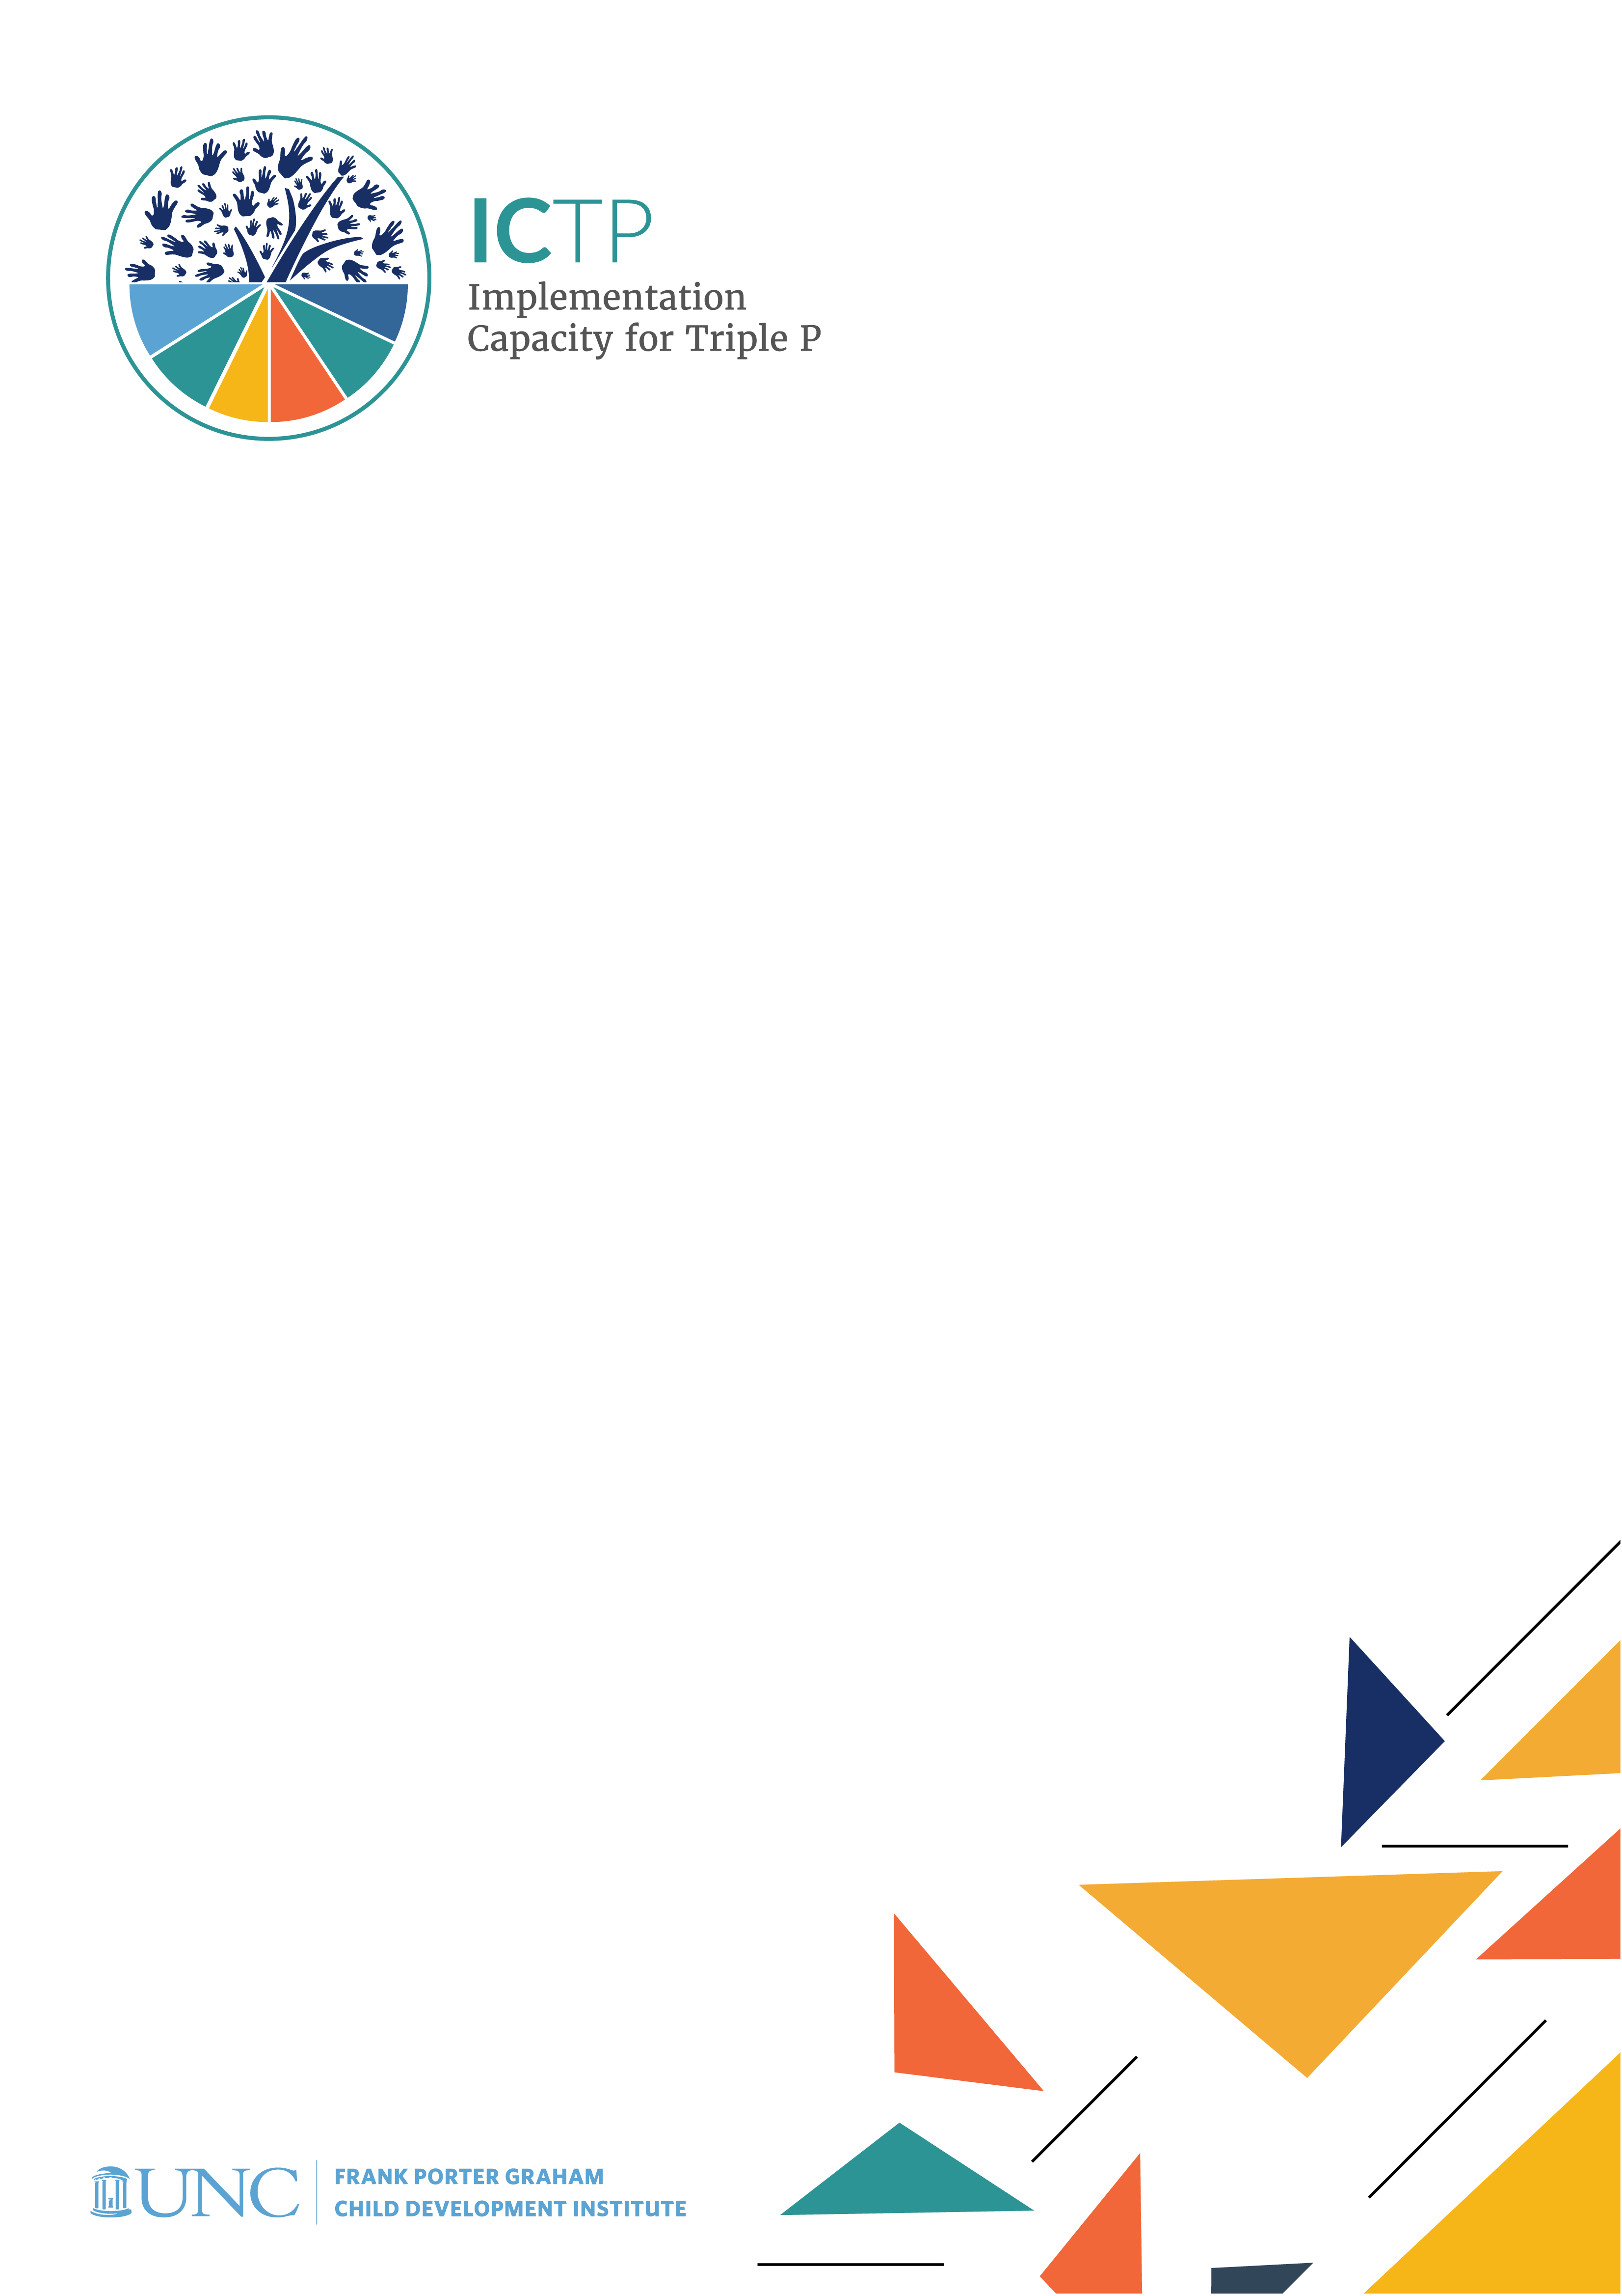

BRIEF 1

NC Triple P

System Overview

Acknowledgements
Development of the ICTP Implementation Support Practice Compendium was supported by the following funding sources:
- The Duke Endowment Grant Agreement No. 2081-SP, The Implementation Capacity for Triple P (ICTP) Projects in North Carolina and South Carolina.
- The North Carolina Department of Health and Human Services, Division of Social Services Contract Numbers 00042356, 00044072, and 00045540, North Carolina Implementation Capacity for Triple P Project.

The authors would like to acknowledge all current and former team members of The Impact Center at Frank Porter Graham Child Development Institute for their contributions to the development and improvement of the practice model represented in the ICTP Implementation Support Practice Compendium. For their reviews, feedback, copyediting, and formatting support, we would like to acknowledge Rona Bernstein of PsycEditing; Kamilah Pickett and Paula Dressel of Race Matters Institute at MDC; and Jennifer Robinette, Julie Chin, LaMana Donadelle, and Lindsay Holland of the ICTP Projects Team, Frank Porter Graham Child Development Institute, UNC-Chapel Hill.

The authors would like to acknowledge Sara van Driel and Courtney Towne for their contributions to the Triple P programmatic details and their support vetting the historical details about North Carolina Triple P in this brief.

Suggested citation: DiSalvo, C. I., Aldridge, W. A., II, Reed, J. J., Banks, C. M., & the members of the ICTP Projects Team (2024, May). NC Triple P system overview (ICTP Implementation Support Practice Compendium, Brief No. 1). Chapel Hill, NC: The Impact Center at Frank Porter Graham Child Development Institute, University of North Carolina at Chapel Hill. https://ictp.fpg.unc.edu/wp-content/uploads/nc-triple-p-system-overview.docx

Christina DiSalvo is now at The Duke Endowment.

The members of the ICTP Projects Team include Principal Investigator William A. Aldridge II; Co-Principal Investigators Christina I. DiSalvo and Jessica J. Reed; Co-Investigators Rebecca H. Roppolo, Sandra J. Diehl, Renée I. Boothroyd, Capri M. Banks, Tamara Robertson, Devon R. Minch, Rohit Ramaswamy, Wendy M. Morgan, and Ximena Franco-Jenkins; and additional team members Shannon D. Chaplo, Sherra C. Lawrence, Kimberly R. Maloney, Marais Pletsch, Ariel B. Everett, Alana Gilbert, Jennifer B. Robinette, Julie Chin, LaMana Donadelle, Andrea Ross, Christine C. Harradine, Lindsay Holland, Margaret Sullivan, and Meera Kumanan.

Correspondence concerning the ICTP Implementation Support Practice Compendium should be addressed to Will Aldridge at FPG Child Development Institute, University of North Carolina at Chapel Hill, CB #8180, Chapel Hill, NC 27599-8180, USA or via email, will.aldridge@unc.edu, phone, 919-966-4713, or fax, 919-966-7532

NC Triple P System Overview

The Triple P – Positive Parenting Program system of interventions offers evidence-based parenting and family supports that aim to increase parents’ knowledge, skills, and confidence in order to improve children’s and adolescents’ mental, emotional, and behavioral health and prevent child maltreatment. Triple P—purveyed globally by Triple P International (TPI) and in the United States by Triple P America (TPA)—is implemented in numerous locations worldwide and in several states, regions, and communities across the United States.

The Impact Center at FPG’s Implementation Capacity for Triple P (ICTP) projects are currently supporting the scale-up of the Triple P system of interventions in North Carolina and South Carolina. In North Carolina, the ICTP project team provides tailored implementation support to nine Triple P regions and design and consultation support to state partners responsible for statewide Triple P strategy, administration, and governance. This brief provides an overview of the structure of the NC Triple P System—including its scale-up since 2012, interactive subsystems, functions, background, and development—and introduces the ICTP project team’s roles and partnerships in the system.

Maps of County & Regional Triple P Scale-Up in NC
The state of North Carolina is scaling-up the Triple P system of interventions with the aspiration to expand its reach statewide. Triple P system scale-up started with seven counties in 2012 and expanded to 37 counties by 2018 (see Figures 1.1–1.3). At that point, the state shifted from a county-driven scaling model to a regionally driven scaling model (see Figures 1.3 and 1.4). The intent of this shift was to create regional backbone organizations, referred to as “lead implementing agencies,” that could both support counties scaling the full Triple P system and provide a point of connection for counties not yet doing so. This model recognized that the state did not yet have the fiscal capacity to fully scale the Triple P system in all 100 counties, despite such visions among state leaders at that time.

Figure 1.1 North Carolina Triple P System County Scale-Up Map, All Funding Sources, March 2012
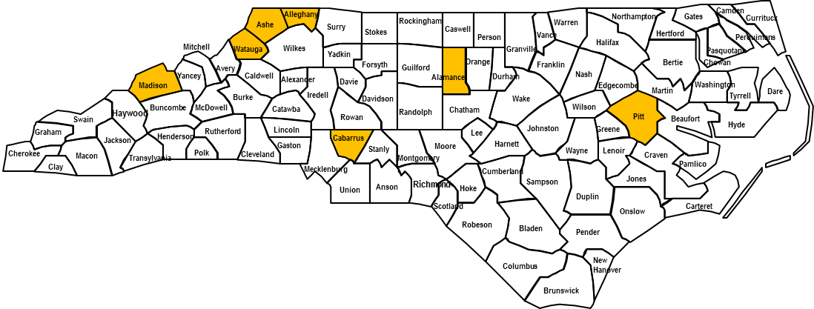

Figure 1.2 North Carolina Triple P System County Scale-Up Map, All Funding Sources, March 2013
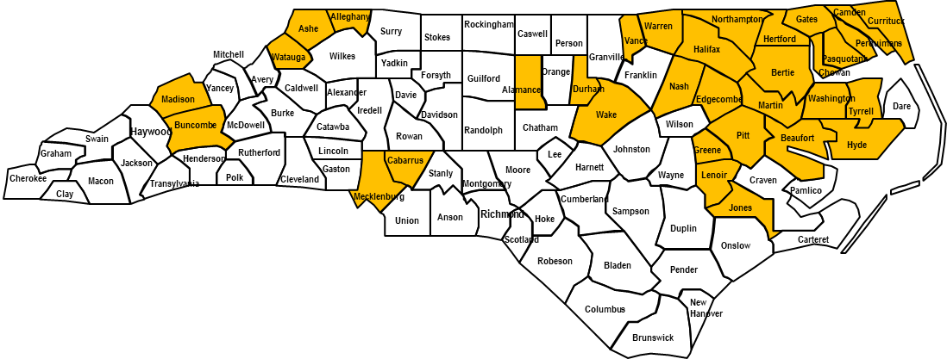

Figure 1.3 North Carolina Triple P System Regional Scale-Up Map Plus Non-scaling Triple P Counties, All Funding Sources, Early 2018. Note. Pale blue shading indicates non-scaling counties, except Wake County, which is a scale-up county; all other shading indicates scale-up counties.

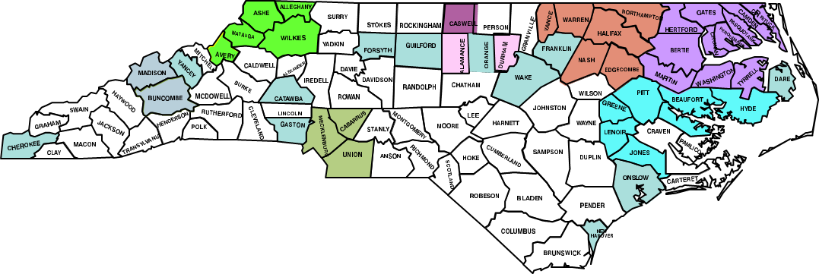

Figure 1.4 North Carolina Triple P System Regional Coverage Map, Early 2018. Notes. Black and red dots indicate locations of regional “lead implementing agencies.” In 2023, the Wake Triple P region merged into the Durham Triple P region, leaving nine total Triple P regions.
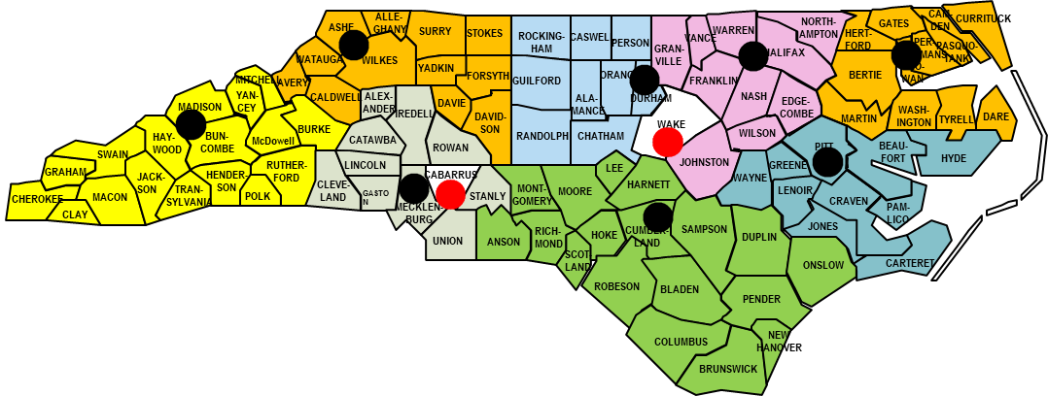

Interactive Triple P Governance, Delivery, & Support Systems in NC
In North Carolina, the Triple P statewide system is composed of three subsystems that work together across multiple levels to ensure the intended delivery of Triple P interventions to families and caregivers. The NC Triple P System includes the following subsystems:
- statewide governance system,
- regionally based delivery system, and
- statewide support system.

Figure 1.5 Functional Levels of the North Carolina Triple P System [1, Adapted from 2]

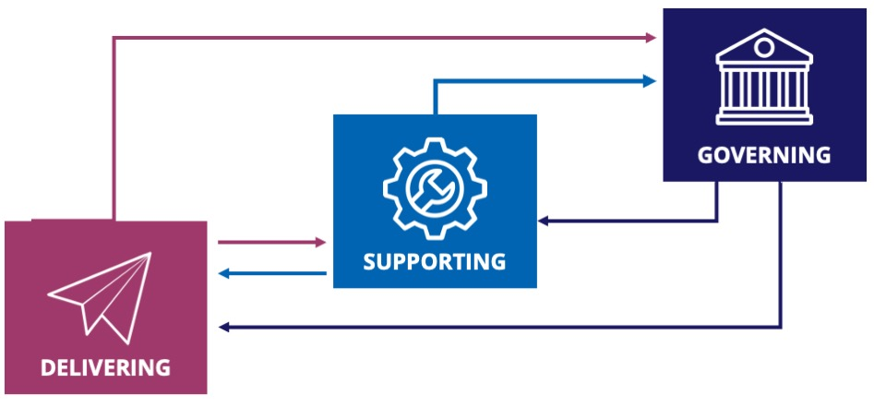

Governance System
Serving a leadership function in the statewide Triple P system, the NC Triple P Governance System is responsible for statewide strategy, communication, resource allocation, and accountability. The original objective of state leaders and funding partners was to replicate in North Carolina the impacts demonstrated in the 2009 U.S. Triple P System Population Trial, funded by the National Center for Injury Prevention and Control, Centers for Disease Control and Prevention (CDC). This place-based, randomized controlled trial of the Triple P system demonstrated large reductions, across county populations, in
- child abuse and neglect,
- out-of-home foster care placements, and
- emergency department visits indicating child injury.
To learn more about the U.S. Triple P System Population Trial, see Prinz and colleagues [3, 4].

The NC Triple P Governance System comprises several state organizations and funding partners. From 2012 until 2017, Triple P scale-up in North Carolina was largely led by the Division of Public Health (DPH) and the Division of Child Development and Early Education (DCDEE) within the NC Department of Health and Human Services (DHHS). These divisions funded Triple P system scale-up through Title V (DPH), Improving Community Outcomes for Maternal and Child Health (ICO4MCH; DPH), and federal Race to the Top – Early Learning Challenge (DCDEE) dollars. However, a small number of counties used direct federal dollars (e.g., from Substance Abuse and Mental Health Services Administration [SAMHSA; Alamance County], CDC [Pitt County]) or private foundation dollars (i.e., the John Rex Endowment in Wake County) for Triple P system scale-up.

In 2017, when many of the public, non-Title V or ICO4MCH funding streams were ending, the Division of Social Services (DSS), NC DHHS began partnering with DPH to blend DSS’s state-allocated funds with DPH’s Title V and ICO4MCH funds to create additional infrastructure funds for counties scaling the Triple P system. DSS also joined The Duke Endowment (TDE) in funding intermediary partners (i.e., The Impact Center at FPG [Frank Porter Graham Child Development Institute, UNC-Chapel Hill] and Prevent Child Abuse North Carolina [PCANC]) to provide a wide array of implementation supports to county and state partners scaling Triple P.

In early 2018, with a blending of funds and leadership from DPH and DSS, plus leadership and funding contributions from TDE, these and three additional state partners (the Division of Mental Health [DMH], the Division of Juvenile Justice [DJJ], and the North Carolina Partnership for Children [NCPC]) engaged in an 18-month strategic planning process. This process was facilitated by two faculty members from the University of North Carolina (UNC) Gilling’s School of Global Public Health and brokered through the ICTP projects. The goal of this strategic planning process was to develop a model of shared state leadership among (1) the NC Triple P System, (2) regional Triple P partners responsible for scaling community-based Triple P systems, and (3) statewide Support System partners responsible for providing implementation supports at regional and state levels.

The outcome of this strategic planning process was the launch of the NC Triple P Partnership for Strategy and Governance (PSG), which was formalized in mid-2019. PSG’s purpose is to coordinate and serve as the leadership team responsible for guiding the statewide scale-up of Triple P through four essential functions:
- strategy development,
- communication,
- resource allocation, and
- accountability (e.g., through the ongoing use of data and evaluation).

An illustration of PSG’s desired statewide outcomes and the intended drivers of those outcomes can be seen in Figure 1.6.

Presently, there are up to 12 seats on the PSG. Eight organizational seats are intended for:
- the Division of Child and Family Well-Being (DCFW; into which DPH Triple P partners were reorganized in 2022)
- DSS
SIDEBAR
For more information about the PSG, see the PSG’s 2019 Governance Manual and Guiding Documents and a 2021 presentation from PSG members to statewide Triple P coordinators, available by request to ICTP project team members and more broadly with permission of the PSG (please contact the ICTP project team through https://ictp.fpg.unc.edu/contact).

- TDE
- DMH
- DJJ
- NCPC
- the Division of Health Benefits
- the Department of Public Instruction

Note that the last two members have yet to fill their seats on the PSG at the time of writing. Two community seats on the PSG are for a community-based Triple P practitioner and a family member receiving Triple P services, but they also have yet to be filled. Finally, two seats are available for Triple P coordinators nominated and selected by their peers.

Figure 1.6 NC Triple P PSG’s Desired Outcomes and Intended Drivers. Note. The Triple P system of interventions includes Level 1, Universal Triple P (communication strategies); Level 2, brief intervention (one-time assistance); Level 3, brief targeted counseling for challenging behaviors; Level 4, broad support for families, including families of children with severe behavior difficulties; and Level 5, intensive support for families with complex needs. PSG = Partnership for Strategy and Governance.

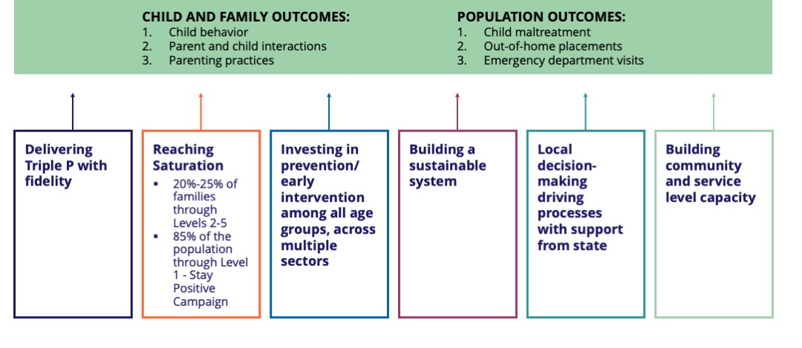

Delivery System
The Delivery System supports and delivers Triple P interventions to families and caregivers within the community. To ensure a community-wide reach of evidence-based parenting and family support, NC counties are presently organized into nine Triple P regions (Cabarrus County is the lone single county region), each involving an array of local family service organizations, supported by a lead implementing agency (LIA; see Figure 1.4).

LIAs across North Carolina develop and provide sustainable community capacity to support local service agencies in selecting and delivering Triple P services. LIAs ensure that the Triple P services selected are responsive to local needs and that the service-delivery partners are trained and provided with coaching to ensure that Triple P is delivered as intended.

Support System
The NC Triple P Support System
- provides tailored implementation support and an array of other intermediary supports to the Delivery System and
- supports the PSG with system design, operationalizing strategy, and system performance consultation to ensure that statewide Triple P scaling strategies are effective and in alignment with systemwide goals and the current needs and progress of the Delivery System.

The NC Triple P Support System consists of three primary partners: The Impact Center at FPG (through the ICTP project team), PCANC, and TPA. While TPA serves as the program purveyor and is available to system partners for program-specific implementation consultation and support, The Impact Center at FPG and PCANC primarily provide general implementation support and other intermediary supports.

Support System Coordination Team
Overseeing the NC Triple P Support System is the Support System Coordination Team, which
- ensures coordinated and aligned supports across the NC Triple P System,
- provides coordinated and aligned communication and feedback loops with the NC Triple P Learning Collaborative (NCLC) and PSG,
- improves the ease of access to supports,
- utilizes data for continuous quality improvement of the Support System,
- provides ongoing support and learning opportunities to Support System members, and
- provides opportunities for regular communication among Support System members.

The Support System Coordination Team comprises representatives from each partner organization. Representatives include:
- PCANC, Capacity Building Director
- PCANC, Capacity Building Team Lead
- Impact Center at FPG, ICTP Principal Investigator/Team Lead
- Impact Center at FPG, ICTP Co-principal Investigator/Team Co-Lead
- Impact Center at FPG, NC DSS Triple P Coordinator
- TPA, Implementation Consultants to North Carolina
- NC DCFW Triple P Coordinator

Support Services & Activities
Figure 1.7 depicts an ideal model of cascading support across the NC Triple P System, including how each partner in the system supports and receives support-based feedback from others. The PSG and NCLC provide support to and receive feedback from LIAs. LIAs in turn provide support to local Triple P service organizations, which support practitioners delivering Triple P interventions to families and caregivers within the community.
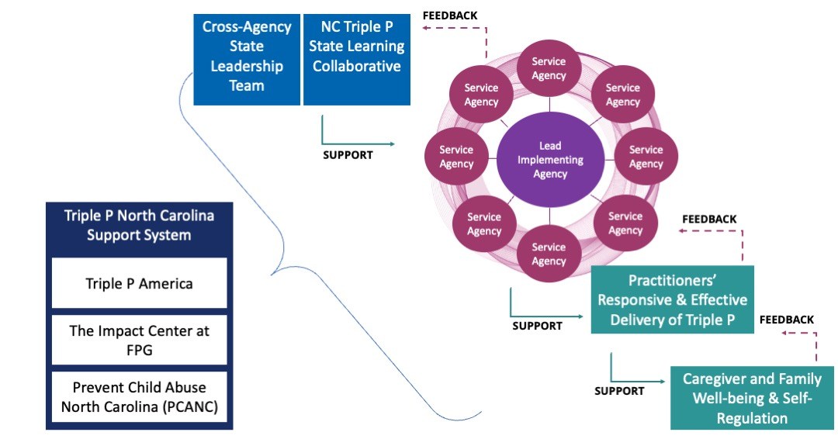

NC Triple P Support System partners work together to offer support services across the following five intermediary functions [5]:
- Research, evaluation, and data linking: helping to ensure the improvement of state and local Triple P efforts through data monitoring, evaluation, and connecting research to practice
- Policy and finance support: helping to ensure hospitable policy and financing environments for Triple P in North Carolina and helping local and state partners to navigate these environments with confidence
- Workforce development: helping to ensure that practitioners can competently and confidently deliver Triple P as intended and in response to caregiver and family needs and preferences
- Partnership engagement and communications: helping to ensure that the right partners are represented at state and community levels to support a hospitable context to achieve Triple P goals; helping to ensure widespread and consistent messaging about positive parenting at state and community levels
- Implementation support: helping to ensure the capacity to scale Triple P with success and sustainability across communities, regions, and the state
DIVE DEEPER
Download Brief #3: ICTP Integrated Theory of Change in section Local Implementation and Scale-Up (Word docx) for more information.

Figure 1.8 depicts the multiple and overlapping ways these five intermediary support functions build local implementation capacity and support local implementation performance.
Figure . The contributions of intermediary services from NC Triple P Support System partners to the development of regional Triple P implementation capacity and performance.

To dive deeper, review sidebar note.
Figure 1.8 NC Triple P Support System Process Map
The NC Triple P Support System Map outlines the work that each Support System member completes. Column one shows the five intermediary support system areas. The arrows to column two show how each Support System Member's work builds local implementation capacity, and the arrows to column three show how it supports local implementation performance. Navy blue arrow represents the Triple P America, orange arrow represents Impact Center at FPG, dotted purple arrow represents Prevent Child Abuse NC, and blue arrows represent local implementation teams.

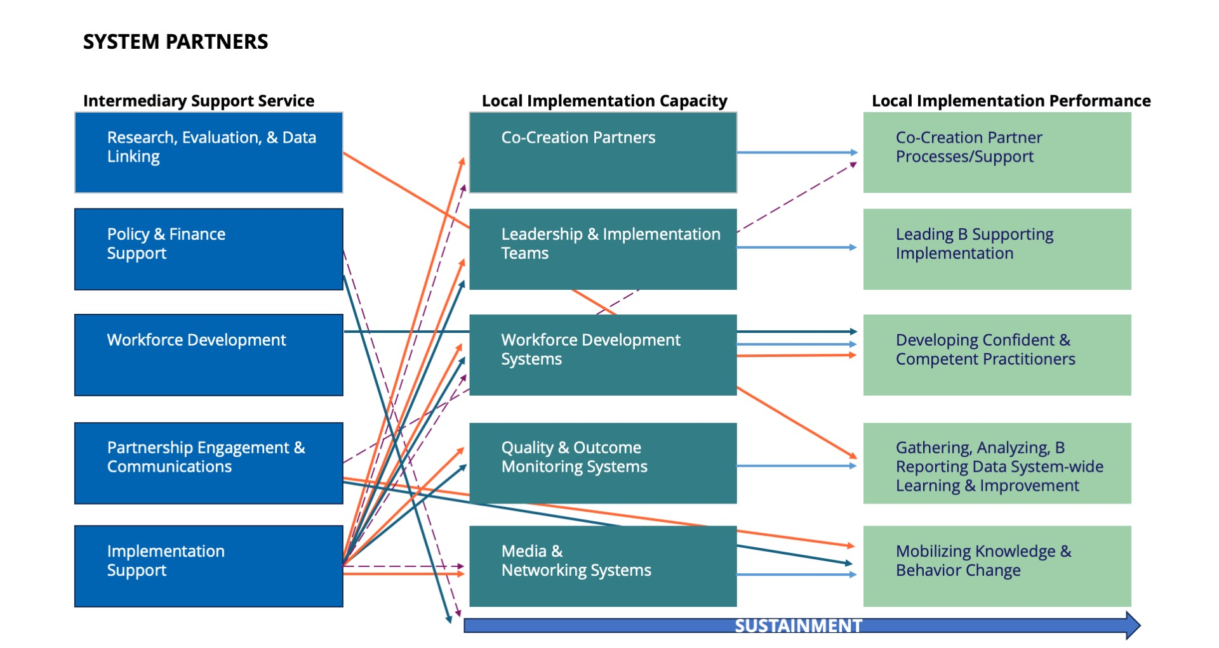

The Support System does not function in a compliance or accountability capacity in any of the NC Triple P regions. Rather, responsibility for compliance and accountability is held by the PSG and individual funders who have detailed each Triple P region’s responsibilities and expectations through annual contracts.

Box 1.1 lists the support services provided by the three Support System partners.

Box 1.1 Summary of Support Services Provided by Each NC Triple P Support System Partner

Triple P America
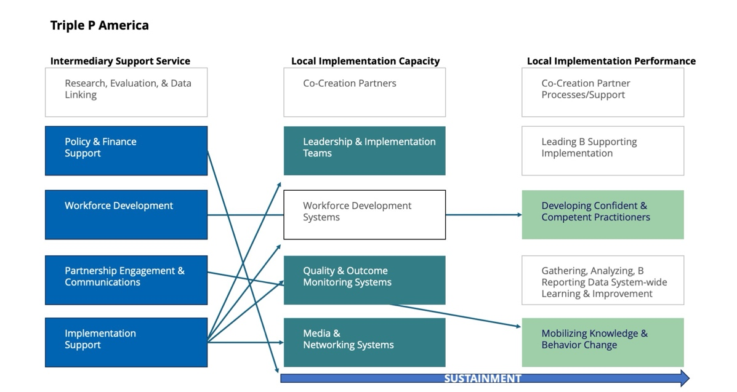

TPA is the program purveyor for the Triple P system of interventions. TPA offers:
- training and accreditation for Triple P providers
- program resource materials for providers and parents
- post-accreditation support for practitioners through workshops, clinical consultation days, or clinical consultation calls
- Stay Positive materials
- Triple P program knowledge, information, and consultation
- national and global Triple P implementation knowledge and experience
- consultation on data and evaluation
- national policy advocacy to prevent child abuse and neglect and promote child and family well-being

The Impact Center at FPG, UNC-Chapel Hill
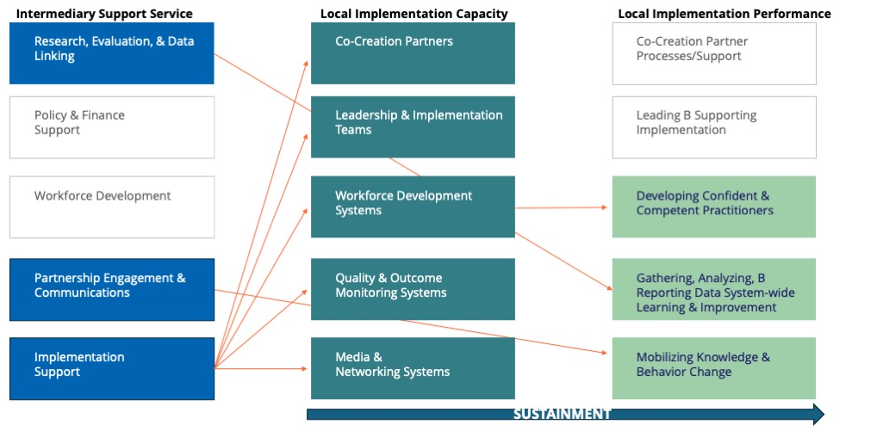

Through the ICTP projects, The Impact Center at FPG offers a variety of implementation supports to state and regional Triple P partners. The Impact Center at FPG offers:
- semi-annual community implementation capacity assessments to monitor and inform improvements for regional Triple P implementation capacity within all nine NC Triple P regions
- proactive and responsive implementation support focused on regional Triple P performance improvement and five areas of implementation capacity (Co-Creation Partners, Leadership & Implementation Teams, Workforce Development Systems, Quality & Outcome Monitoring Systems, Media & Networking Systems) within all nine NC Triple P regions
- a blended media, communications, and networking intervention for statewide Triple P partners to increase learning, favorable attitudes, and support-seeking behaviors related to effective implementation practices; the intervention includes products such as e-newsletters, podcasts, and social media posts as well as universal supports such as ICTP’s online Improvement Lab and Simulation Lab and participation in the NCLC
- implementation design and consultation support for the NC Triple P PSG, NC Triple P Design Team, and NCLC workgroups

Prevent Child Abuse North Carolina
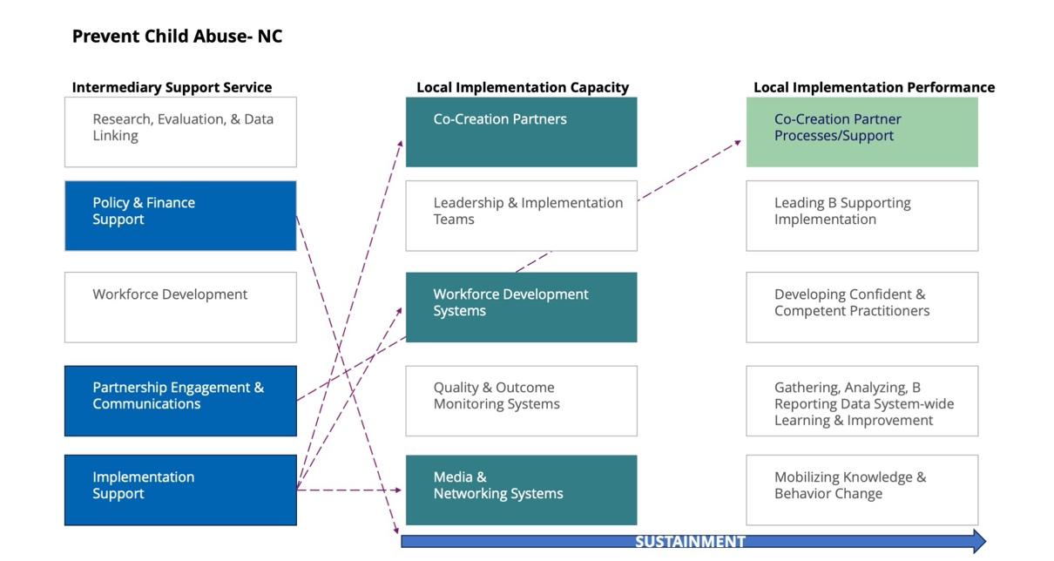

PCANC is a statewide nonprofit organization that offers programmatic training and consultation plus statewide advocacy and communications related to child abuse prevention. PCANC offers the following statewide and regionally tailored supports:
- strengthening Triple P Peer-Assisted Supervision and Support activities (PASS; a peer-based programmatic coaching model)
- skill-based learning opportunities for Triple P practitioners (e.g., virtual delivery of Triple P, peer-coaching skills, parent recruitment and retention strategies, general program facilitation skills)
For a detailed look at how Triple P America and intermediary organizations work in concert to support Triple P implementation, download Support Systems in Action: Alignment of Support Among Triple P America and Intermediary Organizations (docx).

- advocacy for supportive policy and financing environments
- partnership engagement, including communications training and connections to their existing “Prevention Action Network”

PCANC shares with the Triple P Support System Coordination Team and all nine Triple P Regions a monthly calendar of events with brief descriptions.

Onboarding NC Triple P Regions to the Support System
NC Triple P regions were onboarded to the NC Triple P Support System in cohorts based on assessments of their readiness to engage in intensive support processes (see Appendix A for related tools and resources). A map of the original 10 NC Triple P regions with their onboarding dates is provided in Figure 1.9 (the Wake and Durham Triple P regions were separate at the time of their onboarding to the NC Triple P Support System).
Figure 1.9 Dates of Regional Onboarding to the NC Triple P Support System

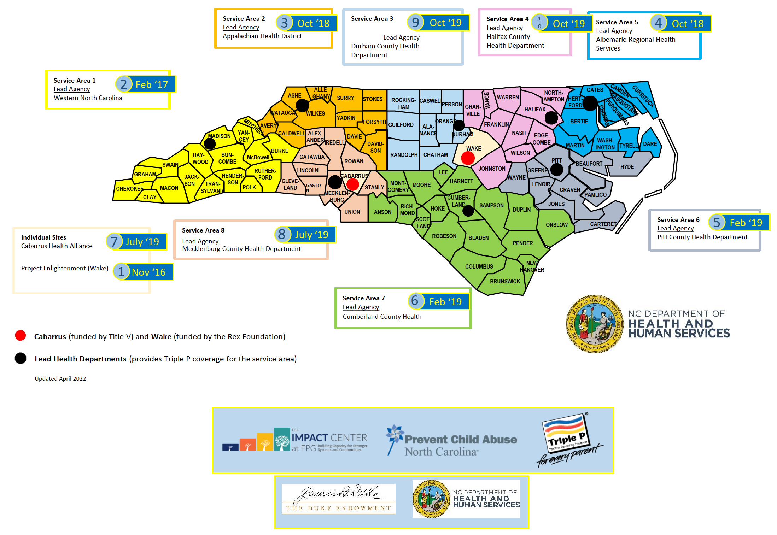

Listen & Learn More About the NC Triple P Support System, for more information or to listen to an in-depth conversation about the NC Triple P Support System:
- A Conversation About How the NC Triple P Support System Works with Communities
- NC Support System Terms of Reference (available by request to ICTP project team members and more broadly with the permission of NC Triple P Support System partners; please contact the ICTP project team through https://ictp.fpg.unc.edu/contact for more information)

Design & Consultation Supports for the NCLC & PSG
In addition to partnering with all NC Triple P regions, NC Triple P Support System partners function in design and consultation support roles with the NCLC (see below) and the PSG. The objectives of design and consultation support are to incorporate effective implementation practices into statewide Triple P working documents and decision-making processes, and to provide system coaching and consultation upon their implementation.

In addition to the three primary interactive systems—governance, support, and delivery—the NC Triple P System is supported by other entities, including a design team and a learning collaborative.

Design Team
The NC Triple P Design Team assists the PSG in translating its strategies into effective system practices and protocols through design, operationalization, and improvement activities. The Design Team typically follows the directions, priorities, and resources of the PSG and, as such, does not have decision-making authority over the adoption or implementation of any system practices or protocols. Rather, the Design Team makes recommendations to the PSG about the elements, in part or in whole, that system practices and protocols must incorporate to be effective and sustainable.

The PSG may request that the Design Team support the translation and operationalization of strategy for any level of the NC Triple P System. Although the Design Team is positioned to mainly be responsive to PSG requests, it may make proactive suggestions or recommendations about the need for new or improved system practices and protocols when needed or otherwise not visible to PSG members.
DIVE DEEPER
Download Brief #3: ICTP Integrated Theory of Change, section Co-Creation Partners and Processes (Word docx) for more information.

The NC Triple P Design Team consists of six members whose objective is to ensure co-creation processes across all its activities. Co-creation involves the collaboration of stakeholders across multiple levels and entities of a system in order to assemble a wide body of knowledge and perspectives. The Design Team comprises
- two regional Triple P coordinators, representing perspectives from regional Triple P partners, delivery systems, and local practice;
- a TPA implementation consultant, representing the Triple P programmatic perspective;
- the principal investigator/team lead of the ICTP projects at The Impact Center at FPG, representing an implementation science perspective;
- the DCFW Triple P Coordinator, representing the perspective of the PSG and state funding agencies; and
- the DSS Triple P Coordinator, also representing the perspective of the PSG and state funding agencies.

While Design Team members may carry out some activities themselves, their responsibility to ensure co-creation processes often necessitates bringing in information, data, and other partners from across the NC Triple P System. This ensures that recommendations to the PSG are shaped through the perspectives of local practice, implementation, and science as well as governance and administrative policies and procedures. Figure 1.10 shows how the design functions integrate with the broader functional levels of the NC Triple P System.

Figure 1.10 Adding Design Functions to the Functional Levels of the NC Triple P System
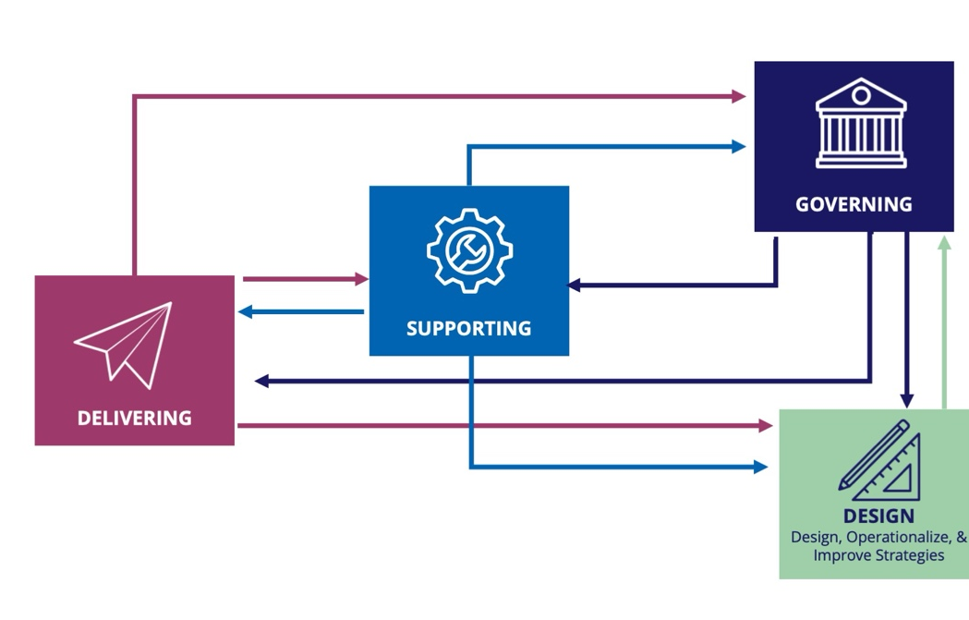

Examples of PSG products, practices, and procedures for which the NC Triple P Design Team has made recommendations to the PSG include
- the NC Triple P Model Scale-Up Plan (2020);
- Five-Year Regional Triple P Strategic Planning Templates and related materials (2020);
- thematic review of regional five-year Triple P strategic plans (2022);
- regional Annual Progress and Action Plan (APAP) templates (2020); and
- communication protocols between the PSG, the NCLC (see below), and other system partners (2021).

Learning Collaborative
Another entity that supports the NC Triple P System is the NC Triple P Learning Collaborative (NCLC), which meets monthly and supports regional Triple P coordinators. The NCLC’s mission is to leverage collective knowledge, experience, and resources to inform both state and local Triple P efforts to reach parents and communities across North Carolina. NCLC activities include
- holding monthly forums to (a) share Triple P implementation successes, challenges, and resources and (b) engage in idea generation, problem solving, and action planning;
- drawing from collective knowledge and data to provide feedback, suggestions, and guidance to PSG members on current and future NC Triple P directions, such as sustainability and expansion;
- reviewing and leveraging state Triple P data for quality improvement;
- creating opportunities for cross-sector and cross-community partnerships, networking, and information sharing; and
- engaging in professional development activities, such as guest speakers and training, and tool development and sharing to build the knowledge and skills of its membership.
The ICTP projects team works closely with the NCLC and its workgroups to design universal implementation support offerings and collect feedback on ICTP support approaches. The ICTP projects team also leverages its knowledge of regional needs and successes, built in part through its participation in NCLC activities, to advocate system change at PSG and Support System Coordination Team meetings.

NC Triple P Model Scale-Up Plan & Regional 5-Year Strategic Planning Process
In early 2019, the PSG requested that the NC Triple P Design Team draft a Triple P model scale-up plan for systemwide partners. In response, members of the NC Triple P Design Team facilitated a structured decision-making process among PSG members over several months. This enabled the PSG to outline and then provide feedback on the features of the plan before and during drafting. At the February 2020 NCLC meeting, the PSG released the NC Triple P Model Scale-Up Plan to state, regional, and local Triple P coordinators, funders, policymakers, and other partners. The plan provided detailed information about the core activities, strategies, structures, and processes needed to scale-up and support the Triple P system of interventions to reach whole communities as driven by local needs.

Soon after releasing the Model Scale-Up Plan, the PSG requested that all DHHS-funded Triple P regions engage in a community- and data-driven strategic planning process so that regional Triple P partners could proactively plan Triple P activities over the next five years. Wake County Triple P, funded separately at that time by a private endowment, chose to participate as well.

To facilitate this process, at the request of the PSG, the NC Triple P Design Team developed the Five-Year Strategic Plan Template, which aligned with the NC Triple P Model Scale-Up Plan. Regional Triple P partners in communities scaling the full Triple P system used this template to detail planned implementation activities, strategies, structures, and processes that align with those detailed in the NC Triple P Model Scale-Up Plan.

The intention was not for communities to replicate the Model Scale-Up Plan but to begin to approximate—in ways specifically tailored to each community’s needs, resources, and specific visions—the models provided in the Model Scale-Up Plan. Secondarily, the PSG intended to use this process to increase statewide consistency among communities scaling Triple P, at least in terms of the core program and implementation components needed for community-driven success and sustainability. The Five-Year Strategic Plan Template also included a separate section for regional Triple P partners to detail planned activities, strategies, structures, and processes to continue support for emergent or developmental Triple P activities in regional communities not presently scaling the full Triple P system.

To aid in the strategic-planning process, the NC Triple P Design Team provided a “Frequently Asked Questions” document and discussed it with all regional Triple P partners early in their strategic planning activities.

Once the five-year strategic plans had been completed, they were to serve as a guide for regional Triple P coordinators in completing Annual Progress and Action Plans (APAPs), required by the PSG. In this way, APAPs were to serve as a tool for community Triple P leaders and implementation teams to review their annual progress and set action plans for the upcoming year based on their five-year strategic plan activities.

The PSG was responsible for communicating, allocating resources toward, ensuring accountability regarding, and otherwise leading the statewide five-year strategic planning process and related APAPs. The NC Triple P Support System was responsible for tailoring statewide and regional support strategies to support the development, revision, and overall implementation of regional five-year strategic plans and related annual activities.

Due to the COVID pandemic in 2020 and 2021, regional engagement in strategic planning was hampered. Though every region turned in a draft of a complete or incomplete five-year strategic plan in August 2021, the pandemic essentially undermined regional Triple P leaders’ and implementation teams’ abilities to engage community partners and carry forward with intended strategic planning activities in efficient and fully effective ways. In 2023, the PSG effectively released all Triple P regions from oversight of progress on their five-year strategic plans due to these impacts but encouraged regions to continue using these plans as useful.

System Contexts & ICTP Implementation Support Practice
ICTP implementation support practitioners (ISPs) provide a range of direct implementation support activities to ensure the success and sustainability of Triple P implementation and scale-up. Engagement in implementation support was consistently high across both state and regional Triple P partners through mid-2022. In the latter half of 2022 and 2023, engagement was more variable across regional Triple P partners. In any situation, it is important to remember that ICTP supports are influenced by system, community, and organizational contexts [6]. The system context refers to sociopolitical and economic forces that either facilitate or hinder community Triple P scaling efforts. The community context refers to activities and relationships within the regional setting that can influence community-based Triple P scale-up and implementation activities. Finally, the organizational context refers to culture and climate factors within an LIA or a Triple P provider organization that influence the scaling or implementation behaviors of leaders and staff.

These three interrelated contexts must inform the approach any ICTP ISP takes in tailoring their implementation support activities. Contextual factors may limit as well as strengthen the ability to provide ICTP implementation supports effectively. ICTP regional support specialists, in particular, require a deep understanding of community context to make decisions about which implementation strategies to select, combine, and/or integrate when supporting regional Triple P partners to address their specific implementation challenges [6, p. 5]. However, all ICTP ISPs—including ICTP design and consultation specialists, media and networking specialists, and regional support teams—need working knowledge of context at all three levels. This allows them to remain aligned and operating as an efficient and effective broader implementation support team within the NC Triple P System. When ICTP ISPs are less familiar with these contextual factors, they risk tailoring support in a way that may fragment ICTP support activities, at least, and NC Triple P System activities, at worst.

In short, ICTP ISPs must
- deliver support in flexible, dynamic ways to account for contextual factors and meet the needs of support participants (i.e., leaders and teams, organizations, and state-level and community partners receiving implementation support) at any level of the NC Triple P System; and
- remain in overall alignment with other ICTP ISPs working at different system levels.

When these aims are accomplished, the influence of the ICTP project team is maximized.

Key Takeaways:
- The state of North Carolina is scaling-up the Triple P system of interventions with the aspiration to expand its reach statewide. Triple P system scale-up started with seven counties in 2012 and expanded to 37 counties by 2018. At that point, the state shifted from a county-driven scaling model to a regionally driven scaling model. At present, there are nine NC Triple P regions.
- In North Carolina, the Triple P statewide system is composed of three sub-systems that work together across multiple levels to ensure the intended delivery of Triple P.
- A governance system—referred to as the “NC Triple P Partnership for Strategy and Governance” (PSG) and comprising several state organizations and funding partners—is responsible for statewide strategy, communication, resource allocation, and accountability.
- A delivery system—comprising local family service organizations supported by a lead implementing agency (i.e., regional backbone organization)—supports and delivers Triple P interventions to community families and caregivers.
- A support system—referred to as the “NC Triple P Support System” and comprising Triple P America (TPA); The Impact Center at FPG, UNC-Chapel Hill; and Prevent Child Abuse North Carolina (PCANC)—supports regional and state partners in building community resources and abilities to implement Triple P programs successfully and sustainably (i.e., implementation capacity) and at a high level of quality (i.e., implementation performance).
- The Impact Center at FPG’s ICTP project team focuses primarily on the provision of external implementation support, or support provided by individuals outside a service organization aimed at influencing change and improvement among people, processes, and structures. In order to provide optimal support, ICTP implementation support practitioners must be familiar with each community’s stages of Triple P implementation as well as multiple context factors related to the system, community, and other support partners.
- To aid state, regional, and local Triple P partners, the PSG rolled out in early 2020 the NC Triple P Model Scale-Up Plan, which details the core expectations, activities, strategies, structures, and processes needed to scale-up and support the Triple P system of interventions. In alignment with this plan, the Five-Year Strategic Plan Template was created to assist regional Triple P partners in creating strategic plans to begin approximating the model scale-up plan over a five-year period. In 2023 mostly to the lasting impacts and changes brought on by the COVID pandemic, the PSG effectively released all Triple P regions from oversight of detailed progress on their five-year strategic plans, though encouraged regions to continue using their strategic plans as useful.

Reference List

- Ramaswamy, R., & Upshaw, V. (2018, January 26). PPP system and components, pre-work for strategic planning retreat. Chapel Hill, NC: Gillings School of Global Public Health, University of North Carolina at Chapel Hill.
- Wandersman, A., Duffy, J., Flaspohler, P., Noonan, R., Lubell, K., Stillman, L., Blachman, M., Dunville, R., & Saul, J. (2008). Bridging the gap between prevention research and practice: The interactive systems framework for dissemination and implementation. American Journal of Community Psychology, 41(3-4), 171–181. https://doi.org/10.1007/s10464-008-9174-z
- Prinz, R. J., Sanders, M. R., Shapiro, C. J., Whitaker, D. J., & Lutzker, J. R. (2009). Population-based prevention of child maltreatment: The U.S. Triple P System Population Trial. Prevention Science, 10(1), 1–12. https://doi.org/10.1007/s11121-009-0123-3
- Prinz, R. J., Sanders, M. R., Shapiro, C. J., Whitaker, D. J., & Lutzker, J. R. (2016). Addendum to "Population-based prevention of child maltreatment: The U.S. Triple P System Population Trial". Prevention Science, 17(3), 410–416. https://doi.org/10.1007/s11121-016-0631-x
- Mettrick, J., Harburger, D. S., Kanary, P. J., Lieman, R. B., & Zabel, M. (2015). Building cross-system implementation centers: A roadmap for state and local child- and family-serving agencies in developing Centers of Excellence (COE). The Institute for Innovation & Implementation, University of Maryland. http://hdl.handle.net/10713/7379
- Metz, A., Burke, K., Albers, B., Louison, L., & Bartley, L. (2020). A practice guide to supporting implementation. ISP Practice Guide-v1-10.27.22.pdf

