Local Implementation & Scale-Up
In the ICTP integrated theory of change, local implementation and scale-up refer to both system capacity and system performance. We’ll break these down below.

System Capacity
System capacity, or implementation capacity, refers to a system’s resources and abilities to successfully and sustainably carry out programs and practices to a level of desired performance [46]. The ICTP projects affirm that the most promising approaches to implementation and scale-up give strong attention to three key features of implementation capacity:
- leadership and implementation teams within community and state service systems (e.g., individual service agencies) and coalitions across community and state service systems (e.g., community coalitions led by local backbone organizations, statewide intermediary organizations, and state service agencies) [13, 35, 36, 47–60];
- workforce development systems that integrate best practices for practitioners’ professional development (i.e., recruitment and selection, training, and coaching) to deliver programs as intended, in response to participants’ needs and perspectives, and with expected benefits for children and families [7, 43, 61–72]; and
EQUITY IN IMPLEMENTATION

Because of their community-wide reach and focus on influencing social norms, which are culturally shaped, media systems, communications, and networking strategies are most effective if they are developed using a racial equity lens and are tailored to identified populations. Download
Brief #5: Foundations of the ICTP Implementation Support Practice Model, Section Equity in Implementation Practice (docx) for more information on equity in implementation practice.
- quality and outcome monitoring systems to foster organizational improvement and program optimization [7, 54, 73–80].

When engaging in community-wide prevention and well-being efforts, it is important to bear in mind that programs and practices will always reach only a small segment of the intended population. To achieve population-level outcomes, it is essential to have a fourth type of system—media and networking—to spread knowledge and mobilize behavior change [8, 9, 53, 81–85]. Media systems, communications, and networking strategies can encourage potential program participants to seek support and influence positive parenting attitudes, knowledge, and skills beyond what is gained from direct practitioner-to-participant interactions.

Leadership and implementation teams provide the “who” of implementation. Evidence about Triple P implementation in North Carolina has indicated that these teams play a significant role in developing other components of implementation capacity (e.g., workforce development systems and quality and outcome monitoring systems) and advancing positive community Triple P implementation outcomes [31, 86, 87]. In the ICTP integrated theory of change (Figure 3.1), this is indicated by the darker green wedge around leadership, implementation teams, and coalitions.

Several types of leadership and implementation team structures are promoted within community Triple P systems, including
- community Triple P leadership teams,
- community Triple P implementation teams,
- community Triple P coalitions, and
- Triple P service provider leadership and implementation teams.
For more information about these teaming structures, including their unique and shared functions, see the NC Triple P Model Scale-Up Plan.

Workforce development systems, quality and outcome monitoring systems, and media and networking systems are considered integrated and compensatory [7], meaning that they operate in concert and often overlap with and influence each other in various ways. For example, quality and outcome data can be collected about workforce development efforts or be used to improve media and networking efforts. This concept is demonstrated by circular arrows in this area of the ICTP integrated theory of change (Figure 3.1). More information about these implementation capacities as related to expectations within the NC Triple P System is also available in the NC Triple P Model Scale-Up Plan.
CONTACT

Please contact us to request plan from the ICTP project team members and more broadly with the permission of the PSG projects.

Multilevel support systems are typically required to foster the development and sustainment of implementation capacities across a region or state. Figure 3.3 presents the ideal multilevel system of Triple P support in North Carolina, which can inform similar models within other locations. The cascading tiers of support provide ways to communicate meaningful roles within each level of a regional or statewide system and support the overall success of initiatives [7, 36]. Although Figure 3.3 depicts support feedback loops between only single levels of the system, feedback from and to each level of the system is necessary for authentic co-creation processes and ongoing quality improvement.

Figure 3.3 Ideal Model of Multilevel Support for the NC Triple P System.
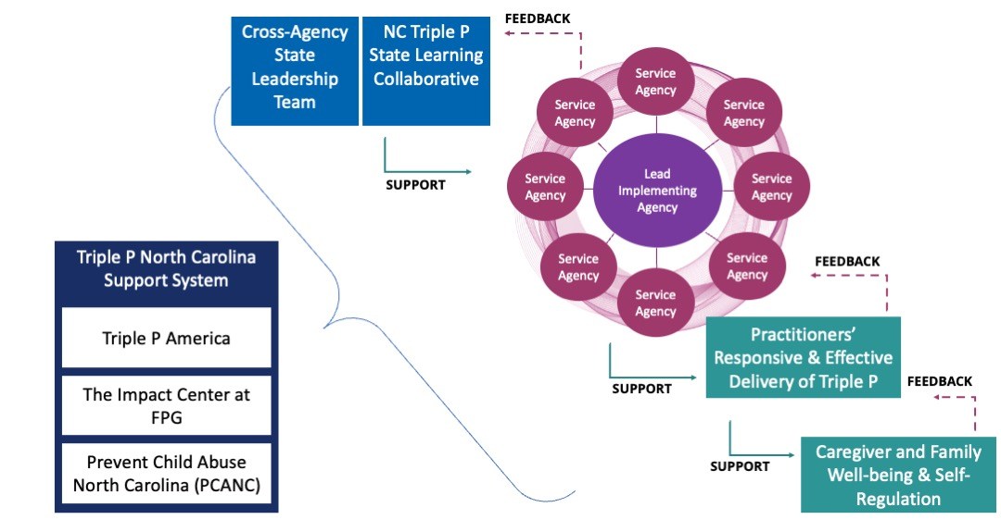

System Performance
The “System Performance” section of the ICTP integrated theory of change (Figure 3.1) demonstrates implementation performance outcomes that align with the four implementation capacity components described in the preceding section. Chinman and colleagues [1] define implementation performance as “the level of quality at which [essential implementation practices] are carried out” (p. 3). The ICTP integrated theory of change details five essential implementation practices:
- leading and supporting Triple P implementation and scale-up, including committing to equitable partnerships, identifying and addressing implementation barriers, and spreading successes;
- developing confident and competent Triple P practitioners who can deliver Triple P with fidelity and in response to parent needs, preferences, and social and cultural identities and histories;
- gathering, analyzing, and reporting—to the right people at the right times, including community members—program and implementation data related to Triple P delivery;
- facilitating system-wide learning and continuous quality improvement of Triple P implementation, delivery, and outcomes; and
- mobilizing knowledge and behavior change across communities, beyond that created by direct interactions between practitioners and program participants.
These performance indicators are high level and may be further broken down into more specific performance behaviors. For example, leading and supporting Triple P implementation may involve executive leaders’ ongoing demonstration of commitment to Triple P implementation (i.e., “implementation climate”) and aligning community prevention strategies through common approaches and intended outcomes [35, 88]. Likewise, developing confident and competent practitioners may involve high-quality practitioner recruitment and selection, training, and coaching practices [7, 35, 88].

