ICTP Media & Networking Influences & Outcomes
Figure 9.1 provides a model for how ICTP media and networking activities influence a distinct set of short-term practice outcomes and complement direct implementation support activities provided by ICTP regional support teams and other ISPs. Within this model, ICTP media and networking team members use network metrics (i.e., relationship measurements) and data visualization ((i.e., visual representations of numerical information) to
- understand, use, and expand existing communication networks and
strategically influence individuals, organizations, and settings to receive, create, and share effective implementation practice information, messages, and modeling.
Figure 9.1 ICTP Model of Media and Networking (M&N) Influences and Outcomes.
Note. TA = technical assistance. Red arrows: primary pathway for influence media and networking efforts (direct intervention), trying to shift attitudes and support seeking behavior in the red triangle. Dotted arrow: is the realization that we don’t expect direct application through M&N alone. Blue arrow: represent traditional on the ground support processes. Green: pathway of activities represent support from the communication network.
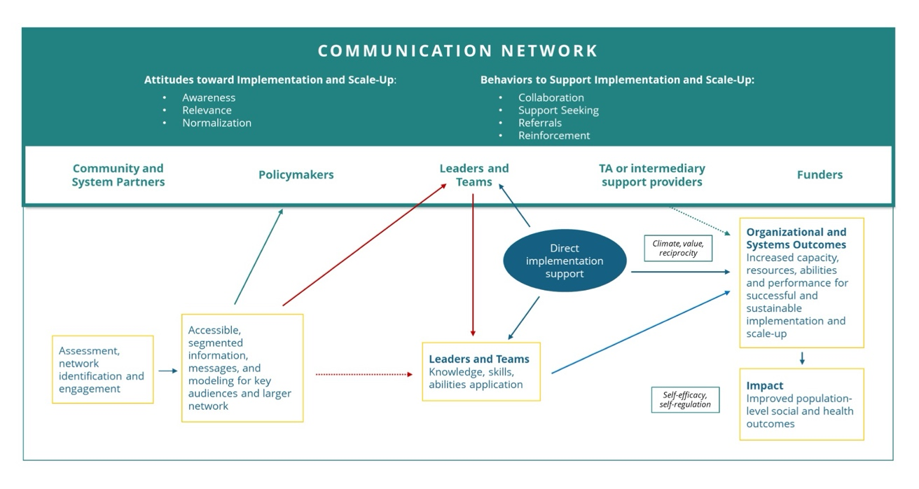

Box 9.3 describes the network metrics used within the ICTP projects.
Box 9.3 ICTP Case Example of Using Network Metrics to Create Strategic Influence on Individuals and Organizations
The Triple P stakeholder network includes regional Triple P leaders and implementation teams, community partners, NC Triple P Support System members, and funders (see Figure 9.1). The ICTP projects use five key network metrics and a 20-item scale to evaluate network functioning. The five metrics are:
- In-degree centralization (how many people have connections to person X). This gives a sense of who may be network influencers.
- Unidirectional ties (person X nominates person Y, but person Y does not nominate person X). A network with a high number of unidirectional ties is siloed and communication among members is weak.
- Reciprocal ties (person X nominates person Y, and person Y nominates person X). This gives a sense of collaboration and trust in a network.
- Network size (the number of people represented in the network who have at least one connection with another person in the network). This gives a sense of the overall network size.
- Density (a statistic that represents the proportion of possible relationships in the network that are actually present). Lower numbers represent networks with no or few relationships and higher numbers represent networks with many or all possible relationships. For the purposes of the Triple P network, a higher number is desirable.

The SPANS (Scale of Perceived Network Support) measures perceived value, reciprocity, and collaboration climate within the network. This scale (and subscales) gives ICTP media and networking team members and other system partners direction in terms of where to focus efforts to change network attitudes and/or behavior.

Individuals central to the Triple P stakeholder network (i.e., those with high in-degree centralization) typically serve as podcast guests, model implementation experiences in The Implementeer newsletters, and lead activities during NCLC sessions.
These network measures are also used for descriptive and evaluation purposes to see how the network is changing over time in response to influences of ICTP media and networking team members and other system partners.

ICTP media and communications strategies employed within the communication network model [Figure 9.1 ICTP Model of Media and Networking Influences and Outcomes] are tailored to best practices, needs, and audience preferences, as illustrated in the practice example in Box 9.4. They involve an array of digital and interpersonal communications activities to
- share effective implementation practice information and resources,
- model real-world implementation,
- build network familiarity,
- build effective implementation practice skills, and
- model and normalize implementation support-seeking behaviors.
Box 9.4 ICTP Case Example of Tailoring Digital and Interpersonal Communications to System Needs and Preferences for Implementation

The ICTP projects published four issues of The Implementeer between July 2022 and June 2023 that focused on topics selected by NCLC members through a survey. Nominations for topics included in the survey came from
- ICTP regional support teams, based on their work with regional Triple P partners,
- records of NCLC meeting questions and conversations, and
- ICTP project team member meetings with Triple P America implementation consultants.

Out of approximately seven topics, including write-ins, ICTP media and networking team members selected the top four:
September 2022 Building Community Coalitions
December 2022 Honoring Family and Community Voices
March 2023 Creating a Shared Triple P Vision
June 2023 10 Things I Hate about Data
These issues generally followed a sequential pattern around community engagement and visioning and included stories from key network leaders and community Triple P implementation teams.
While media and communications efforts might directly target community Triple P leaders and implementation teams (the red arrows in Figure 9.1), these efforts also help the broader network of co-creation partners to create secondary influences, strengthening the entire network (the blue arrows and circles in Figure 9.1). This is illustrated in the practice example in Box 9.5. Co-creation partners are not typically static groups, but rather interact with and influence each other, creating the possibility for accelerating social influence and learning.

Box 9.5 ICTP Case Example of Using ICTP Media and Networking Activities to Influence Broader Co-creation Partners and Create Broader System Influences
In 2018 and 2019, ICTP design and consultation specialists used a high-level community Triple P scale-up template developed by partners in South Carolina to model effective implementation design strategies to members of the NC Triple P Partnership for Strategy and Governance (PSG). The primary goals of this model activity were to
- influence PSG members’ attitudes about the acceptability and feasibility of creating a similar system-wide Triple P implementation template for NC communities,
- increase their confidence that they could be responsive to regional Triple P partners’ requests for such templates, and
- increase the likelihood that they would request support from NC Triple P Design Team members to facilitate the development of similar templates.
These efforts were successful, leading to an invitation for the NC Triple P Design Team to facilitate the PSG’s development of what became the North Carolina Triple P Model Scale-Up Plan. The NC Triple P Model Scale-Up Plan subsequently influenced regional Triple P partners’ attitudes about effective implementation practices; their development of regional, five-year strategic Triple P scale-up plans; and their support-seeking behaviors with ICTP regional support teams and other Support System members (e.g., Triple P America, Prevent Child Abuse North Carolina).

Moreover, as discussed above, the influence of media and communications on community Triple P leaders’ and teams’ implementation knowledge, skills, and abilities and their application of effective implementation practices is greatly enhanced by the engagement of direct, tailored support from ISPs (the green arrows and box in Figure 9.1). Altogether, these influences may accelerate intended effects on longer-term practice outcomes, such as implementation capacity and performance.

The short-term outcomes of ICTP media and networking activities include a variety of attitudes and behaviors that reflect Triple P partners’ readiness to adopt and apply effective implementation practices. For example, by normalizing partners’ experiences with typical challenges implementing and scaling Triple P, ICTP media and networking activities may build Triple P partners’ resiliency. By highlighting partners’ use of effective implementation practices, their successes, and case examples from similar implementation efforts, ICTP media and networking activities may contribute to partners’ awareness and perceived relevance of effective implementation practices. Furthermore, they may shape partners’ motivation to adopt similar implementation strategies and confidence that they can be utilized with good effect.

By embedding a “call to action” in media and communications, ICTP media and networking activities can influence partners’ support-seeking behaviors, including where to go for more information, collaboration, or direct support. Support seeking may afford opportunities to
- reinforce existing connections with ICTP regional support teams and other ISPs and
- broker connections to peer supports and broader co-creation partners.

In the following two sections, we provide details about current ICTP media and networking activities, including network assessment methods and media and communications channels.

