ICTP Implementation

Support Practice Model: Background & Development

In this brief, we provide a concise overview of implementation science to serve as context in which to understand the Implementation Capacity for Triple P (ICTP) implementation support practice model, a detailed approach for supporting Triple P implementation and scale-up in the Carolinas. Following this, we describe the development and status of the ICTP implementation support practice model. A starting point to appreciating implementation science and its use as the foundation of the ICTP projects is understanding that the field originated to address critical challenges that persist today regarding the implementation of evidence-based prevention programs.

Evidence-based prevention programs offer a great deal of promise to support the health and well-being of children, youth, families, and communities. Many funders and service providers have shifted toward program models that have demonstrated (a) positive impact through rigorous evaluations and (b) positive outcomes with regard to choice, fit, and feasibility within adopting locations.

However, in the context of established health, well-being, and prevention systems, the implementation and scale-up of these innovations can be challenging. Implementation is defined as “a specified set of activities designed to put into practice an activity or program of known dimensions” [1] (p. 5). Scale-up refers to systematic approaches used to increase intervention coverage, range, and sustainability [2]. Scale-up can occur both vertically (i.e., involving multiple system levels) and horizontally (i.e., spread across individual or cross-sector networks). For example, a program can expand from a successful local program into regional, national, or international levels.

One reason implementation and scale-up often prove challenging is that despite their best intentions, longstanding, complex, and fragmented service systems tend to revert from innovation back to past practices. Additionally, structural inequities that result in the marginalization of diverse community, family, and practitioner voices often limit the optimization of scale-up. These challenges continue to prevent evidence-based strategies from yielding intended outcomes. To address challenges related to implementation and scale-up, the ICTP projects utilize implementation science and related equity-informed practices to develop methods, materials, and opportunities to support statewide partners and local communities in North Carolina and South Carolina to successfully and sustainably scale the Triple P – Positive Parenting Program (Triple P) system of interventions. Our long-term goal is to support our partners to realize intended population-level benefits while substantially reducing or eliminating disparities among children, families, and communities, at least insofar as Triple P implementation and programmatic opportunities may afford.

More specifically, the ICTP projects leverage
- current research and effective practices from implementation science, particularly those that reinforce health equity and may help counteract historical system and community inequities;
DIVE DEEPER
Refer Brief #2: NC Triple P Implementation Evaluation, for more information.
- mixed-methods evaluation findings from the North Carolina Triple P Implementation Evaluations (TPIE and TPIE-Qualitative); and
- partnerships with statewide stakeholders involved in scaling-up the Triple P system.

In the next section, we offer a brief synopsis of the components of implementation science as they pertain to the ICTP projects.

Implementation Science: Research & Practice
Implementation science is defined as “the scientific study of methods to promote the systematic uptake of research findings and other evidence-based practices into routine practice, and, hence, to improve the quality and effectiveness of health services and care” [3]. In accordance with this definition, implementation science is evolving into a field that recognizes both research and practice activities (see Figure 4.1; [4]). Implementation research focuses on developing and testing generalizable approaches to applying effective interventions (e.g., programs, practices, and policies) in typical human service settings. Implementation practice focuses on tailoring and applying those approaches within context-specific settings to achieve intended outcomes. Implementation research and practice also entail developing innovative interventions or adapting existing effective interventions in real-world practice settings. Implementation research and practice operate on a common set of implementation outcomes: adoption, feasibility, appropriateness, fidelity, acceptability, reach, cost, and sustainability [5].

Figure 4.1 The Two Equally Important Components of Implementation Science [4, p. 2]
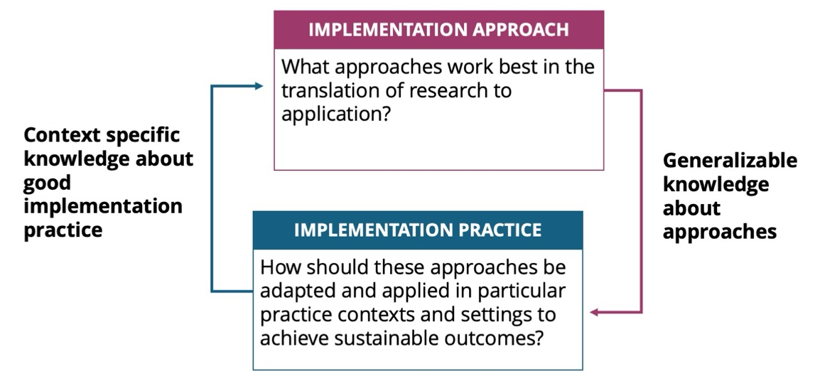

In implementation practice, the focus of much of this compendium, the goal is not discovering whether things could work, but rather engineering strategies and approaches that enable things to work within specific contexts and for involved partners [6]. The focus is on figuring out how, rather than examining whether, success can be achieved. To these ends, the ICTP projects align with the view that implementation practice is a process that “involves multiple decisions, actions, and corrections to change the structures and conditions necessary to implement and sustain new practices and programs successfully” [7].

Among the partners engaged in implementation practice are implementation support practitioners (ISPs) [8]. ISPs draw from widely recognized disciplines—such as technical assistance, practice facilitation, system coaching, change agency, and knowledge brokerage—that aim to move research into practice and policy. Metz and colleagues [9] explain that ISPs
. . . can reside outside the service systems they work in but may also operate from within a service system when those systems have internal work units specifically designed to support innovation, implementation, improvement, and/or scaling efforts [e.g., implementation teams]. Implementation support is often delivered through partnerships between professionals residing inside and outside public service systems. (p.239–240)

The ICTP implementation support practice model, described below, was designed by Aldridge and colleagues [10] for ISPs who reside outside the service systems in which they work. Thus, this approach is referred to as external implementation support (EIS). EIS is aimed at influencing internal practice change and improvement among people, processes, and structures. As a form of implementation practice, EIS has been characterized as “both proactive and responsive in nature and usually involves a combination of implementation science and skills training, facilitation, and supportive behavioral coaching for individuals, groups, and organizations” [6, p. 192]. Through EIS, ISPs foster the partnerships and conditions needed for internal change agents to implement and scale-up effective interventions successfully and equitably.

