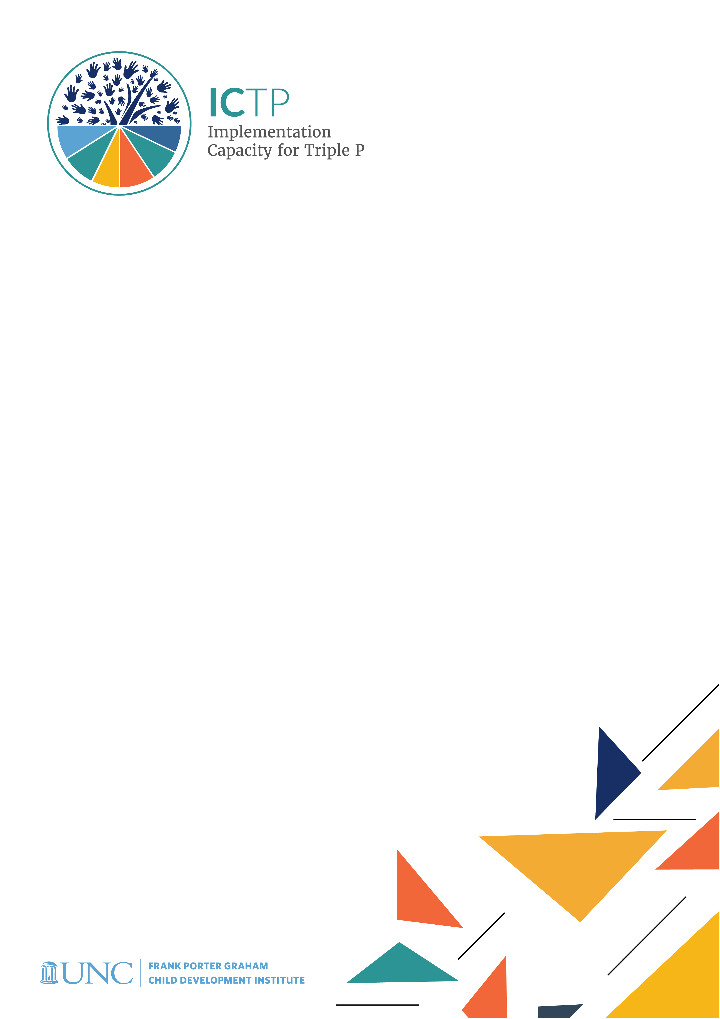

BRIEF 10

ICTP Project Infrastructure for Ongoing Learning & Improvement

Acknowledgements
Development of the ICTP Implementation Support Practice Compendium was supported by the following funding sources:
- The Duke Endowment Grant Agreement No. 2081-SP, The Implementation Capacity for Triple P (ICTP) Projects in North Carolina and South Carolina.
- The North Carolina Department of Health and Human Services, Division of Social Services Contract Numbers 00042356, 00044072, and 00045540, North Carolina Implementation Capacity for Triple P Project.

The authors would like to acknowledge all current and former team members of The Impact Center at Frank Porter Graham Child Development Institute for their contributions to the development and improvement of the practice model represented in the ICTP Implementation Support Practice Compendium. For their reviews, feedback, copyediting, and formatting support, we would like to acknowledge Rona Bernstein of PsycEditing; Kamilah Pickett and Paula Dressel of Race Matters Institute at MDC; and Jennifer Robinette, Julie Chin, LaMana Donadelle, and Lindsay Holland of the ICTP Projects Team, Frank Porter Graham Child Development Institute, UNC-Chapel Hill.

Suggested citation: Everett, A. B., Banks, C. R., Roppolo, R. H., DiSalvo, C. I., Lawrence, S. C., Aldridge, W. A., II, Reed, J. J, & the members of the ICTP Projects Team (2024, May). ICTP Projects infrastructure for ongoing learning and improvement (ICTP Implementation Support Practice Compendium, Brief No. 10). University of North Carolina at Chapel Hill, The Impact Center at Frank Porter Graham Child Development Institute. https://ictp.fpg.unc.edu/wp-content/uploads/ictp-project-infrastructure-for-ongoing.docx

Christina DiSalvo is now at The Duke Endowment.

The members of the ICTP Projects Team include Principal Investigator William A. Aldridge II; Co-Principal Investigators Christina I. DiSalvo and Jessica J. Reed; Co-Investigators Rebecca H. Roppolo, Sandra J. Diehl, Renée I. Boothroyd, Capri R. Banks, Tamara Robertson, Devon R. Minch, Rohit Ramaswamy, Wendy M. Morgan, and Ximena Franco-Jenkins; and additional team members Shannon D. Chaplo, Sherra C. Lawrence, Kimberly R. Maloney, Marais Pletsch, Ariel B. Everett, Alana Gilbert, Jennifer B. Robinette, Julie Chin, LaMana Donadelle, Andrea Ross, Christine C. Harradine, Lindsay Holland, Margaret Sullivan, and Meera Kumanan

Correspondence concerning the ICTP Implementation Support Practice Compendium should be addressed to Will Aldridge at FPG Child Development Institute, University of North Carolina at Chapel Hill, CB #8180, Chapel Hill, NC 27599-8180, USA or via email, will.aldridge@unc.edu, phone, 919-966-4713, or fax, 919-966-7532.

ICTP Project Infrastructure for Ongoing Learning & Improvement
A crucial aspect of any implementation support project is an infrastructure that supports ongoing learning and improvement. This includes a robust quality and outcome monitoring system as well as an effective coaching process for implementation support practitioners (ISPs). In this brief, we describe the Implementation Capacity for Triple P (ICTP) projects’ infrastructure and shared processes related to (1) the monitoring of, and use of data to improve, implementation support practice, and (2) effective practice-based coaching. The ICTP projects utilize a multifaceted quality and outcome monitoring system, comprising various trackers for all types of support provision along with the regular use of surveys and other data monitoring and reporting activities. Additionally, the ICTP projects employ a peer-to-peer practice coaching method to support the development of skills and bolster confidence for ISPs providing support at any level of the Triple P Systems in North Carolina and South Carolina.

ICTP Implementation Support Practice Quality & Outcome Monitoring System
The purpose of the ICTP quality and outcome monitoring system (QOMS) is to collect data and feedback about ICTP implementation support practice. ISPs use this information to monitor the quality of implementation support practice, track participants’ progress, and improve ICTP implementation supports. All ICTP implementation support practice QOMS resources, including measures and surveys, are available in Appendix I. Many of these resources are described in this brief.

ICTP Implementation Support Practice Tracking System
The ICTP implementation support practice tracking system includes several resources to track implementation support practice at various levels of the ICTP projects. It is used to document and track all implementation support activities within the ICTP projects, whether tailored implementation support at the regional level, universal implementation support, or design and consultation support. The ICTP implementation support practice tracking system is also used to document and track NC Triple P Support System Coordination Team interactions. Using the below resources, ICTP ISPs are expected to complete an entry in one of the following trackers within one week of any partner interactions during which support was provided, whether scheduled in advance or not and whether provided in person or virtually (e.g., via Zoom, phone, or email).

Regional Support Tracker
The Regional Support Tracker is used to document and track implementation support activities for tailored implementation support at the regional level. This tracker asks regional support team members to report time spent supporting areas of capacity development, time spent providing support by core practice component, and which practice activities they utilized within each core practice component tracked. ICTP regional support teams also report support participants’ attendance and engagement as well as ICTP learning, application, and measurement resources used during support.

Universal Support Tracker
The Universal Support Tracker is used to document and track all direct universal implementation support activities within the ICTP project. This includes support activities provided during in-person or virtual meetings of the NC Triple P Learning Collaborative (NCLC) and the Child Welfare Triple P Learning Collaborative. For all direct universal implementation support activities, the Universal Support Tracker asks ICTP ISPs to report any topics covered and time spent providing support. The Universal Support Tracker is not intended for tracking media-based universal support activities, such as engagement with the ICTP website, eNewsletters, social media, and podcasts, which are monitored through the ICTP Media and Networking QOMS.

NC State System Tracker
The NC State System Tracker is used to document and track design and consultation support activities provided to NC state and statewide partners within ICTP projects. This includes support activities provided to
- the NC Triple P Partnership for Strategy and Governance (PSG), its teams (e.g., the NC Triple P Design Team) and committees (e.g., the PSG Evaluation Committee), and its individual members;
- working committees of the NCLC (e.g., Communications Committee, Planning Workgroup, DEI [Diversity, Equity, Inclusion] Committee, Mentoring Committee, Basecamp Committee); and
- the NC State Triple P Data Team.
The NC State System Tracker is also used to document and track NC Triple P Support System Coordination Team interactions.

The NC State System Tracker asks ICTP ISPs to report any partners in attendance, topics covered, any documents The Impact Center at FPG’s project team is contributing to, and time spent providing support.

ICTP Implementation Support Practice Surveys
In addition to the tracking system, the ICTP QOMS utilizes a variety of surveys to obtain feedback from both regional support participants and ICTP regional support team members.

Regional Support Participant Survey
The ICTP projects has developed a single-question survey that can be embedded in an email or slide to collect feedback from support participants following regional support events. This question asks about the quality of the support received and allows the respondent to provide any additional information. As this survey is used for quality improvement related to discrete regional support events, it is sent to support participants by ICTP regional support teams at their own discretion.

Quarterly Surveys: ICTP Regional Support Engagements
Quarterly surveys are completed by both ICTP regional support teams and, separately, regional support participants.

Quarterly Surveys for Regional Support Team Members
Every three months, ICTP regional support team members complete a survey for every Triple P region they support. These quarterly surveys ask ICTP regional support team members to rate their collaborative working relationships with regional support participants using an adapted version of the Brief Alliance Inventory [1].

ICTP regional support team members also rate support participants’ abilities to self-regulate effective implementation processes using ICTP’s Local Regulation of Implementation Processes (LRIP) scale. This data began being collected in July 2019 following reliability and validity testing of the LRIP.

Finally, quarterly surveys provide open-ended prompts for ICTP regional support team members to detail context factors and characteristics of the region that facilitated or hindered Triple P implementation and ICTP support activities over the past quarter.

Quarterly Surveys for Regional Support Participants
Every three months, regional support participants complete a survey. These quarterly surveys ask regional support participants to rate their collaborative working relationships with ICTP regional support team members using an adapted version of the Brief Alliance Inventory [1].

Using ICTP’s LRIP scale, regional support participants also rate their ability to self-regulate effective implementation processes. This data began being collected in July 2019 following reliability and validity testing of the LRIP.

Regional support participants also provide the following ratings regarding the implementation support that they received in the prior quarter:
- accessibility of support
- quality of support
- how often they used the strategies and resources provided to them through ICTP implementation support
- their confidence that Triple P will be sustained in the region over the next five years

Finally, quarterly surveys provide open-ended prompts for regional support participants to detail context factors and characteristics of the region that facilitated or hindered their Triple P implementation and ICTP support activities over the past quarter.

Quarterly Data Dashboards for ICTP Regional Support Engagements
Quarterly data dashboards provide a summary of ICTP regional implementation support activities, regional support participant feedback, and ICTP regional support team ratings. The ICTP projects team utilizes this information to make data-driven decisions and improvements. Data are collected and compiled from four instruments:
- Regional Support Tracker
- Regional Support Participant Survey
- Quarterly surveys completed by ICTP regional support team members
- Quarterly surveys completed by regional support participants

The quarterly dashboard communicates the dates and format of ICTP implementation support interactions over the prior quarter, the dose (i.e., amount) of support by core practice component, and the dose of support related to each area of capacity development. Additionally, the dashboard reflects changes in the Community Capacity Assessment for the Triple P System of Interventions (CCA-TP) scores, support participants’ ratings of implementation support from the prior quarter, ratings of the relationship and working alliance between ICTP regional support teams and regional support participants, and ratings of support participants’ abilities to self-regulate effective implementation processes. Responses to open-ended prompts about important contextual factors from the past quarter are provided in a qualitative summary within the data dashboard.

Monthly Project Management Reporting
Each month, ICTP ISPs complete project management reports. These reports are used to communicate key details and project team needs from recent support activities related to all types and levels of ICTP implementation support practice (e.g., regional, design and consultation, and media and networking).

ICTP regional support team members use monthly project management reports to communicate regional support progress, successes, and barriers as well as upcoming goals on which support will be focused and related action steps. They also indicate on the report whether any support is needed from other ICTP project team members; this helps project team members anticipate outreach from ICTP regional support teams.

Monthly project management reports from all ICTP ISPs are consolidated into a single document and disseminated to the full ICTP projects team ahead of monthly project management meetings.

Practice Improvement Activities
Using the Qualtrics reporting feature, data from the Regional Support Tracker and the Regional Support Participant Survey are immediately available for review by ICTP regional support teams. This immediate access allows ICTP regional support teams to ensure the accuracy of the support events they have tracked and have quicker access to participants’ ratings of their support to better tailor future support activities to their needs.

ICTP Peer-To-Peer Practice Coaching
The ICTP projects have developed and installed practice-based coaching procedures and structures to bolster ISPs’ confidence and competence to provide implementation support in ways that (1) align with the ICTP practice model and (2) address support participants’ contexts, needs, and preferences. ICTP ISPs providing support at any level of the NC Triple P System benefit from receiving ongoing support to practice in an impactful and dynamic way. Therefore, project team members across all support roles are encouraged, and provided time, to attend regular practice coaching sessions.

The ICTP peer-to-peer practice coaching process has clearly established purposes and goals and a well-defined method, format, and set of norms, which we describe below.

Purposes
ICTP practice coaching has several purposes. The primary purpose is to create a culture of ongoing support by utilizing coaching to enhance implementation support skills. Secondary purposes include
- supporting ICTP ISPs’ skill usage following (a) their initial orientation to the ICTP project and (b) The Impact Center at FPG’s Foundational Professional Development Series;
- informing needed enhancements to our practice model theory, values, principles, core practice components, practice activities, and tools; and
- informing needed ongoing professional development opportunities.

Goals
The goals of ICTP practice coaching are
- to increase the use of support practices that demonstrate alignment with ICTP practice model theory, values, and principles and core practice components;
- to increase ISPs’ confidence and competence in applying practices in diverse contexts; and
- to increase ICTP project capacity to use a coaching approach to support ISPs.

Method
ICTP practice coaching is facilitated by the practice coaching lead, who is an experienced member of the project team. The ICTP practice coaching method utilizes a case conceptualization template (see Appendix C) to present a case for support. The information presented on the case includes
- identified strengths and challenges of implementation support,
- reflections on the support given to date and what future support provision might look like, and
- requests for peer-to-peer feedback on ways to enhance support.

Format
The format of coaching sessions includes four components:
- case presentation and corresponding coaching activities
- open time to identify and discuss other coaching needs
- selection of a note taker and case presenter for the next session
- closing process evaluation

Norms
ICTP practice coaching relies on accessing experiences across the projects team and gathering information to inform individual and group learning. Coaching is not intended to drive perceptions about implementation support fidelity; nor is the use of practice-based coaching data intended to drive compliance with certain procedures for providing support. ISPs at all levels are continually learning from the field, from the application of ICTP tools and resources, and from each other. They draw on the strengths of all team members and the diversity of backgrounds and experiences that each member brings. A key aspect of ISPs’ participation in coaching is nurturing their own professional judgment to use core practice components and resources in ways that align with ICTP practice model theory, values, and principles and match the needs and context of ICTP support participants. To support this approach, ICTP ISPs are expected to adhere to the following norms [adapted from 2] within their coaching interactions:
- respect and acceptance
- nonjudgment (critical reflection helps unearth assumptions, not evaluate others’ actions)
- focus on “responsibility” (to influence and respond to the situation) rather than “blame” (for controlling or causing the situation)
- openness to other, perhaps contradictory, perspectives (which does not mean having to give up one’s own perspective)
- separating reflective analysis from the need to make changes or take action

Along with the comprehensive ICTP quality and outcome monitoring system, described earlier in this brief, this peer-to-peer practice coaching process supports ongoing learning and improvement among ICTP ISPs providing Triple P implementation support at any level.

Key Takeaways:
- The purposes of the ICTP quality and outcome monitoring system (QOMS) are to collect data and feedback to monitor the quality of ICTP implementation support practice, to track participants’ progress, and to improve ICTP implementation supports. The QOMS includes the following trackers and surveys, which are completed by various ICTP implementation support practitioners (ISPs) and support participants:
  - ICTP Implementation Support Practice Tracking System, for ISPs to document and track all implementation support activities using the following resources:
    - Regional Support Tracker, for regional support team members to document and track all regional implementation support activities
    - Universal Support Tracker, for ISPs to document and track all direct universal implementation support activities
    - NC State System Tracker, for ISPs to document and track design and consultation support activities and NC Triple P Support System Coordination Team interactions
  - Regional Support Participant Survey, a one-question survey for support participants to provide feedback on discrete implementation support events
  - Quarterly Surveys for ICTP Regional Support Engagements, completed by both ICTP regional support teams and, separately, regional support participants
- Results from regional trackers and surveys are communicated via quarterly data dashboards for ICTP regional support engagements. Monthly project management reports are used to communicate key details and project team needs from recent support activities. The ICTP projects team utilizes these dashboards and reports to make data-driven decisions and improvements.
  - ICTP project team members across all support roles are encouraged, and provided time, to attend regular practice coaching sessions with an experienced member of the project team. The goals of peer-to-peer practice coaching are, primarily, (1) to increase the use of support practices that align with the ICTP practice model theory, values, principles, and core practice components and (2) to increase ISPs’ confidence and competence in applying implementation support practices in diverse contexts. ICTP ISPs are expected to adhere to certain norms (e.g., respect, nonjudgment) within their coaching interactions.

REFERENCES

Mallinckrodt, B., & Tekie, Y. T. (2015). Item response theory analysis of Working Alliance Inventory, revised response format, and new Brief Alliance Inventory. Psychotherapy Research, 26(6), 694–718. https://doi.org/10.1080/10503307.2015.1061718
Lishman, J. (Ed.). (2015). Handbook for practice learning in social work and social care (3rd ed.). Jessica Kingsley Publishers.

