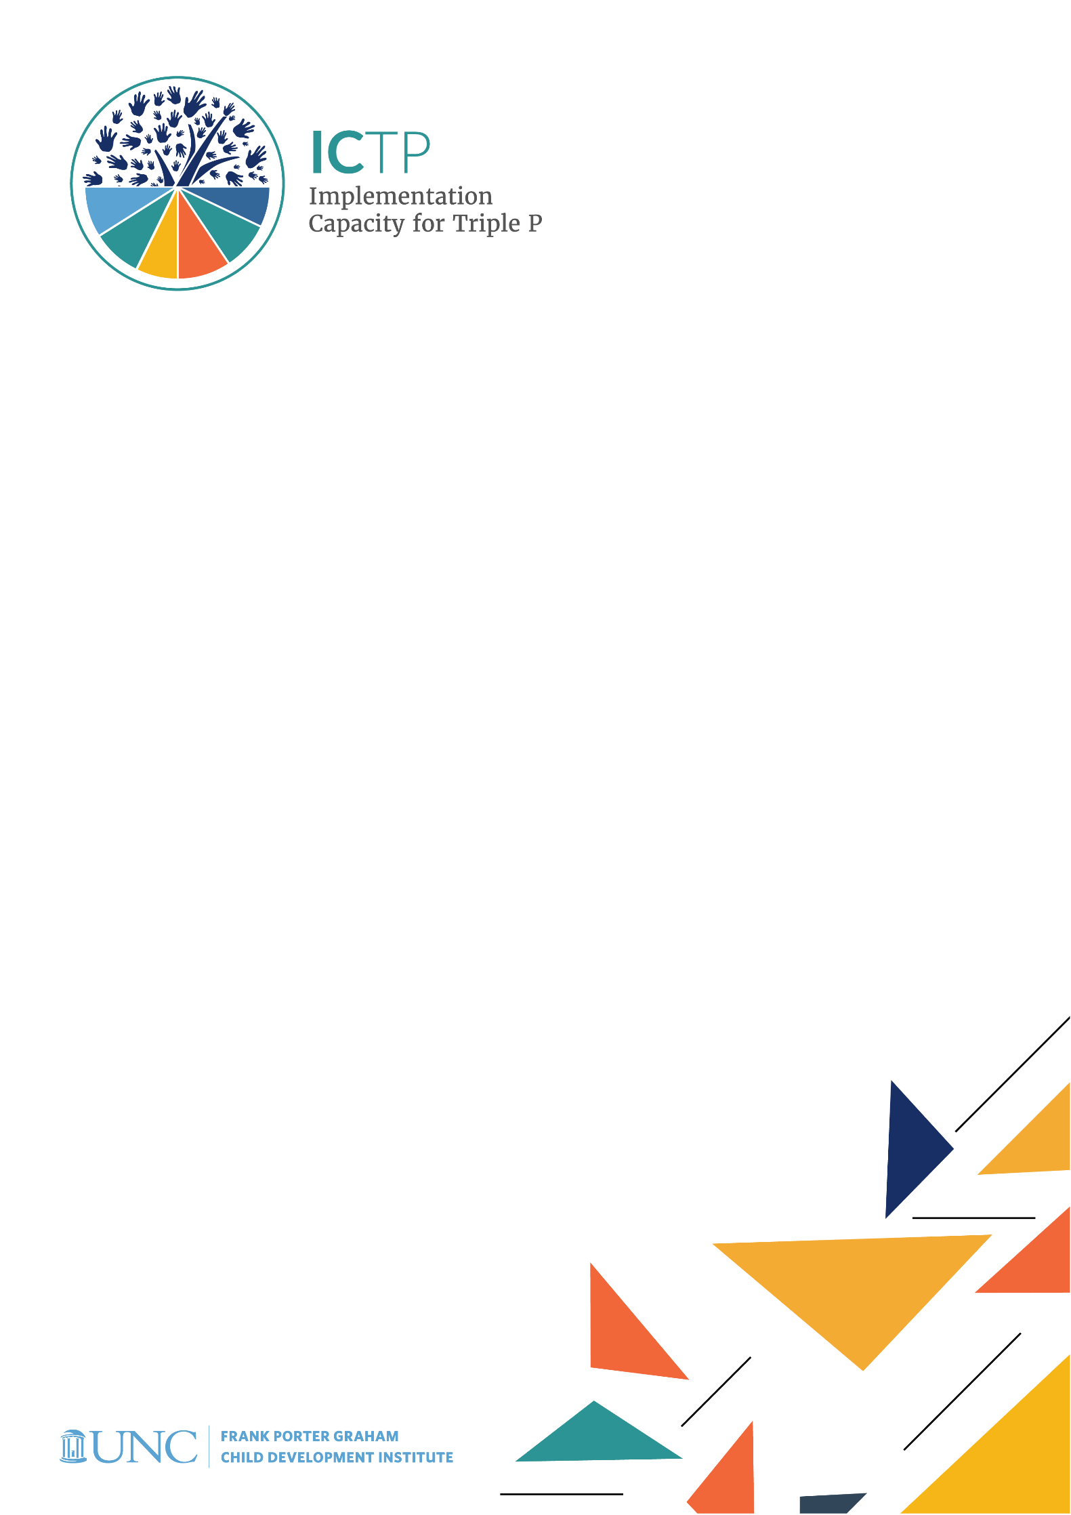

BRIEF 3

ICTP Integrated Theory of Change

Acknowledgements
Development of the ICTP Implementation Support Practice Compendium was supported by the following funding sources:
- The Duke Endowment Grant Agreement No. 2081-SP, The Implementation Capacity for Triple P (ICTP) Projects in North Carolina and South Carolina.
- The North Carolina Department of Health and Human Services, Division of Social Services Contract Numbers 00042356, 00044072, and 00045540, North Carolina Implementation Capacity for Triple P Project.

The authors would like to acknowledge all current and former team members of The Impact Center at Frank Porter Graham Child Development Institute for their contributions to the development and improvement of the practice model represented in the ICTP Implementation Support Practice Compendium. For their reviews, feedback, copyediting, and formatting support, we would like to acknowledge Rona Bernstein of PsycEditing; Kamilah Pickett and Paula Dressel of Race Matters Institute at MDC; and Jennifer Robinette, Julie Chin, LaMana Donadelle, and Lindsay Holland of the ICTP Projects Team, Frank Porter Graham Child Development Institute, UNC-Chapel Hill.

Suggested citation:
Aldridge, W. A., II, DiSalvo, C. I., Lawrence, S. C., Minch, D. R., Banks, C. R., & the members of the ICTP Projects Team (2024, May). ICTP integrated theory of change (ICTP Implementation Support Practice Compendium, Brief No. 3). University of North Carolina at Chapel Hill, The Impact Center at Frank Porter Graham Child Development Institute. https://ictp.fpg.unc.edu/wp-content/uploads/ictp-integrated-theory-of-change.docx

Christina DiSalvo is now at The Duke Endowment.

The members of the ICTP Projects Team include Principal Investigator William A. Aldridge II; Co-Principal Investigators Christina I. DiSalvo and Jessica J. Reed; Co-Investigators Rebecca H. Roppolo, Sandra J. Diehl, Renée I. Boothroyd, Capri R. Banks, Tamara Robertson, Devon R. Minch, Rohit Ramaswamy, Wendy M. Morgan, and Ximena Franco-Jenkins; and additional team members Shannon D. Chaplo, Sherra C. Lawrence, Kimberly R. Maloney, Marais Pletsch, Ariel B. Everett, Alana Gilbert, Jennifer B. Robinette, Julie Chin, LaMana Donadelle, Andrea Ross, Christine C. Harradine, Lindsay Holland, Margaret Sullivan, and Meera Kumanan.

Correspondence concerning the ICTP Implementation Support Practice Compendium should be addressed to Will Aldridge at FPG Child Development Institute, University of North Carolina at Chapel Hill, CB #8180, Chapel Hill, NC 27599-8180, USA or via email, will.aldridge@unc.edu, phone, 919-966-4713, or fax, 919-966-7532.

ICTP Integrated Theory of Change
This brief describes the Implementation Capacity for Triple P (ICTP) integrated theory of change, which is used by ICTP implementation support practitioners (ISPs) to increase regional Triple P partners’ understanding of the change processes necessary to achieve their desired Triple P performance goals.

This theory of change also informs ICTP support activities at all system levels, with the intention of broadly influencing more supportive system environments. A theory of change is essentially an explanation of how one or more interventions are expected to result in a desired change or changes. Drawing heavily on Chinman and colleagues’ implementation technical assistance logic model [1], Aldridge and colleagues [2, 3] originally proposed the ICTP integrated theory of change. This high-level theory of change describes the relationships between key intermediate and long-term outcomes of Triple P scale-up, including outcomes relevant to ISPs, the individuals supporting state and regional Triple P partners with implementation and scale-up.

This theory of change was adapted by a National Academies of Sciences, Engineering, and Medicine (NASEM) consensus study committee for its 2019 report, Fostering Healthy Mental, Emotional, and Behavioral Development Among Children and Youth: A National Agenda [4]. We further refined this theory of change for this brief by positioning co-creation partners (i.e., all individuals and organizations involved, on some level, in creating sustainable implementation capacity) and related processes as the foundation of, and spanning the entire length of, the model (see Figure 3.1).

Two important considerations of the ICTP integrated theory of change are worth highlighting. First, this theory is intended to frame implementation learning and application activities across all co-creation partners engaging with ICTP implementation supports. The use of this high-level theory of change is intended to allow ICTP ISPs to work with support participants (i.e., individuals and organizations receiving implementation support) to understand the change process and how to drive their desired Triple P improvements. To facilitate this, ICTP ISPs may collaborate with support participants to identify, through various assessments, areas of desired Triple P performance or outcome improvement within this theory of change. They may then co-design with support participants the needed capacities, partnerships, and related action steps that can drive such improvements. Relatedly, the ICTP integrated theory of change is intended to afford ICTP ISPs an integrated model that incorporates essential implementation science concepts, theories, frameworks, and models that might be useful to support participants’ implementation efforts. For example, the integrated theory of change explicitly integrates co-creation theory [5], implementation outcomes [6], and intended Triple P program and population outcomes. The theory of change also embeds the implementation teams and implementation drivers frameworks [7] and elements of mass media, social network, and communications theories (e.g., [8–10]) within the “Capacity” and “Performance” areas of the model.

Most other major concepts and frameworks within the field of implementation science can be accommodated within the ICTP integrated theory of change as helpful and relevant to ISPs and support participants. For example, the concept of readiness (e.g., [15, 16]), discussed later in this brief, may be included as a key factor related to effective co-creation partners and processes as well as leadership and implementation teams. Implementation strategies (e.g., [17]) may be incorporated within the action steps among co-creation partners, community leaders, and community implementation teams to drive performance improvements and outcomes. Implementation climate (e.g., [11]) is a key performance indicator of community Triple P leaders and implementation teams. Finally, implementation stages [7] may be helpful to describe the necessary phases of work to drive improvement of any performance, program, or population outcomes embedded in the theory of change.

Figure 3.1 ICTP Integrated Theory of Change for Supporting the Implementation and Scale-Up of the Triple P System of Interventions to Achieve Intended Population-Level Outcomes [1–4]. Note. MEB = mental, emotional, and behavioral.
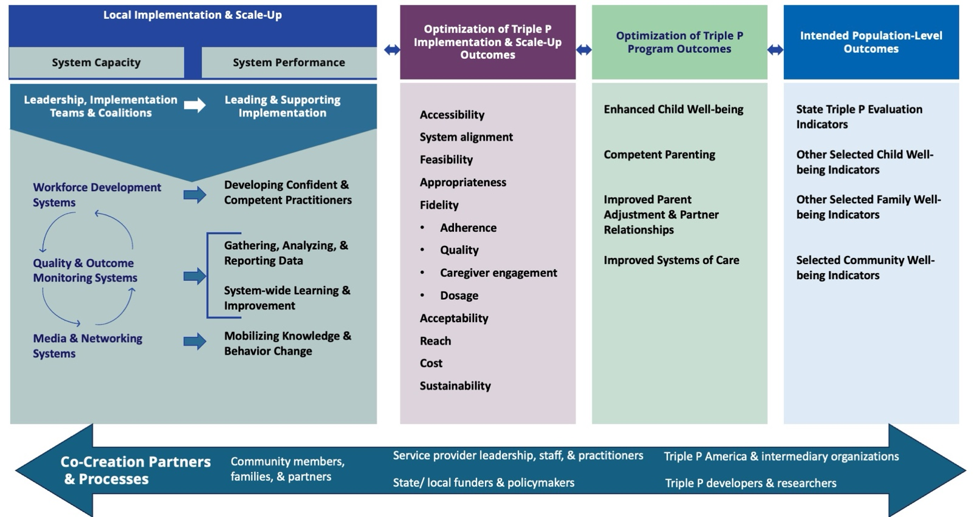

Key Implementation Science Terms and Definitions

Co-creation: “the active involvement of stakeholders in all stages of the production process resulting in a shared body of usable knowledge across scientific, governance, and local practice boundaries” [5, p. 117].
For additional terms, download Compendium Glossary (Word).

Implementation climate: “employees’ shared perceptions of the importance of innovation implementation within the organization” [11, p. 813].

Implementation drivers: “the core components or building blocks of the infrastructure needed to support practice, organizational, and systems change” when implementing or scaling a new program or practice [7, p. 13].

Implementation outcomes: “the effects of deliberate and purposive actions to implement new treatments, practices, and services” [6, p. 65].

Implementation strategies: “methods or techniques used to enhance the adoption, implementation, and sustainability of a . . . program or practice” [12, p. 2].

Implementation stages: the recursive stages of the implementation process “through which organizations and systems support and promote new program models, innovations, and initiatives” [7, p. 12]. The four functional stages include the exploration stage, the installation stage, the initial implementation stage, and the full implementation stage.

Implementation team: A structured group of individuals, internal to an organization or system, whose charge is to design and lead the implementation of selected programs and practices through the stages of implementation [7, 13].

Readiness: “the extent to which organizational members are psychologically and behaviorally prepared to implement organizational change” [14, p. 381]. Readiness invariably involves a combination of willingness to change, abilities to change, and perceived fit of the change with long-term aspirations.

A second important consideration regarding the ICTP integrated theory of change is that it is not meant to replace the need for locally developed theories of change or suggest a prescribed process for scaling Triple P. Rather, local communities and system partners might customize their use of this theory of change according to their improvement goals and support needs. For example, it may guide the development of local theories of change. At certain times, local communities will choose to monitor only certain outcomes detailed in this theory of change. Co-creation partner roles will vary in intensity and function according to community context. Furthermore, within the co-creation process, each partner will have their own mechanisms for contributing to intermediate and long-term outcomes.

In the following sections, we detail each area of the ICTP integrated theory of change, along with citations to related literature. We encourage ICTP ISPs to engage in ongoing professional development opportunities to stay on top of the emergent implementation science related to each area within the theory of change as well as related implementation concepts, theories, models, and frameworks. To successfully translate implementation science into contextually relevant practice, ICTP ISPs benefit from being well informed consumers of implementation science literature, presentations, and other media.

Co-creation Partners & Processes
Metz and Bartley [5] defined co-creation for public services as
the active involvement of stakeholders in all stages of the production process resulting in a shared body of usable knowledge across scientific, governance, and local practice boundaries. From this perspective, the use of evidence is often a result of iterative, messy, and dynamic interactions among public agencies, policymakers, researchers, intervention developers, practitioners, communities, and families. (p. 117)
Metz and Bartley further described several conditions that foster co-creative processes, the foremost being the ability to leverage collaborative relationships and draw on interpersonal contacts between and within partner groups at multiple system levels. Other conditions that foster co-creation, according to Metz and Bartley, include
- taking into account multiple perspectives and all factors when defining problems;
- jointly developing models of analytic tools through repetitive processes and learning;
- “zooming in” on the needs of users of research evidence; and
- “zooming out” to promote systems thinking among key stakeholders. (p. 119)

The result of co-creation partnerships and processes is what Metz [18] describes as co-creative capacity, a “joining of scientific resources, governance capability, and adaptive leadership at multiple and whole systems levels to create the infrastructure and conditions needed for the sustainable use of evidence” (p. 1).

Features of co-creation partnerships and processes can be traced back to foundational principles of ecological systems theory, social cognitive theory, and collective behavior and learning theories. Although a description of these theories is beyond the scope of this brief, they all recognize the importance of choice, systems, context, and lived experience as central lenses through which interventions research and practice should be approached [19–23]. Furthermore, these theories view behavior as a response to and interaction with a complex, multilayered system context [19, 20].
DIVE DEEPER

Download
Brief #5: Foundations of the ICTP Implementation Support Practice Model, section Theoretical Underpinnings (docx) for more info on:

- Social Cognitive Theory in Action: Reciprocal Determinism

To dive deeper into these theories, refer to Dive Deeper sidebar.

These perspectives highlight the importance of understanding the contexts in which interventions are being implemented, the people implementing the interventions, and the interactions within and across different levels of the system to ensure implementation success [24–26]. In addition to its vital role in human services, co-creation is an essential process in business, design science, and technology development.

Key Features of Co-creation
Co-creation processes necessitate working alongside multiple system partners to develop and design approaches that blend each partner’s experiential and content knowledge. Approaches developed through such processes are more likely to be implemented with success—for example, with fidelity and sustainability—and to yield positive outcomes. For more information, see person-centered planning approaches (e.g., [25, 27, 28]).

Metz [18] originally conceptualized the range of partners necessary for sufficient co-creation processes during implementation and scale-up to include
- service provider organizations,
- funders and policymakers,
- intermediary and purveyor organizations,
- community members and consumers, and
- program developers and researchers.
When the full range of co-creation partners are actively and equitably engaged, the value and need for services and the ways in which they are implemented are defined in more effective, sustainable, and culturally relevant ways. All co-creation partner voices, but particularly those of community members and families, must be empowered, invited, and supported to speak about system characteristics, the potential impact of policies and practices, and community values and needs. Collectively, co-creation partners build a vision for the work and ensure aligned leadership and management, delivery support, and problem-solving forums to support change.

When this process is working well, co-creation partners are
- actively engaged and supported across the full range of implementation stages to build, organize, align, and refine the capacities needed for effective implementation (see Figure 3.1);
- contributing time, effort, connections, funds, and other resources to nurture the ongoing development and sustainment of system-wide implementation capacities; and
- welcoming and creating safe spaces for other co-creation partners to contribute to the system environment.
Furthermore, when co-creation processes are successful, knowledge is expanded, alliances are strengthened, services and outcomes are improved (see Figure 3.1), and communities and service systems thrive [29].
DIVE DEEPER
Learn more on co-creation structures, refer Brief #1: NC Triple P System,
- Download Section Interactive Systems (Word docx) for more information on the NC Triple P Learning Collaborative and Design Team
- Download section Scale-Up Plan and Strategic Planning (Word docx) to learn more on Community Leadership Teams in the NC Triple P Model Scale-Up Plan.

Ensuring effective co-creative processes requires deliberate and resourced attention to co-creation. This includes
- creating opportunities for partners to self-organize into meaningful co-creative roles;
- developing and maintaining effective co-creation structures (e.g., learning collaboratives involving system partners from multiple levels, community leadership teams involving community partners from multiple levels or roles, system teams that integrate co-creation partners for design and decision making);
- centering the importance of relationships, diversity, equity, inclusion, communication, and transparency in teaming structures, group agreements, norms, and values;
- defining what co-creation looks like (e.g., roles, behaviors, processes, goals);
- continually assessing how engaged and supported stakeholders are in sharing perspectives and new knowledge for the development of system implementation capacities; and
- learning and improving co-creation processes with process checks and feedback loops.

Key Features of Co-creation Partner Roles
The key features of co-creation partner roles as identified in the ICTP integrated theory of change and described below are not intended to be comprehensive. Individual co-creation partners may serve a variety of unique and shared functions. Furthermore, the nature and intensity of partner roles may shift and change over time as Triple P implementation and scale-up progresses.

Community Members, Families, & Partners
EQUITY IN ACTION

Download Brief #5: Foundations of the ICTP Implementation Support Practice Model, Section Equity in Implementation Practice (docx) for additional discussion on equity in implementation practice.
As the only partner group not connected to community Triple P systems through professional or paid roles, family and community members are unique co-creation partners. Because they are the primary consumers and beneficiaries of community-based programs like Triple P, families and other community members are best positioned to speak to the community’s history, needs, priorities, and values related to parenting and family supports. Family and community members need to be engaged in defining why, how, and to what end Triple P programs might be regionally adopted and implemented. They are also best positioned to communicate with other community members about the value or benefits of programs like Triple P, both personally and for the community as a whole.

Because family and community members are not connected to community Triple P systems through professional or paid roles, they are also at risk for being positioned in purely extractive roles: feeding information and other personal or cultural investments into community systems without structural support, recognition, or compensation. This can reinforce existing inequities and indignities, even if unintentional. Structural considerations to ensure that the participation of family and community members is both meaningful and dignified must be made to prevent this from happening. Examples of structural mechanisms that might be considered include compensation policies for families and community members, standardized procedures for providing childcare and travel support, and explicit opportunities for family and community members to be recognized within leadership roles alongside other system leaders involved in co-creation processes.

Integrating families and community members into programmatic and implementation decisions, particularly in response to identified trends in disaggregated data from the community, ensures that their needs and preferences are accommodated, often resulting in higher community reach. Integrating community members into key implementation processes (e.g., leading and supporting Triple P scale-up, gathering and using data for decision making, developing competent and confident practitioners, mobilizing Triple P beyond direct practitioner delivery) ensures that the community’s strengths and assets are capitalized on, often resulting in greater appropriateness and stronger sustainability of regional Triple P scale-up.

Defining family and community member functions in implementation and scale-up has benefited from prior practice engagements. For example, prior partnerships between The Impact Center at FPG and community partners have helped operationalize key functions related to community members’ participation in implementation and scale-up. Collaborative reflection and writing activities held with community and system partners addressing institutional racism, historical community trauma, and racial disparities in the California child welfare system suggested key community member functions to ensure a more equitable approach during implementation [30]. And results from the TPIE-Qualitative evaluation, which focused on scaling Triple P in the Carolinas, suggested key community member functions specifically related to Triple P scale-up [31]. These functions are detailed in Table 3.1.

Table 3.1 Family and Community Member Functions in Implementation and Scale-Up
Family and Community Member Functions to Ensure a More Equitable Approach During Implementation [30] | Family and Community Member Functions Related to Triple P in the Carolinas [31]
Listening to learn about and begin to address historical trauma (historical maltreatment of families in key communities identified by social factors such as race or income level), mistrust of agencies and systems, and other longstanding and institutional barriers to safety, health, and well-being | Providing feedback and supporting continuous quality improvement of Triple P delivery at service provider, county, and state levels
Working with community members to identify systemic barriers to improved outcomes for children and families and implement action plans to address those barriers | Catalyzing Triple P engagement within their communities by word-of-mouth advertising, sharing positive experiences, and transferring Triple P learning and parenting skills to community parents and partners
Collaborating with community members to establish culturally relevant supports and services to meet the underlying needs of children and families | Championing Triple P with local, county, and statewide partners
Meaningfully involving community members in practitioner professional development activities and community design teams for effective, sustained implementation | Fully participating in Triple P implementation structures, such as decision-making bodies that select which Triple P programs to adopt or adapt locally
Ensuring partnership meetings, forums, and feedback loops are sustained so that community members are continuously connected to and help guide practice and system changes
Of particular note from the TPIE-Qualitative evaluation is that participants suggested an overall need for more actively and purposefully engaging families and community members in local Triple P implementation activities and decision making [31]. To this end, the ICTP projects apply the “community engagement to ownership” model for decisions directly related to community programmatic and implementation processes (sample in Figure 3.2 and related resources in Appendix F; [32]). Based on this model, ICTP ISPs strive to influence co-creation processes that reflect a stance of “collaborate” at all times and that have an impact of “community ownership” when possible and most important.

Figure 3.2 The Spectrum of Community Engagement to Ownership [32, p. 2] Available in “community engagement to ownership” model document, page 2.
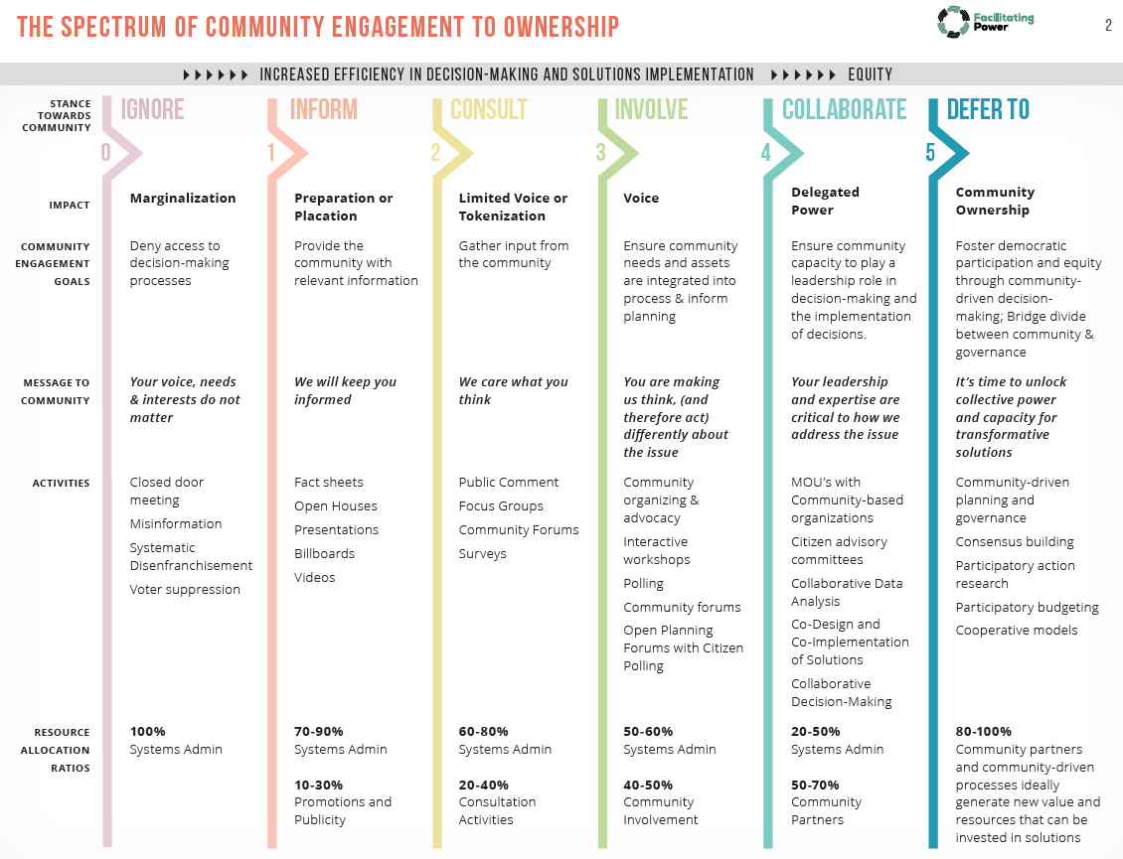

Strategies for engaging families and community members in Triple P implementation and scaling activities include
- using asset mapping and other data-collection methods to identify all families that the community Triple P initiative needs to serve and how best to engage them;
- establishing shared purposes and goals, while balancing them with responsive and flexible approaches [29];
- presenting information as ideas to get started rather than final decisions;
- empowering new partners to share their voices and perspectives on how activities will unfold;
- making intentional efforts to advance community partnerships high on the spectrum of community engagement to ownership (see Figure 3.2);
- financially compensating community members for their participation in co-creation and other Triple P implementation activities;
- integrating families and community members into community Triple P leadership and other teaming structures to ensure meaningful connections to the system; and
- developing written partnership engagement plans to guide and monitor the progress of partnerships with families and community members.

For additional community engagement strategies that have demonstrated the ability to increase Triple P program fit and reach, see Sanders and Kirby [33]. For more detailed information about engaging and supporting family members as co-creation partners, see the ICTP online microlesson, Families as Co-creation Partners. A case example of one NC Triple P region’s efforts to bring families and community members into their community Triple P leadership team is available in the December 2022 issue of The Implementeer.
EQUITY IN ACTION

The expertise of leadership, staff, and practitioners within community service organizations that belong to minoritized racial or ethnic groups will allow them to provide essential insight into the needs and experiences of families who participate in Triple P. However, they should not bear the burden of racial translation for other colleagues. Often, in the absence of readily available learning mechanisms, operationalizing racial equity becomes the job of minoritized staff. Organizational supports for racial equity learning and application among all staff will mitigate this risk.” Refer to Brief #5: Foundations of the ICTP Implementation Support Practice Model, download Section Equity in Implementation Practice (docx) for additional discussion on equity in implementation practice.

Service Provider Leadership, Staff, & Practitioners
Leadership, staff, and practitioners within community service organizations have essential insight into the needs and experiences of families who participate in Triple P. As such, they can provide particularly helpful perspectives about, and support, several key Triple P implementation factors and functions.

Leadership, staff, and practitioners engage in conversations about, and foster readiness for, Triple P implementation and scale-up at local levels. Local readiness for implementation can be understood as an ongoing combination of partners’ commitment to necessary change processes and their collective belief that they can make the required changes [34]. Several factors may influence readiness, such as the value placed on making the necessary changes, potential task demands, resource availability, and relevant situational factors.

Leaders and staff within community service organizations must also ensure several leadership and coordination functions for implementing Triple P in their organizations [35]. For example, an organization’s Triple P executive leaders can support success and sustainability by (1) demonstrating ongoing commitment to organizational and systems change processes and the inclusion of community partnerships, and (2) actively creating and nurturing opportunities for change [35].

Service provider leadership and staff may also contribute to community Triple P efforts by helping ensure that (1) Triple P and related family support programs are well aligned and usable by practitioners and families, (2) community-wide policies and practices facilitate delivery of Triple P interventions as intended, and (3) service changes and successes are well communicated across partners and community members [35].

Finally, teams managing Triple P program implementation within and across community service provider organizations can support success and sustainability by (1) organizing, aligning, and sustaining the necessary infrastructure to support Triple P implementation, and (2) actively using data and other information for Triple P implementation quality improvement [35].

Institutionalizing, or embedding, these leadership, management, and coordination functions within team structures across community service provider organizations is an essential part of developing and sustaining local implementation capacity and performance [7, 35, 36]. Moreover, continually integrating the unique perspectives of service provider leadership, staff, and practitioners into Triple P implementation activities strengthens community efforts and supports more hospitable climates for scaling Triple P [11].

State/Local Funders & Policymakers
State and local funders and policymakers have important roles in creating nurturing system environments for community Triple P scale-up. In particular, key functions include [37]
- ensuring the availability of adequate financial resources to develop implementation capacity and support the delivery of Triple P,
- ensuring adequate time and space to reasonably expect community efforts to translate into population-level outcomes, and
- setting expectations and providing resources for monitoring quality and outcome across all levels of the Triple P system.
Like service provider leaders and staff, funders and policymakers must also play active and engaged leadership roles by (1) demonstrating ongoing commitment to necessary change processes and equitable change partnerships, and (2) creating and nurturing opportunities for change within state and local service systems. This often means identifying, leveraging, and/or changing administrative and legislative policies that may be facilitating or hindering successful scaling efforts or perpetuating systemic inequities that lead to disparities. Funders and administrators also support and participate in statewide learning collaboratives, statewide implementation support partnerships, and statewide communication campaigns.

Finally, research consistently demonstrates that administrative and legislative policymakers in implementation are more effective when they develop broad political and administrative support by engaging multiple partners, such as community service providers and academic institutions, rather than forcing top-down approaches or using mandates [38, 39].

Triple P America & Intermediaries
Triple P America (TPA) is the U.S.-based purveyor of Triple P training, materials, and implementation support. Triple P International published the Triple P Implementation Framework (TPIF), which details TPA’s roles in supporting Triple P implementation and sustainability [40]. TPIF details five phases of activities for TPA to engage in with local service partners adopting Triple P interventions:
- Engagement: Initial interactions with community stakeholders to explore if Triple P is a good fit for the community’s goals and needs
- Commitment and Contracting: Confirmation of the scope of Triple P implementation and facilitation of written agreements for training, resources, and support
- Implementation Planning: Collaboration on creation of an implementation plan, including plans for communications, training and accreditation, service delivery, quality assurance, and evaluation
- Training and Accreditation: Delivery of standardized training and management of the accreditation process for practitioners
- Implementation and Maintenance: Engagement in feedback cycles with community partners around service delivery, quality improvement, ongoing development, and sustainability mechanisms

Across these five phases, TPA helps to support organizational leaders’, managers’, and practitioners’ professional development to improve their delivery of Triple P interventions as intended, ensure quality, enable outcome monitoring, and contribute to the development of local program capacity to support and improve Triple P implementation.

To accomplish its roles, TPA works closely with intermediary organizations. These organizations differ from program purveyors in that they support the implementation of more than one evidence-based program or practice and, therefore, typically have a more expanded role than program purveyors [41]. They are often housed within academic institutions or nonprofit organizations. As defined by Mettrick and colleagues [42], an intermediary organization
supports service array development through implementation technical assistance, creative financing options, training, coaching, education, continuous quality improvement monitoring, and outcomes evaluation. [An intermediary organization] connects providers, state agencies, local jurisdictions, and purveyors to ensure that effective implementation leads to improved outcomes and builds on existing systems reform efforts. (p. 3)

Unlike program purveyors, which typically have a national or international presence, intermediary organizations are usually located within the same region as implementation sites and are therefore able to serve more specialized functions. Following the model of a Center of Excellence Learning Community funded by the Annie E. Casey Foundation, Mettrick and colleagues [42] detailed five core functions for intermediary organizations:

- tailored implementation support for evidence-based programs;
- research, evaluation, and data-linking;
- partnership engagement and collaboration;
- workforce development activities (including practitioner training and coaching); and
- policy and finance expertise.

Intermediary organizations do not replicate the role of state agencies or program purveyors; rather, they work in concert with state agencies, funders, and program purveyors to support the achievement of common goals. Where functions or activities overlap among any co-creation partners, it becomes essential to develop clear agreements about roles and how to support synergistic, rather than duplicative, work patterns.

Within the context of the ICTP projects, The Impact Center at FPG serves as an intermediary support structure to provide information, consultation, and tailored implementation support to NC regions and state partners in both North Carolina and South Carolina scaling‐up Triple P.

Triple P Developers & Researchers
Triple P developers and researchers have both proactive and responsive roles relative to the implementation and scale-up of Triple P. Proactively, Triple P developers need to ensure that Triple P programs and strategies are equitable and usable within community prevention and intervention systems [36, 43–45]. Interventions that meet usability criteria are regarded as teachable, learnable, doable, repeatable, and assessable in practice [44, 45]. Triple P researchers have a key role in ensuring that Triple P programs and media strategies are, and remain, evidence-based. This was one of the most widely identified roles of Triple P researchers during the TPIE-Qualitative evaluation [31]. As identified in TPIE-Qualitative, Triple P researchers also have ongoing roles in (1) making the Triple P evidence base accessible and usable to state and community partners and (2) using naturally occurring implementation efforts as opportunities to test and refine Triple P implementation strategies.

Local Implementation & Scale-Up
In the ICTP integrated theory of change, local implementation and scale-up refer to both system capacity and system performance. We’ll break these down below.

System Capacity
System capacity, or implementation capacity, refers to a system’s resources and abilities to successfully and sustainably carry out programs and practices to a level of desired performance [46]. The ICTP projects affirm that the most promising approaches to implementation and scale-up give strong attention to three key features of implementation capacity:
- leadership and implementation teams within community and state service systems (e.g., individual service agencies) and coalitions across community and state service systems (e.g., community coalitions led by local backbone organizations, statewide intermediary organizations, and state service agencies) [13, 35, 36, 47–60];
- workforce development systems that integrate best practices for practitioners’ professional development (i.e., recruitment and selection, training, and coaching) to deliver programs as intended, in response to participants’ needs and perspectives, and with expected benefits for children and families [7, 43, 61–72]; and
EQUITY IN IMPLEMENTATION

Because of their community-wide reach and focus on influencing social norms, which are culturally shaped, media systems, communications, and networking strategies are most effective if they are developed using a racial equity lens and are tailored to identified populations. Download
Brief #5: Foundations of the ICTP Implementation Support Practice Model, Section Equity in Implementation Practice (docx) for more information on equity in implementation practice.
- quality and outcome monitoring systems to foster organizational improvement and program optimization [7, 54, 73–80].

When engaging in community-wide prevention and well-being efforts, it is important to bear in mind that programs and practices will always reach only a small segment of the intended population. To achieve population-level outcomes, it is essential to have a fourth type of system—media and networking—to spread knowledge and mobilize behavior change [8, 9, 53, 81–85]. Media systems, communications, and networking strategies can encourage potential program participants to seek support and influence positive parenting attitudes, knowledge, and skills beyond what is gained from direct practitioner-to-participant interactions.

Leadership and implementation teams provide the “who” of implementation. Evidence about Triple P implementation in North Carolina has indicated that these teams play a significant role in developing other components of implementation capacity (e.g., workforce development systems and quality and outcome monitoring systems) and advancing positive community Triple P implementation outcomes [31, 86, 87]. In the ICTP integrated theory of change (Figure 3.1), this is indicated by the darker green wedge around leadership, implementation teams, and coalitions.

Several types of leadership and implementation team structures are promoted within community Triple P systems, including
- community Triple P leadership teams,
- community Triple P implementation teams,
- community Triple P coalitions, and
- Triple P service provider leadership and implementation teams.
For more information about these teaming structures, including their unique and shared functions, see the NC Triple P Model Scale-Up Plan.

Workforce development systems, quality and outcome monitoring systems, and media and networking systems are considered integrated and compensatory [7], meaning that they operate in concert and often overlap with and influence each other in various ways. For example, quality and outcome data can be collected about workforce development efforts or be used to improve media and networking efforts. This concept is demonstrated by circular arrows in this area of the ICTP integrated theory of change (Figure 3.1). More information about these implementation capacities as related to expectations within the NC Triple P System is also available in the NC Triple P Model Scale-Up Plan.
CONTACT

Please contact us to request plan from the ICTP project team members and more broadly with the permission of the PSG projects.

Multilevel support systems are typically required to foster the development and sustainment of implementation capacities across a region or state. Figure 3.3 presents the ideal multilevel system of Triple P support in North Carolina, which can inform similar models within other locations. The cascading tiers of support provide ways to communicate meaningful roles within each level of a regional or statewide system and support the overall success of initiatives [7, 36]. Although Figure 3.3 depicts support feedback loops between only single levels of the system, feedback from and to each level of the system is necessary for authentic co-creation processes and ongoing quality improvement.

Figure 3.3 Ideal Model of Multilevel Support for the NC Triple P System.
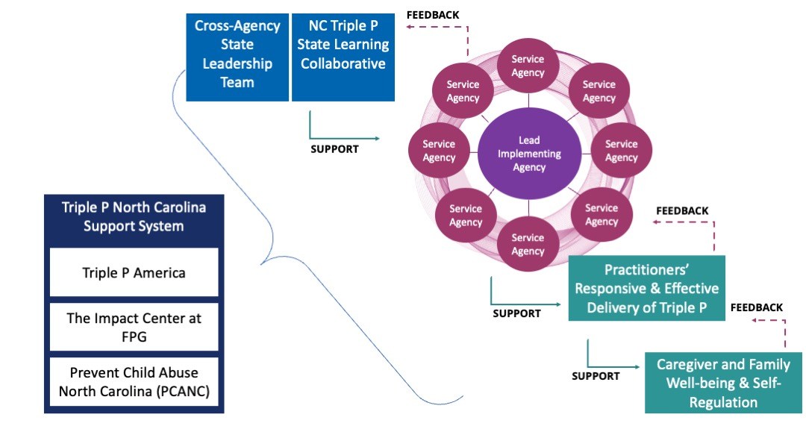

System Performance
The “System Performance” section of the ICTP integrated theory of change (Figure 3.1) demonstrates implementation performance outcomes that align with the four implementation capacity components described in the preceding section. Chinman and colleagues [1] define implementation performance as “the level of quality at which [essential implementation practices] are carried out” (p. 3). The ICTP integrated theory of change details five essential implementation practices:
- leading and supporting Triple P implementation and scale-up, including committing to equitable partnerships, identifying and addressing implementation barriers, and spreading successes;
- developing confident and competent Triple P practitioners who can deliver Triple P with fidelity and in response to parent needs, preferences, and social and cultural identities and histories;
- gathering, analyzing, and reporting—to the right people at the right times, including community members—program and implementation data related to Triple P delivery;
- facilitating system-wide learning and continuous quality improvement of Triple P implementation, delivery, and outcomes; and
- mobilizing knowledge and behavior change across communities, beyond that created by direct interactions between practitioners and program participants.
These performance indicators are high level and may be further broken down into more specific performance behaviors. For example, leading and supporting Triple P implementation may involve executive leaders’ ongoing demonstration of commitment to Triple P implementation (i.e., “implementation climate”) and aligning community prevention strategies through common approaches and intended outcomes [35, 88]. Likewise, developing confident and competent practitioners may involve high-quality practitioner recruitment and selection, training, and coaching practices [7, 35, 88].

Optimization of Triple P Implementation & Scale-Up Outcomes
The ICTP projects promote the idea that implementation and program outcomes can be optimized in the local context [73]. Hence, we refer to this section of the ICTP integrated theory of change as “Optimization of Triple P Implementation and Scale-Up Outcomes.” Implementation capacity and performance are primary influencers of implementation outcomes [1]. Perhaps the most well-recognized implementation outcome is fidelity—delivery of a program as intended. However, several other implementation outcomes are also important, particularly as related to achieving favorable service and client outcomes at scale.

Proctor and colleagues [6] detail eight implementation outcomes: acceptability, adoption, appropriateness, cost, feasibility, fidelity, penetration, and sustainability. The ICTP integrated theory of change adapts and incorporates essential features of these and includes other implementation outcomes that may be of particular interest given Triple P’s model, history, and ongoing aims in the Carolinas:
- Accessibility. Progressing beyond Proctor and colleagues’ adoption outcome, we define accessibility as the degree to which families can obtain Triple P services in accordance with the level of support they need or prefer.
- System Alignment. Not represented in Proctor and colleagues’ original list but important for any system of interventions like Triple P, system alignment is defined by the ICTP projects as the degree to which community Triple P service providers and/or individual Triple P interventions work in concert toward collective well-being goals rather than in silos or fragmentation.
- Feasibility. Adapting Proctor and colleagues’ definition for the ICTP projects, feasibility is the extent to which Triple P can be successfully used or carried out within a given setting (e.g., region, community, or organization). Feasibility hinges largely on whether or not the local setting of care has the necessary financial, human, and implementation resources to support delivery of Triple P as intended.
- Appropriateness. Adapting Proctor and colleagues’ definition for the ICTP projects, appropriateness is the perceived fit, relevance, or compatibility of Triple P for a given community, practice setting, practitioner, or caregiver/family; and/or the perceived fit of Triple P to address a particular issue or problem in the community or organization, or for a given practitioner or caregiver/family. When considered at the community level, appropriateness should also include racialized histories of place that acknowledge the history and impacts of similar parenting and family support interventions.
- Fidelity. Adapting Proctor and colleagues’ definition for the ICTP projects, fidelity is the degree to which Triple P is delivered as prescribed in current program protocols or as it was intended by Triple P program developers. Within ICTP, we consider Triple P fidelity related to the presence of core Triple P program components rather than just to session protocols. To learn more about core Triple P program components, view Module 9 in the ICTP Simulation Lab.
- Dane and Schneider [89] detailed four dimensions of program fidelity relevant to community Triple P implementation, which were later reinforced by Mihalic [90]. We adapt those definitions for the ICTP projects as follows:
- Adherence refers to whether Triple P is being delivered as it was designed or written (i.e., with all core components being delivered to the appropriate population; practitioners trained appropriately; using the right protocols, techniques, and materials; and in the locations or contexts prescribed).
- Quality of program delivery is the manner in which a practitioner delivers Triple P (e.g., skill in using the techniques, methods, and core components prescribed by Triple P; enthusiasm; preparedness; and attitude).
EQUITY IN IMPLEMENTATION

Disaggregated data could be helpful in illuminating the potential presence of systemic issues that may be contributing to these discrepancies. Download

Brief #5: Foundations of the ICTP Implementation Support Practice Model, Section Equity in Implementation Practice (docx) for more information on equity in implementation practice

Brief #7: Digging Deeper Into the Implementation Support Practice Model at the Regional Level, Section Co-designed Support Planning and Processes (docx) for more information on Disaggregation of Data.
- Caregiver engagement is the extent to which participants are engaged by and involved in the activities and content of Triple P (e.g., role plays, homework).
- Dosage may include any of the following: the number of Triple P sessions delivered, the length of each session, or the frequency with which Triple P program techniques were implemented.
- Acceptability. Adapting Proctor and colleagues’ definition for the ICTP projects, acceptability is the perception among implementation partners, including families, that Triple P is agreeable, palatable, or satisfactory as delivered.
- Reach. Proctor and colleagues use a synonymous term, penetration, which we define as the integration of Triple P within a service setting and its subsystems. Reach might be measured by (a) the number of people who receive Triple P in a community or population, or (b) the number of practitioners actively delivering Triple P compared to the number trained in or expected to deliver Triple P. Triple P Implementation Evaluation (TPIE) results and experience from Triple P stakeholders in North Carolina suggest that a significant discrepancy has existed between the number of practitioners trained in Triple P and those who remain actively delivering Triple P interventions to community families.
- Cost. Adapting Proctor and colleagues’ definition for the ICTP projects, cost is related to the financial impact of a Triple P implementation effort. Proctor and colleagues note three cost components that may be of interest:
- costs of delivering Triple P,
- costs of the implementation strategies that will be used to support Triple P, and
- cost variability associated with the local service delivery setting.
- An additional variable related to cost, benefit-cost, has received increasing interest and attention relative to the implementation and scale-up of evidence-based practices [91]. In the context of implementation, this variable typically represents the ratio of realized participant or societal financial benefits (e.g., increased earnings and productivity) and/or cross-system financial savings (e.g., decreased taxpayer expenditures in health, criminal justice, child welfare, or other systems) in comparison to the costs associated with program implementation at some scale [92]; for more information, visit https://www.wsipp.wa.gov/BenefitCost.
- Sustainability. Adapting Proctor and colleagues’ definition for the ICTP projects, sustainability is the extent to which Triple P is maintained or institutionalized within a region’s, community’s, or service setting’s ongoing, stable operations.

System partners involved in different levels of Triple P scale-up (e.g., state, county, agency, and practitioner) may have varied interests across these nine implementation outcomes. While partners may want to review these alternatives and determine which mix may be useful at their system level, the ICTP projects team strongly recommends that program fidelity be monitored by every system level. Fidelity has demonstrated particular importance in replicating evidence-based program outcomes in real-world settings [90, 93]. In addition, by choosing from and attending to other implementation outcomes, we believe that system partners at any level can monitor implementation in accordance with Triple P’s stated philosophy of “fidelity and flexibility.” For example, monitoring variables like acceptability and appropriateness can ensure that core intervention components are reaching local families in a way that is responsive to their needs and preferences.

Optimization of Triple P Program Outcomes
Similar to the name for the prior section of the ICTP integrated theory of change, the name for this section, with its emphasis on optimization, affirms continuous quality improvement efforts among co-creation partners, leaders, and implementation teams within local contexts.

Reviews of the research literature have made clear that implementation quality impacts the realization of intended outcomes when evidence-based programs are used [93]. Triple P programs have demonstrated the ability to influence several child, youth, family, and community outcomes. In their most recent Triple P logic model (see Figure 3.4), Sanders and Prinz [94] identify five aims for implementing the Triple P system of interventions in a community. We incorporate the first four aims within this section of the ICTP integrated theory of change to identify Triple P program outcomes that may be regionally optimized by NC Triple P System partners working in collaboration. These four aims are
- enhanced child well-being,
- competent parenting,
- improved parent adjustment and partner relationships, and
- improved systems of care.

Each of these program aims may be further operationalized through the corresponding short-term outcomes listed in the Triple P system logic model (Refer Figure 3.4). We locate Sanders and Prinz’s [94] fifth aim, “healthier communities,” within the next section of the ICTP integrated theory of change, “Intended Population-Level Outcomes.”

Figure 3.4 Triple P System Logic Model [94]
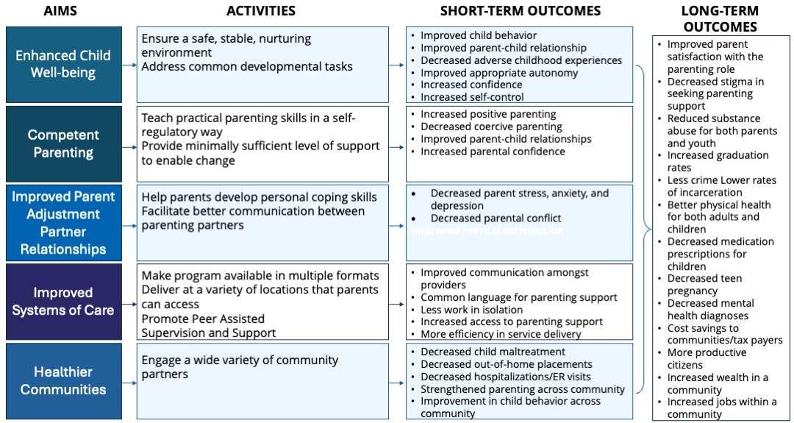

Intended Population-Level Outcomes
NC Triple P System partners have expressed interest in and commitment to statewide evaluation activities that incorporate monitoring population-level outcomes. In particular, the Partnership for Strategy and Governance has expressed its intention to monitor the following three outcomes, which have demonstrated a positive response to Triple P in prior research in the Southeastern United States [95]:

- substantiated child abuse and neglect,
- out-of-home foster care placements, and
- child injuries treated in a hospital.

In addition to these population-level outcomes and the Triple P program outcomes named in the prior section of the ICTP integrated theory of change, community Triple P coalitions may have interest and resources to monitor other child, family, and community outcomes that have demonstrated responsivity to Triple P. Triple P, both through individual interventions and the aggregate system, has demonstrated positive child and family outcomes across several research and evaluation trials globally. Local Triple P coalitions may benefit from examining the full Triple P evidence base, available at https://pfsc.psychology.uq.edu.au/research/triple-p-evidence-base. Readers can search the Triple P evidence base for individual Triple P interventions as well as key topics and outcome variables of interest.

As a reminder, a key notion of the ICTP projects is that intervention outcomes can be optimized in a local context [73]. We hope that partners involved in community Triple P scale-up will take advantage of this perspective and strive to move beyond the level of outcomes established in prior Triple P research for the benefit of their communities.

A more detailed discussion of the available literature related to each segment of the ICTP integrated theory of change can be found in chapter 9 of the NASEM 2019 consensus study report on fostering healthy mental, emotional, and behavioral development among children and youth [4].

Key Takeaways:
- The ICTP integrated theory of change describes the relationships between co-creation processes and key intermediate and long-term outcomes of Triple P scale-up, enabling ICTP ISPs to work with support participants (i.e., individuals and organizations receiving implementation support) to understand the change process and how to drive their desired Triple P improvements. As such, the theory of change is used to frame implementation learning and application activities across all support activities.
- The ICTP integrated theory of change is intended to afford ICTP ISPs an integrated model that incorporates essential implementation science concepts, theories, frameworks, and models that might be useful to support participants’ implementation efforts. To optimize their use of this model, ICTP ISPs should be well informed consumers of implementation science literature, presentations, and other media.
- Co-creation is the active involvement of stakeholders in all stages of the production process, resulting in a shared body of usable knowledge across scientific, governance, and local practice boundaries [5, p. 117]. Co-creation partners (i.e., all individuals and organizations involved in creating sustainable implementation capacity) and processes form the foundation, and span the entire length, of the ICTP integrated theory of change. Co-creation partner roles include the following:
  - Community members, families, and partners. Families and other community members are best positioned to speak to the community’s history, needs, priorities, and values related to parenting and family supports and to communicate with other community members about the value or benefits of Triple P. Therefore, ISPs strive to ensure the purposeful and equitable inclusion of families and community members in Triple P implementation activities and decision making.
  - Service provider leadership, staff, and practitioners. These co-creation partners have vital insight into the needs and experiences of families who participate in Triple P. Their roles include (1) engaging in conversations about, and fostering readiness for, implementation and scale-up at local levels; (2) leading and coordinating the implementation of Triple P in their organizations; (3) contributing to community-wide Triple P partnerships and efforts; and (4) ensuring the success and sustainability of Triple P through the development of necessary implementation infrastructure and the use of data for ongoing improvement.
  - State/local funders and policymakers. Key functions of these co-creation partners include (1) ensuring the availability of adequate financial resources, time, and space for community efforts to translate to population-level outcomes; (2) providing resources for monitoring quality and outcome across all levels of the Triple P system; (3) committing to and fostering opportunities for change in state and local service systems; and (4) fostering broad political and administrative support by engaging multiple partners, such as community service providers and academic institutions, rather than forcing top-down approaches or using mandates.
  - Triple P America (TPA) and intermediary organizations. As detailed in the Triple P Implementation Framework (TPIF), TPA supports local Triple P service partners across five phases of Triple P implementation and maintenance. TPA’s functions include (1) supporting practitioners’ professional development to improve their delivery of Triple P interventions as intended, (2) enabling outcome monitoring, and (3) fostering development of local program capacity to support and improve Triple P implementation. To accomplish these functions, TPA works closely with intermediary organizations, whose functions include (1) providing tailored implementation support for evidence-based programs; (2) conducting research, evaluation, and data-linking activities; (3) engaging and collaborating with partners; (4) offering workforce development activities; and (5) providing policy and finance expertise.
  - Triple P developers and researchers. These co-creation partners ensure that Triple P programs and strategies are feasible prior to initiating Triple P implementation. Their ongoing roles include making the Triple P evidence base accessible and usable and testing and refining Triple P programmatic and implementation strategies.
- Supported by co-creation partners and processes, the ICTP integrated theory of change addresses four main areas:
  - Local implementation and scale-up. This refers to a system’s capacity (i.e., resources and abilities to carry out programs and practices successfully and sustainably) and performance (i.e., level of quality at which essential implementation practices are carried out). Optimal implementation capacity requires strong leadership and implementation teams, workforce development systems, quality and outcome monitoring systems, and (for population-level outcomes) media and networking systems. The ICTP integrated theory of change outlines five high-level performance indicators that conceptualize performance related to these four areas of implementation capacity.
  - Optimization of Triple P implementation and scale-up outcomes. The nine implementation and scale-up outcomes outlined in the ICTP integrated theory of change are accessibility, system alignment, feasibility, appropriateness, fidelity, acceptability, reach, cost, and sustainability. The ICTP projects promote the idea that implementation outcomes can be optimized through continuous quality improvement efforts among co-creation partners, leaders, and implementation teams within local contexts.
  - Optimization of Triple P program outcomes. Program outcomes supported by the Triple P system include enhanced child wellbeing, competent parenting, improved parent adjustment and partner relationships, and improved systems of care. As with implementation outcomes, the ICTP projects promote the idea that program outcomes can be optimized through continuous quality improvement efforts among co-creation partners, leaders, and implementation teams within local contexts.
  - Intended population-level outcomes. Three population-level outcomes that have demonstrated a positive response to Triple P (i.e., a reduction) are child abuse and neglect, foster care placements, and child injuries requiring treatment in a hospital. NC Triple P System partners have expressed a commitment to statewide evaluation activities that incorporate monitoring these population-level outcomes. Community Triple P coalitions may have interest and resources to monitor other child, family, and community outcomes that have demonstrated responsivity to Triple P.

Reference List
- Chinman, M., Acosta, J., Ebener, P., Malone, P. S., & Slaughter, M. E. (2016). Can implementation support help community-based settings better deliver evidence-based sexual health promotion programs? A randomized trial of Getting To Outcomes®. Implementation Science, 11(1), 78. https://doi.org/10.1186/s13012-016-0446-y
- Aldridge, W. A., II, Boothroyd, R. I., Veazey, C. A., Powell, B. J., Murray, D. W., & Prinz, R. J. (2016, December). Ensuring active implementation support for North Carolina counties scaling the Triple P system of interventions. Chapel Hill, NC: Frank Porter Graham Child Development Institute, University of North Carolina at Chapel Hill.
- Aldridge, W. A., II, Boothroyd, R. I., Veazey, C. A., Powell, B. J., Murray, D. W., & Prinz, R. J. (2018, May). Ensuring active implementation support for counties & communities scaling the Triple P system of interventions. Chapel Hill, NC: The Impact Center at Frank Porter Graham Child Development Institute, University of North Carolina at Chapel Hill.
- National Academies of Sciences, Engineering, and Medicine. (2019). Fostering healthy mental, emotional, and behavioral development in children and youth: A national agenda. The National Academies Press. https://doi.org/10.17226/25201
- Metz, A., & Bartley, L. (2015). Co-creating the conditions to sustain the use of research evidence in public child welfare. Child Welfare, 94(2), 115–140. https://www.jstor.org/stable/48623521
- Proctor, E., Silmere, H., Raghavan, R., Hovmand, P., Aarons, G., Bunger, A., Griffey, R., & Hensley, M. (2011). Outcomes for implementation research: Conceptual distinctions, measurement challenges, and research agenda. Administration and Policy in Mental Health and Mental Health Services Research, 38(2), 65–76. https://doi.org/10.1007/s10488-010-0319-7
- Metz, A., & Bartley, L. (2012). Active implementation frameworks for program success: How to use implementation science to improve outcomes for children. Zero to Three, 32(4), 11–18. https://www.zerotothree.org/resource/journal/vol-32-no-4-supporting-quality-through-evidence-based-practices/
- Sanders, M. R., & Prinz, R. J. (2008). Using the mass media as a population level strategy to strengthen parenting skills. Journal of Clinical Child and Adolescent Psychology, 37(3), 609–621. https://doi.org/10.1080/15374410802148103
- Valente, T. W., Palinkas, L. A., Czaja, S., Chu, K.-H., & Brown, C. H. (2015). Social network analysis for program implementation. PLoS One, 10(6), e0131712. https://doi.org/10.1371/journal.pone.0131712
- Wakefield, M. A., Loken, B., & Hornik, R. C. (2010). Use of mass media campaigns to change health behaviour. The Lancet, 376(9748), 1261–1271. https://doi.org/10.1016/s0140-6736(10)60809-4
- Klein, K. J., Conn, A. B., & Sorra, J. S. (2001). Implementing computerized technology: An organizational analysis. Journal of Applied Psychology, 86(5), 811–824. https://doi.org/10.1037/0021-9010.86.5.811
- Proctor, E. K., Powell, B. J., & McMillen, J. C. (2013). Implementation strategies: Recommendations for specifying and reporting. Implementation Science, 8. https://doi.org/10.1186/1748-5908-8-139
- Higgins, M. C., Weiner, J., & Young, L. (2012). Implementation teams: A new lever for organizational change. Journal of Organizational Behavior, 33(3), 366–388. https://doi.org/10.1002/job.1773
- Weiner, B., Amick, H., & Lee, S. (2008). Conceptualization and measurement of organizational readiness for change: A review of the literature in health services research and other fields. Medical Care Research and Review, 65(4), 379–436. https://doi.org/10.1177/1077558708317802
- Chilenski, S. M., Greenberg, M. T., & Feinberg, M. E. (2007). Community readiness as a multidimensional construct. Journal of Community Psychology, 35(3), 347–365. https://doi.org/10.1002/jcop.20152
- Shea, C. M., Jacobs, S. R., Esserman, D. A., Bruce, K., & Weiner, B. J. (2014). Organizational readiness for implementing change: A psychometric assessment of a new measure. Implementation Science, 9(7), 1–15. https://doi.org/10.1186/1748-5908-9-7
- Waltz, T. J., Powell, B. J., Matthieu, M. M., Damschroder, L. J., Chinman, M. J., Smith, J. L., Proctor, E. K., & Kirchner, J. E. (2015). Use of concept mapping to characterize relationships among implementation strategies and assess their feasibility and importance: Results from the Expert Recommendations for Implementing Change (ERIC) study. Implementation Science, 10(1), 109. https://doi.org/10.1186/s13012-015-0295-0
- Metz, A. (2015). Implementation brief: The potential of co-creation in implementation science. National Implementation Research Network, Frank Porter Graham Child Development Institute, University of North Carolina at Chapel Hill. NIRN-Metz-ImplementationBrief-CoCreation.pdf
- Bandura, A., & National Institutes of Mental Health. (1986). Social foundations of thought and action: A social cognitive theory. Prentice-Hall, Inc.
- Bronfenbrenner, U. (1977). Toward an experimental ecology of human development. American Psychologist, 32(7), 513–531. https://doi.org/10.1037/0003-066X.32.7.513
- Carr, E. G., Horner, R. H., Turnbull, A. P., Marquis, J. G., Magito-McLaughlin, D., McAtee, M. L., Smith, C. E., Anderson-Ryan, K. A., Ruef, M. B., & Doolabh, A. (1999) Positive behavior support for people with developmental disabilities: A research synthesis. American Association on Mental Retardation.
- Coyne, M. D., Kame'enui , E. J., & Carnine, D. W. (2007). Effective teaching strategies that accommodate diverse learners (3rd ed.). Pearson Merrill Prentice Hall.
- Paludi, M. A. (2002). Human development in multicultural contexts: A book of readings. Prentice-Hall.
- Dunst, C. J., & Trivette, C. M. (1987). Enabling and empowering families: Conceptual and intervention issues. School Psychology Review, 16(4), 443–456.
- Durand, V. M., & Hieneman, M. (2008). Helping parents with challenging children: Positive family intervention, Workbook. Faculty Books. 43. https://digitalcommons.usf.edu/books/43
- Sheridan, S. M., & Kratochwill, T. R. (2008). Conjoint behavioral consultation: Promoting family-school connections and interventions (2nd ed.). Springer Science + Business Media.
- O’Neill, R. E., Horner, R. H., Albin, R. W., Sprague, J. R., Storey, K., & Newton, J. S. (1997). Functional assessment and program development for problem behavior: A practical handbook (2nd ed.). Brooks/Cole.
- Lucyshyn, J. M., Dunlap, G., & Albin, R. W. (Eds.). (2002). Families and positive behavior support: Addressing problem behavior in family contexts. Paul H. Brookes Publishing.
- Aguilar-Gaxiola, S., Ahmed, S. M., Anise, A., Azzahir, A., Baker, K. E., Cupito, A., Eder, M., Everette, T. D., Erwin, K., Felzien, M., Freeman, E., Gibbs, D., Greene-Moton, E., Hernández-Cancio, S., Hwang, A., Jones, F., Jones, G., Jones, M., Khodyakov, D., Michener, J. L., . . . Zaldivar, R. (2022). Assessing meaningful community engagement: A conceptual model to advance health equity through transformed systems for health: Organizing committee for assessing meaningful community engagement in health & health care programs & policies. NAM Perspectives, 10.31478/202202c. https://doi.org/10.31478/202202c
- Boothroyd, R. I., Flint, A. Y., Lapiz, A. M., Lyons, S., Jarboe, K. L., & Aldridge, W. A., II. (2017). Active involved community partnerships: Co-creating implementation infrastructure for getting to and sustaining social impact. Translational Behavioral Medicine, 7(3), 467–477. https://doi.org/10.1007/s13142-017-0503-3
- Aldridge, W. A., II, Boothroyd, R. I., Skinner, D., Veazey, C. A., Murray, D. W., & Prinz, R. J. (2016). Qualitative report: The Triple P implementation evaluation, Cabarrus and Mecklenburg Counties, NC. Chapel Hill, NC: Frank Porter Graham Child Development Institute, University of North Carolina at Chapel Hill.
- González, R. (2019). The spectrum of community engagement to ownership. Oakland, CA.
- Sanders, M. R., & Kirby, J. N. (2012). Consumer engagement and the development, evaluation, and dissemination of evidence-based parenting programs. Behavior Therapy, 43(2), 236–250. https://doi.org/10.1016/j.beth.2011.01.005
- Weiner, B. J. (2009). A theory of organizational readiness for change. Implementation Science, 4, 67. https://doi.org/10.1186/1748-5908-4-67
- Aldridge W. A., II, Boothroyd R. I., Fleming W. O., Lofts Jarboe K., Morrow J., Ritchie G. F., & Sebian J. (2016). Transforming community prevention systems for sustained impact: Embedding active implementation and scaling functions. Translational Behavioral Medicine, 6(1), 135–144. https://doi.org/10.1007/s13142-015-0351-y
- Fixsen, D., Blase, K., Metz, A., & Van Dyke, M. (2013). Statewide implementation of evidence-based programs. Exceptional Children, 79(3), 213–230. https://doi.org/10.1177/001440291307900206
- Aldridge, W. A., II, Blase, K. A., Van Dyke, M., Fixsen, D. L., & Metz, A. (2014, January). Implementing evidence-based prevention programs: Four things policymakers need to know with related policy recommendations. Chapel Hill, NC: National Implementation Research Network, Frank Porter Graham Child Development Institute, University of North Carolina at Chapel Hill.
- Powell, B. J., Beidas, R. S., Rubin, R. M., Stewart, R. E., Wolk, C. B., Matlin, S. L., Weaver, S., Hurford, M. O., Evans, A. C., Hadley, T. R., & Mandell, D. S. (2016). Applying the policy ecology framework to Philadelphia's behavioral health transformation efforts. Administration and Policy in Mental Health, 43(6), 909–926. https://doi.org/10.1007/s10488-016-0733-6
- Willging, C. E., Green, A. E., Gunderson, L., Chaffin, M., & Aarons, G. A. (2015). From a "perfect storm" to "smooth sailing": Policymaker perspectives on implementation and sustainment of an evidence-based practice in two states. Child Maltreatment, 20(1), 24–36. https://doi.org/10.1177/1077559514547384
- McWilliam, J., Brown, J., Sanders, M. R., & Jones, L. (2016). The Triple P Implementation Framework: The role of purveyors in the implementation and sustainability of evidence-based programs. Prevention Science, 17(5), 636–645. https://doi.org/10.1007/s11121-016-0661-4
- Franks, R. P., & Bory, C. T. (2015). Who supports the successful implementation and sustainability of evidence-based practices? Defining and understanding the roles of intermediary and purveyor organizations. New Directions for Child and Adolescent Development, 2015(149), 41–56. https://doi.org/10.1002/cad.20112
- Mettrick, J., Harburger, D. S., Kanary, P. J., Lieman, R. B., & Zabel, M. (2015). Building cross-system implementation centers: A roadmap for state and local child- and family-serving agencies in developing Centers of Excellence (COE). The Institute for Innovation & Implementation, University of Maryland. http://hdl.handle.net/10713/7379
- Aarons, G. A., Green, A. E., Palinkas, L. A., Self-Brown, S., Whitaker, D. J., Lutzker, J. R., Silovsky, J. F., Hecht, D. B., & Chaffin, M. J. (2012). Dynamic adaptation process to implement an evidence-based child maltreatment intervention. Implementation Science, 7, 32. https://doi.org/10.1186/1748-5908-7-32
- Blase, K., & Fixsen, D. (2013, February). Core intervention components: Identifying and operationalizing what makes programs work (U.S. Department of Health & Human Services, Ed.). Office of the Assistant Secretary for Planning and Evaluation, Office of Human Services Policy, U.S. Department of Health and Human Services. https://aspe.hhs.gov/reports/core-intervention-components-identifying-operationalizing-what-makes-programs-work-0
- Flaspohler, P. D., Meehan, C., Maras, M. A., & Keller, K. E. (2012). Ready, willing, and able: Developing a support system to promote implementation of school-based prevention programs. American Journal of Community Psychology, 50(3-4), 428–444. https://doi.org/10.1007/s10464-012-9520-z
- US AID & MEASURE Evaluation. (2012, December 5). Self-assessment of organizational capacity in monitoring and evaluation. https://www.slideshare.net/measureevaluation/selfassessment-of-organizational-capacity-in-monitoring-evaluation-by
- Aarons, G. A., Ehrhart, M. G., Farahnak, L. R., & Hurlburt, M. S. (2015). Leadership and organizational change for implementation (LOCI): A randomized mixed method pilot study of a leadership and organization development intervention for evidence-based practice implementation. Implementation Science, 10, 11. https://doi.org/10.1186/s13012-014-0192-y
- Aarons, G. A., Ehrhart, M. G., Farahnak, L. R., & Sklar, M. (2014). Aligning leadership across systems and organizations to develop a strategic climate for evidence-based practice implementation. Annual Review of Public Health, 35, 255–274. https://doi.org/10.1146/annurev-publhealth-032013-182447
- Brown, C. H., Chamberlain, P., Saldana, L., Padgett, C., Wang, W., & Cruden, G. (2014). Evaluation of two implementation strategies in 51 child county public service systems in two states: Results of a cluster randomized head-to-head implementation trial. Implementation Science, 9, 134. https://doi.org/10.1186/s13012-014-0134-8
- Brown, L. D., Feinberg, M. E., Shapiro, V. B., & Greenberg, M. T. (2015). Reciprocal relations between coalition functioning and the provision of implementation support. Prevention Science, 16(1), 101–109. https://doi.org/10.1007/s11121-013-0447-x
- Bumbarger, B. K., & Campbell, E. M. (2012). A state agency-university partnership for translational research and the dissemination of evidence-based prevention and intervention. Administration and Policy in Mental Health, 39(4), 268–277. https://doi.org/10.1007/s10488-011-0372-x
- Hanleybrown, F., Kania, J., & Kramer, M. (2012, January 26). Channeling change: Making collective impact work. Stanford Social Innovation Review. https://ssir.org/articles/entry/channeling_change_making_collective_impact_work
- Hawkins, J. D., Catalano, R. F., & Arthur, M. W. (2002). Promoting science-based prevention in communities. Addictive Behaviors, 27(6), 951–976. https://doi.org/10.1016/s0306-4603(02)00298-8
- Meyers, D. C., Durlak, J. A., & Wandersman, A. (2012). The quality implementation framework: A synthesis of critical steps in the implementation process. American Journal of Community Psychology, 50(3-4), 462–480. https://doi.org/10.1007/s10464-012-9522-x
- Saldana, L., & Chamberlain, P. (2012). Supporting implementation: The role of community development teams to build infrastructure. American Journal of Community Psychology, 50(3-4), 334–346. https://doi.org/10.1007/s10464-012-9503-0
- Spoth, R., & Greenberg, M. (2011). Impact challenges in community science-with-practice: Lessons from PROSPER on transformative practitioner-scientist partnerships and prevention infrastructure development. American Journal of Community Psychology, 48(1-2), 106–119. https://doi.org/10.1007/s10464-010-9417-7
- Durlak, J. A., & DuPre, E. P. (2008). Implementation matters: A review of research on the influence of implementation on program outcomes and the factors affecting implementation. American Journal of Community Psychology, 41(3-4), 327–350. https://doi.org/10.1007/s10464-008-9165-0
- Rhoades, B. L., Bumbarger, B. K., & Moore, J. E. (2012). The role of a state-level prevention support system in promoting high-quality implementation and sustainability of evidence-based programs. American Journal of Community Psychology, 50(3-4), 386–401. https://doi.org/10.1007/s10464-012-9502-1
- Kegler, M. C., Steckler, A., Malek, S. H., & McLeroy, K. (1998). A multiple case study of implementation in 10 local Project ASSIST coalitions in North Carolina. Health Education Research, 13(2), 225–238. https://doi.org/10.1093/her/13.2.225
- Kegler, M. C., Steckler, A., McLeroy, K., & Malek, S. H. (1998). Factors that contribute to effective community health promotion coalitions: A study of 10 Project ASSIST coalitions in North Carolina. American Stop Smoking Intervention Study for Cancer Prevention. Health Education & Behavior, 25(3), 338–353. https://doi.org/10.1177/109019819802500308
- Aarons, G. A., Sommerfeld, D. H., Hecht, D. B., Silovsky, J. F., & Chaffin, M. J. (2009). The impact of evidence-based practice implementation and fidelity monitoring on staff turnover: Evidence for a protective effect. Journal of Consulting and Clinical Psychology, 77(2), 270–280. https://doi.org/10.1037/a0013223
- Beidas, R. S., & Kendall, P. C. (2010). Training therapists in evidence-based practice: A critical review of studies from a systems-contextual perspective. Clinical Psychology: Science and Practice, 17(1), 1–30. https://doi.org/10.1111/j.1468-2850.2009.01187.x
- Dunst, C. J., & Trivette, C. M. (2012). Moderators of the effectiveness of adult learning method practices. Journal of Social Sciences, 8(2), 143–148. https://doi.org/10.3844/jssp.2012.143.148
- Herschell, A. D., Kolko, D. J., Baumann, B. L., & Davis, A. C. (2010). The role of therapist training in the implementation of psychosocial treatments: A review and critique with recommendations. Clinical Psychology Review, 30(4), 448–466. https://doi.org/10.1016/j.cpr.2010.02.005
- Joyce, B., & Showers, B. (2002). Student achievement through staff development (3rd ed.). Association for Supervision and Curriculum Development.
- Nadeem, E., Gleacher, A., & Beidas, R. S. (2013). Consultation as an implementation strategy for evidence-based practices across multiple contexts: Unpacking the black box. Administration and Policy in Mental Health, 40(6), 439–450. https://doi.org/10.1007/s10488-013-0502-8
- Schoenwald, S. K., Sheidow, A. J., & Letourneau, E. J. (2004). Toward effective quality assurance in evidence-based practice: Links between expert consultation, therapist fidelity, and child outcomes. Journal of Clinical Child and Adolescent Psychology, 33(1), 94–104. https://doi.org/10.1207/S15374424JCCP3301_10
- Schoenwald, S. K., Sheidow, A. J., & Chapman, J. E. (2009). Clinical supervision in treatment transport: Effects on adherence and outcomes. Journal of Consulting and Clinical Psychology, 77(3), 410–421. https://doi.org/10.1037/a0013788
- Stormont, M., Reinke, W. M., Newcomer, L., Marchese, D., & Lewis, C. (2014). Coaching teachers’ use of social behavior interventions to improve children’s outcomes: A review of the literature. Journal of Positive Behavior Interventions, 17(2), 69–82. https://doi.org/10.1177/1098300714550657
- Webster-Stratton, C. H., Reid, M. J., & Marsenich, L. (2014). Improving therapist fidelity during implementation of evidence-based practices: Incredible Years program. Psychiatric Services, 65(6), 789–795. https://doi.org/10.1176/appi.ps.201200177
- Kavanagh, D. J., Spence, S. H., Strong, J., Wilson, J., Sturk, H., & Crow, N. (2003). Supervision practices in allied mental health: Relationships of supervision characteristics to perceived impact and job satisfaction. Mental Health Services Research, 5(4), 187–195. https://doi.org/10.1023/a:1026223517172
- Hattie, J. A. C. (2009). Visible learning: A synthesis of over 800 meta-analyses relating to achievement. Routledge.
- Chambers, D. A., Glasgow, R. E., & Stange, K. C. (2013). The dynamic sustainability framework: Addressing the paradox of sustainment amid ongoing change. Implementation Science, 8, 117. https://doi.org/10.1186/1748-5908-8-117
- Herschell A. D. (2010). Fidelity in the field: Developing infrastructure and fine-tuning measurement. Clinical Psychology: Science and Practice, 17(3), 253–257. https://doi.org/10.1111/j.1468-2850.2010.01216.x
- Kershner, S., Flynn, S., Prince, M., Potter, S. C., Craft, L., & Alton, F. (2014). Using data to improve fidelity when implementing evidence-based programs. Journal of Adolescent Health, 54(3 Suppl), S29–S36. https://doi.org/10.1016/j.jadohealth.2013.11.027
- Komro, K. A., Flay, B. R., Biglan, A., & Wagenaar, A. C. (2016). Research design issues for evaluating complex multicomponent interventions in neighborhoods and communities. Translational Behavioral Medicine, 6(1), 153–159. https://doi.org/10.1007/s13142-015-0358-4
- Liedgren, P., Elvhage, G., Ehrenberg, A., & Kullberg, C. (2016). The use of decision support systems in social work: A scoping study literature review. Journal of Evidence-Informed Social Work, 13(1), 1–20. https://doi.org/10.1080/15433714.2014.914992
- Milat, A. J., Bauman, A., & Redman, S. (2015). Narrative review of models and success factors for scaling up public health interventions. Implementation Science, 10, 113. https://doi.org/10.1186/s13012-015-0301-6
- Schoenwald S. K. (2011). It's a bird, it's a plane, it's . . . fidelity measurement in the real world. Clinical Psychology: Science and Practice, 18(2), 142–147. https://doi.org/10.1111/j.1468-2850.2011.01245.x
- Walker, S. C., Bumbarger, B. K., & Phillippi, S. W., Jr. (2015). Achieving successful evidence-based practice implementation in juvenile justice: The importance of diagnostic and evaluative capacity. Evaluation and Program Planning, 52, 189–197. https://doi.org/10.1016/j.evalprogplan.2015.05.001
- Dearing J. W. (2008). Evolution of diffusion and dissemination theory. Journal of Public Health Management and Practice, 14(2), 99–108. https://doi.org/10.1097/01.PHH.0000311886.98627.b7
- Johnson, K., Quanbeck, A., Maus, A., Gustafson, D. H., & Dearing, J. W. (2015). Influence networks among substance abuse treatment clinics: Implications for the dissemination of innovations. Translational Behavioral Medicine, 5(3), 260–268. https://doi.org/10.1007/s13142-015-0327-y
- Khatri, G. R., & Frieden, T. R. (2002). Rapid DOTS expansion in India. Bulletin of the World Health Organization, 80(6), 457–463.
- Love, S. M., Sanders, M. R., Turner, K. M., Maurange, M., Knott, T., Prinz, R., Metzler, C., & Ainsworth, A. T. (2016). Social media and gamification: Engaging vulnerable parents in an online evidence-based parenting program. Child Abuse & Neglect, 53, 95–107. https://doi.org/10.1016/j.chiabu.2015.10.031
- Palinkas, L. A., Holloway, I. W., Rice, E., Fuentes, D., Wu, Q., & Chamberlain, P. (2011). Social networks and implementation of evidence-based practices in public youth-serving systems: A mixed-methods study. Implementation Science, 6, 113. https://doi.org/10.1186/1748-5908-6-113
- Aldridge, W. A., II, Murray, D. W., Prinz, R. J., & Veazey, C. A. (2016). Final report and recommendations: The Triple P implementation evaluation, Cabarrus and Mecklenburg Counties, NC. Chapel Hill, NC: Frank Porter Graham Child Development Institute, University of North Carolina at Chapel Hill.
- Aldridge, W. A., II, Veazey, C. A., Murray, D. W., & Prinz, R. J. (2017, May). Assessing capacity for the implementation and scale-up of effective parenting and family support programs in community public health collaborations [Paper presentation]. Annual meeting of the Society for Prevention Research, Washington, DC, United States.
- Weiner, B. J., Lewis, M. A., Clauser, S. B., & Stitzenberg, K. B. (2012). In search of synergy: Strategies for combining interventions at multiple levels. Journal of the National Cancer Institute Monographs, 2012(44), 34–41. https://doi.org/10.1093/jncimonographs/lgs001
- Dane, A. V., & Schneider, B. H. (1998). Program integrity in primary and early secondary prevention: Are implementation effects out of control? Clinical Psychology Review, 18(1), 23–45. https://doi.org/10.1016/s0272-7358(97)00043-3
- Mihalic, S. (2004). The importance of implementation fidelity. Emotional and Behavioral Disorders in Youth, 4(4), 83–105.
- National Academies of Sciences, Engineering, and Medicine. (2016). Advancing the power of economic evidence to inform investments in children, youth, and families. The National Academies Press (US). https://www.doi.org./10.17226/23481
- Washington State Institute for Public Policy. Overview of WSIPP’s benefit-cost model, a brief guide. https://www.wsipp.wa.gov/TechnicalDocumentation/Overview%20of%20WSIPPs%20Benefit-Cost%20Model.pdf
- Leeman, J., Calancie, L., Hartman, M. A., Escoffery, C. T., Herrmann, A. K., Tague, L. E., Moore, A. A., Wilson, K. M., Schreiner, M., & Samuel-Hodge, C. (2015). What strategies are used to build practitioners' capacity to implement community-based interventions and are they effective?: A systematic review. Implementation Science, 10, 80. https://doi.org/10.1186/s13012-015-0272-7
- Sanders, M. R., & Prinz, R. J. (2017). Emergence of a population approach to evidence-based parenting support. In M. R. Sanders & T. G. Mazzucchelli (Eds.), The power of positive parenting: Transforming the lives of children, parents, and communities using the Triple P system (p. 42). Oxford University Press. https://www.doi.org./10.1093/med-psych/9780190629069.003.0003
- Prinz, R. J., Sanders, M. R., Shapiro, C. J., Whitaker, D. J., & Lutzker, J. R. (2009). Population-based prevention of child maltreatment: The U.S. Triple P System Population Trial. Prevention Science, 10(1), 1–12.

