BRIEF 6

ICTP Implementation Support Practice at the Regional Level

Acknowledgements
Development of the ICTP Implementation Support Practice Compendium was supported by the following funding sources:
- The Duke Endowment Grant Agreement No. 2081-SP, The Implementation Capacity for Triple P (ICTP) Projects in North Carolina and South Carolina.
- The North Carolina Department of Health and Human Services, Division of Social Services Contract Numbers 00042356, 00044072, and 00045540, North Carolina Implementation Capacity for Triple P Project.

The authors would like to acknowledge all current and former team members of The Impact Center at Frank Porter Graham Child Development Institute for their contributions to the development and improvement of the practice model represented in the ICTP Implementation Support Practice Compendium. For their reviews, feedback, copyediting, and formatting support, we would like to acknowledge Rona Bernstein of PsycEditing; Kamilah Pickett and Paula Dressel of Race Matters Institute at MDC; and Jennifer Robinette, Julie Chin, LaMana Donadelle, and Lindsay Holland of the ICTP Projects Team, Frank Porter Graham Child Development Institute, UNC-Chapel Hill.

Suggested citation: Aldridge, W. A., II, DiSalvo, C. I., Lawrence, S. C., Reed, J. J, Roppolo, R. H., Banks, C. R., Boothroyd, R. I., & the members of the ICTP Projects Team (2024, May). ICTP implementation support practice at the regional level (ICTP Implementation Support Practice Compendium, Brief No. 6). University of North Carolina at Chapel Hill, The Impact Center at Frank Porter Graham Child Development Institute. https://ictp.fpg.unc.edu/wp-content/uploads/ictp-implementation-support-practice-at-the-regional-level.docx

Christina DiSalvo is now at The Duke Endowment.

The members of the ICTP Projects Team include Principal Investigator William A. Aldridge II; Co-Principal Investigators Christina I. DiSalvo and Jessica J. Reed; Co-Investigators Rebecca H. Roppolo, Sandra J. Diehl, Renée I. Boothroyd, Capri R. Banks, Tamara Robertson, Devon R. Minch, Rohit Ramaswamy, Wendy M. Morgan, and Ximena Franco-Jenkins; and additional team members Shannon D. Chaplo, Sherra C. Lawrence, Kimberly R. Maloney, Marais Pletsch, Ariel B. Everett, Alana Gilbert, Jennifer B. Robinette, Julie Chin, LaMana Donadelle, Andrea Ross, Christine C. Harradine, Lindsay Holland, Margaret Sullivan, and Meera Kumanan.

Correspondence concerning the ICTP Implementation Support Practice Compendium should be addressed to Will Aldridge at FPG Child Development Institute, University of North Carolina at Chapel Hill, CB #8180, Chapel Hill, NC 27599-8180, USA or via email, will.aldridge@unc.edu, phone, 919-966-4713, or fax, 919-966-7532.

ICTP Implementation Support Practice at the Regional Level

In the prior brief, “Foundations of the ICTP Implementation Support Practice Model,” we discussed essential themes for the use of the Implementation Capacity for Triple P (ICTP) implementation support practice model at any level. These included practice model theory, values, and principles; equity in ICTP implementation support practice; navigating the tension of change in practice; co-practice; and common challenges across any use of the practice model.

In this brief, we begin to focus on the use of the practice model to support regional Triple P activities. As reviewed in the “NC Triple P System Overview” brief and further discussed in this brief, the state is organized into nine Triple P regions. Within each of these regions, Triple P is supported by regional Triple P coordinators—organized into a community implementation team (CIT)—and a variety of community Triple P leaders and partners, including leaders within the regional backbone organization, or “lead implementing agency,” which serves as the contractor for state Triple P funds.

The use of the ICTP implementation support practice model at the regional level presents the most essential and intensive use of the practice model within the NC Triple P System. Triple P regions are where program implementation and scale-up occur, where families are impacted, and where sufficient implementation capacity and performance can be the most elusive, particularly with intended levels of success and sustainability. The inertia of historical community practices, systems, and partnerships (or lack thereof) can present substantial challenges to the implementation of any innovative program or practice, and even more so for the scale-up of a system of interventions like Triple P. Systems historically built on practices rooted in racist policies work in ways that punish families for lacking resources, create racial inequities in involvement with social services, and require families to seek supports that are not culturally responsive. These practices become the status quo and require the dismantling of systems of oppression while building systems of support for interventions.

The use of the ICTP implementation support practice model at the regional level is where we expect—and are accountable for contributing to—individual/team behavior change and organization/system performance improvement, all aligned with effective implementation practices that support community-driven goals and statewide impact. We systematically use core practice components (CPCs), hypothesized as the mechanisms of change in implementation support practice [1], in both proactive and responsive ways with regional support participants.

This brief focuses on general information about ICTP implementation support practice at the regional level. We discuss participants in ICTP regional implementation support and how we further operationalize the practice model for use at the regional level to support intended change and improvement. We also discuss the flexible use of the practice model at the regional level to match the dynamic nature of implementation practice at this level and the need to tailor support to local context, needs, preferences, and strengths. In the next brief, we dig deeper into how CPCs and practice activities can be used systematically to support change and improvement with regional support participants.

Determining Readiness for Participation in ICTP Regional Implementation Support
A major intended use of the ICTP practice model is to assist regional partners scaling the Triple P system of interventions in developing or improving implementation capacity and performance. This use of the practice model is grounded in five assumptions about regional and broader system partners’ readiness. These readiness factors are listed in Table 6.1. Additionally, regional support participants must be able to agree to and follow through with the expectations laid out in the ICTP document Partnering With The Impact Center at FPG’s Regional Support Team, located in Appendix A.

Insufficient readiness related to one or more of the five factors in Table 6.1, in and of itself, should not preclude the provision of ICTP regional implementation support by ICTP implementation support practitioners (ISPs). In reality, readiness is a constantly changing contextual feature of implementation and scale-up activities, particularly across individuals and teams in organizational and system environments.

Although full partner readiness to engage with regional Triple P programmatic or implementation supports is ultimately not their responsibility, ICTP ISPs may use strategies to influence or contribute to regional readiness for engaging in ICTP implementation support. Several example strategies are listed in Table 6.1. Using these, or similar, strategies may be necessary to move ICTP implementation support work forward in a variety of situations. Because some strategies may involve practice work outside of the regional level, ICTP ISPs working at different system levels (e.g., state vs. regional) may need to combine their efforts to be most effective.

Table 6.1 Key Readiness Factors for Engaging in ICTP Regional Implementation Support and Example ISP Strategies for Influencing Readiness
EQUITY IN ACTION
Download Brief #5: Foundations of the ICTP Implementation Support Practice Model, Section Equity in Implementation Practice (docx) for additional discussion on equity in implementation practice.
Key Readiness Factors for Engaging in ICTP Regional Implementation Support | Example ISP Strategies for Influencing Readiness to Engage in ICTP Regional Implementation Support
Regional and broader system partners invite Triple P programmatic and implementation supports to address identified community needs. | Support regional and broader system partners to  - assess community needs and preferences related to parent and family support, and  - engage community partners to explore the fit of Triple P for identified needs and preferences.
Regional and broader system partners are able to resource Triple P programmatic and implementation activities in racially equitable ways at some level of scale within the region. | Support regional and broader system partners to identify or advocate for sufficient resources, such as funding, time, and personnel effort.  Support regional and broader system partners to match the level of available resources with a proportionate level of scaling activities.
Regional partners are willing and able to explore system performance improvements and related changes to their implementation practice behaviors and organizational policies, structures, and procedures. | Use mixed-methods assessments to develop a shared understanding of regional strengths and needs related to implementation.  Engage current/potential regional partners with motivational interviewing strategies.
Willing and capable leaders are continuously engaged to facilitate organizational and systems learning and improvement activities. | Work with current/potential regional partners to identify and engage needed leaders.  Educate and advocate leadership involvement in regional implementation and scaling activities.  Engage regional leaders with motivational interviewing strategies.
Broader system partners (e.g., funders, policymakers, community members with lived experience) are willing and able to support change processes and engage in related co-creation efforts. | Work with current/potential regional partners to identify and engage needed co-creation partners and processes.  Educate and advocate for broader system partner involvement in regional implementation and scaling activities.  Identify and acknowledge where partners have differing resources to engage in co-creation efforts and support change processes. Advocate for equitable resources.  Engage co-creation partners with motivational interviewing strategies.
EQUITY IN ACTION
Download Brief #5: Foundations of the ICTP Implementation Support Practice Model, Section Equity in Implementation Practice (docx) for additional discussion on equity in implementation practice.
Regional Triple P partners’ readiness to engage in ICTP regional support is an important factor to consider when determining when to engage in such support or, if ICTP project team capacity to provide support is limited, which regional partners to prioritize for support. The ICTP project team has developed a variety of resources and protocols that may be useful when exploring regional Triple P partners’ readiness to engage in ICTP support. These resources are located in Appendix A.

Providing ICTP regional implementation support in the context of limited partner readiness will greatly limit the effectiveness of support. At best, progress may be slow or stall. At worst, relationships between the ICTP project team and regional partners may become strained. Therefore, when regional partners and the ICTP project team reach a consensus that sufficient readiness for engaging in ICTP regional support is not present, they may discuss alternative support options and activities offered by the ICTP project team and allowable within the scope of regional partner agreements with their funders and state Triple P leaders. For example, universal support activities or design and consultation support activities (Refer to Brief #8, ICTP Design and Consultation Support) may be deemed more feasible or appropriate.
DIVE DEEPER

To learn more about universal supports, download
Brief #6: ICTP Implementation Support Practice at the Regional Level, section Dynamic Implementation Support (docx).

At times, the readiness assumptions may become insufficiently met in the course of an existing support engagement, or existing support participants may become unable to consistently meet the expectations in the “Partnering” document. In these cases, ICTP regional support teams should meet with regional Triple P leaders and implementation team members to review assumptions and expectations, determine adjustments or strategies that might enable expectations to be met, or revisit the current nature of the support relationship, as discussed above.

Regardless, the ICTP practice model at the regional level is not intended to be used with individuals as the sole focus of support or with implementation teams without active, involved organizational and system leaders who can create opportunities for change and nurture change once it is underway [2].

Support Participants, Partners, & Activities
ICTP regional support teams are present to support the entire region of partners scaling the Triple P system of interventions. This includes its full collection of current and potential partners and intended beneficiaries. Regions may be differentially defined, sometimes limited to a single community or county scaling Triple P through a local backbone organization. At other times, they may be defined as collections of neighboring communities or counties scaling Triple P through semi-autonomous efforts organized under a regional backbone organization.

Additionally, regions may have different collections of partners involved in Triple P scaling processes and may define partners and partnership roles differently. For example, regional partners may be defined as broadly as any child and family support partners, participants, and advocates in the region. Alternatively, they may be defined in more limited ways, such as community Triple P coalition members. Because definitions may vary across and even within regions over time, ICTP regional support teams should have conversations with regional Triple P leaders about how they define this group at any given time.

Because engaging directly with all regional partners is impractical and oversteps the primary role and relationships of the Triple P backbone organization within the region, ICTP regional support teams must be considerate and intentional about how they engage a Triple P region.

Primary support participants include community Triple P leaders and community implementation team (CIT) members supporting Triple P scale-up in their region. Community Triple P leaders include those with executive authority for Triple P implementation or scale-up activities—those who make consequential decisions about community Triple P activities and related structural and procedural systems. This may include executive Triple P leaders within Triple P backbone organizations (e.g., the health director or individual to whom the health director has delegated executive authority for regional Triple P activities) and community-wide Triple P leaders represented within cross-sector community Triple P leadership teams across partner organizations (e.g., executives or delegated authorities from community Triple P service provider organizations).

CIT members include those individuals with day-to-day roles and responsibilities managing or otherwise ensuring Triple P implementation and scale-up activities across the community. These individuals are typically housed within Triple P backbone organizations and may be referred to as regional or community “Triple P coordinators.” While ideally these individuals are well identified, highly supported, and well organized in teaming structures, these factors may not always be present, especially early in support engagements.

ICTP regional support teams contribute to regional Triple P activities and outcomes by recognizing and shaping community leaders and implementation team members as active and effective change agents within their community-based, collective Triple P efforts. Community Triple P efforts are typically complex and evolving, at times becoming diminished in whole or in part. Therefore, within collaborative working relationships, ICTP regional support teams contribute to the conditions through which the behaviors of community leaders and implementation team members are shaped to generate more equitable, stable, and positive expressions of collective community Triple P scaling efforts.

Secondary support participants include broader regional Triple P partners. Support activities with secondary participants are frequently co-designed and are often carried out in partnership with community Triple P leaders and implementation teams. However, in recognition of their roles and relationships, community leaders and implementation teams should be the primary agents when carrying out support activities with secondary support participants.

ICTP regional support teams must also recognize that as a co-creation partner, they are one contributor to regional Triple P outcomes. The actions and decisions of other co-creation partners participating at the community level are consequential to support efforts. This may include not only co-creation partners living within the region, but also statewide co-creation partners acting at state or regional levels, such as NC Triple P Partnership for Governance and Strategy members and NC Triple P Support System partners.
DIVE DEEPER
Refer to Brief 1: NC Triple P System Overview for more information about the PSG and Support System.

The more that ICTP ISPs can harness and guide co-creation partner activities toward productive processes and outcomes, the more impactful regional support contributions may be, and the more successful community Triple P scale-up efforts may be. Different ICTP ISPs have different roles and responsibilities for regular interactions and support activities with co-creation partners at different system levels. This may include working with ICTP ISPs within the broader project team.

These support relationships and partnerships are quite complex and share characteristics with the principles and mechanisms of emergent engineering [3]. Cause and effect is not a simple assumption. Moreover, rather than trying to control the details of regional change processes, ICTP ISPs better consider their role as helping to establish a set of conditions for system improvement and evolution that align with effective implementation practices and are yet still recognizable and self-organized within community context. Primary support participants, working directly with ICTP regional support teams, are essential to this set of conditions and afford the principal levers for broad regional change processes. ICTP ISPs further influence necessary conditions through partnerships, supportive training and coaching, small tests of change, guided evolution, and creating the conditions for other co-creation partners to maximize their contributions to community Triple P successes.

Regional Implementation Support Objectives & Practice Outcomes
ICTP implementation support, across all forms and activities, seeks to strengthen the multilevel system of NC Triple P implementation—from state to regions to communities to agencies to practitioners to families [Refer Brief #1 NC Triple P System Overview, and download section Interactive Systems (docx) to Figure 1.7 “Ideal Model of Triple P Support Across North Carolina”]. The objectives of regional-level ICTP implementation support include
- scaling the Triple P system in a way that is inclusive of community voice; supported by equitable partnerships; and directly responsive to identified community needs, readiness, and characteristics, including historical inequities and current disparities; and
EQUITY IN ACTION

Download Brief #5: Foundations of the ICTP Implementation Support Practice Model,

Section Principles (docx) and

Section
Equity in Implementation Practice (docx) for more information on equity in implementation.

- optimizing regional Triple P implementation and scale-up outcomes, an expected precursor to the optimization of regional Triple P programmatic and population outcomes [4].
These practice objectives are complex, may be long term, and are not fully in the control or direct influence of ICTP regional support teams. Therefore, more short- and intermediate-term implementation support practice outcomes are needed to guide ICTP regional support team interactions with regional Triple P partners. In this section we detail five practice outcomes (see Figure 6.1), drawing from an earlier description by Aldridge and colleagues [1]:
- working alliance between ICTP regional support teams and support participants and their partners;
- regional implementation performance goals on which to focus support;
- effective implementation practice knowledge, skills, abilities, and behaviors among community leaders and implementation team members participating in support;
- regional Triple P capacity and performance for implementation and scale-up; and
- community leaders’ and teams’ ability to self-regulate effective implementation performance.

A working alliance between ICTP regional support teams and support participants sets the foundation for all practice outcomes; it is the basis through which all other practice components and outcomes are nurtured. Through collaborative, equitable, and inclusive relationship-building activities, working alliance is the foremost practice outcome to influence during any, if not all, support interactions. Implementation capacity and performance are well anchored in the ICTP integrated theory of change and set the ultimate outcomes of most external implementation support models in the field. In the ICTP projects, the consideration of regional implementation capacity and performance—particularly across community leadership teams (CLTs), CITs, and community Triple P service providers—is essential. This recognizes both the horizontal (across service providers) and vertical (CLT, CIT with a specific role supporting service providers implementing Triple P) scaling activities present in most regional Triple P efforts. Still, organization and system capacities may take months, if not years, to influence and require the active engagement of support participants to shape their own environments, likely in partnership with a broad array of co-creation partners and local actors. These environments are also influenced by external factors, such as funding, organizational and system priorities, turnover, and ongoing readiness and buy-in for change. Consequently, these are likely the most complex practice outcomes to influence. They take vision and intentionality to pursue and persistence and strong working alliances to achieve.

The remaining three practice outcomes are the building blocks of effective implementation support practice: (1) jointly established regional implementation performance goals on which to focus support; (2) community Triple P leaders’ and implementation team members’ knowledge, skills, abilities, and behaviors with regard to effective implementation practice; and (3) their abilities to collectively self-regulate effective implementation performance over time and without dependence on external implementation support. These short-term practice outcomes are directly influenced by ISPs through co-design activities, adult learning, coaching, and facilitation best practices that promote and reinforce self-regulation behaviors that maintain these outcomes. Figure 6.1 shows how the various practice outcomes are believed to influence, and be influenced by, each other. Primary influences are represented by dark arrows and secondary influences by grey arrows. For example, although increases in leaders’ and teams’ implementation knowledge, skills, and abilities (left middle box) are believed to primarily influence their abilities to self-regulate effective implementation practices (left bottom box), this self-regulation of effective implementation will likely create reciprocal opportunities to generalize implementation skills and abilities. Likewise, although self-regulation of effective implementation will primarily improve and sustain the implementation capacity and performance of an organization or system (right middle box), the presence of such capacities and performance will increase reciprocal opportunities and demands for leaders and teams to self-regulate implementation.
Figure 6.1 Conceptual Model of ICTP Implementation Support Practice Outcomes [1]
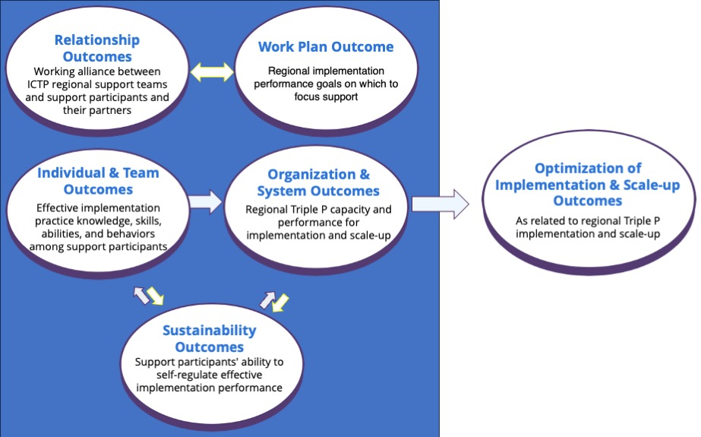

Implementation Support Core Practice Components & Practice Activities
As described in “Historical Development and Current Status of the ICTP Practice Model,” the ICTP projects are based on a detailed model and robust theory of how external implementation support creates changes and how ISPs might influence implementation support practice outcomes over time. The ICTP implementation support practice model outlines 10 CPCs; these are believed to be the essential components, or active ingredients, of implementation practice. These CPCs are grounded in social cognitive theory and bolstered by 11 practice values and eight implementation support practice principles. In this section, we introduce two models that illustrate (1) the theory of change for how these CPCs work together to contribute to favorable practice outcomes and (2) the typical patterns through which these CPCs are used to co-design implementation support activities and influence changes at the regional level. We also introduce practice activities, which further operationalize the CPCs.
DIVE DEEPER
Download Brief #5: Foundations of the ICTP Implementation Support Practice Model, Section
Theoretical Underpinnings (docx)

Values (docx)

Principles (docx)

for more information and discussion.

Core Practice Components
The 10 CPCs are listed in Table 6.2, along with their primary focus of change and most direct practice outcome(s). There are several key features of these CPCs to be aware of when using them in practice. Here we highlight two features that are central when considering ICTP implementation support at the regional level. (See Aldridge and colleagues [1] for a discussion of other important features.)
Table 6.2 Core Practice Components, Focus of Change, and Proximal Practice Outcomes
Core Practice Component | Primary Focus of Change | Proximal Implementation Support Practice Outcomes
Build collaborative relationships | Individuals, Teams | Working alliance
Reinforce leaders’ and teams’ self-regulation of effective implementation processes | Individuals, Teams | Self-regulation of effective implementation processes
Assess implementation capacity, implementation performance, and progress toward intended outcomes | Organization/System | Regional implementation performance goals on which to focus support
Facilitate collaborative agreements about implementation performance goals on which to focus support | Organization/System | Working alliance  Regional implementation performance goals on which to focus support
Provide learning to support leaders’ and teams’ acquisition of new implementation practice knowledge and skills | Individuals, Teams | Effective implementation practice knowledge, skills, abilities, and behaviors
Facilitate leaders’ and teams’ development of organizational and system implementation capacities | Organization/System | Regional Triple P capacity and performance for implementation and scale-up
Facilitate habituation and experiential learning related to the use of skills, resources, and abilities | Individuals, Teams  Organization/System | Effective implementation practice knowledge, skills, abilities, and behaviors  Regional Triple P capacity and performance for implementation and scale-up  Self-regulation of effective implementation processes
Provide supportive behavioral coaching to leaders and teams | Individuals, Teams | Effective implementation practice knowledge, skills, abilities, and behaviors  Self-regulation of effective implementation processes
Facilitate organizational and system learning and adaptive problem solving | Organization/System | Regional Triple P capacity and performance for implementation and scale-up  Self-regulation of effective implementation processes
Transition out of intensive implementation support | Individuals, Teams | Sustainment, under certain conditions

Multiple Pathways for Influencing Change
In Figure 6.2, we present a composite theory of change for external implementation support. This theory of change combines several smaller, elemental results chains—which describe how CPCs are used to influence individual practice outcomes—into an approximation of the whole picture. From this larger picture, we can see that CPCs are likely to influence practice outcomes in multiple ways. Practice outcomes (shown in shaded, lettered boxes) may be influenced through individual and combinations of CPCs (shown in unshaded, numbered boxes). For example, community leaders’ and teams’ implementation practice knowledge, skills, abilities, and behaviors may be influenced by ICTP regional support teams’ providing new learning to these support participants about effective implementation practices (CPC 5). At the same time, when ICTP regional support teams use combinations of CPC 5, CPC 7 (facilitate the habituation of skills, resources, and abilities), and CPC 8 (provide supportive behavioral coaching to leaders and teams) either in successive support interactions or over time, the potency of influence on community leaders’ and teams’ knowledge, skills, and abilities grows. Likewise, CPCs 7, 8, and 9 are likely to collectively influence leaders’ and teams’ self-regulatory abilities, particularly when used in combination with CPC 2 (reinforce leaders’ and teams’ self-regulation of effective implementation processes). These multiple pathways to influence practice outcomes can be helpful for tailoring support activities to a regional context.
Figure 6.2 A Composite Theory of Change for External Implementation Support, Adapted for the ICTP Projects [1]. Note. CPCs are shown in rectangles, numbered boxes; practice outcomes are shown in circles.
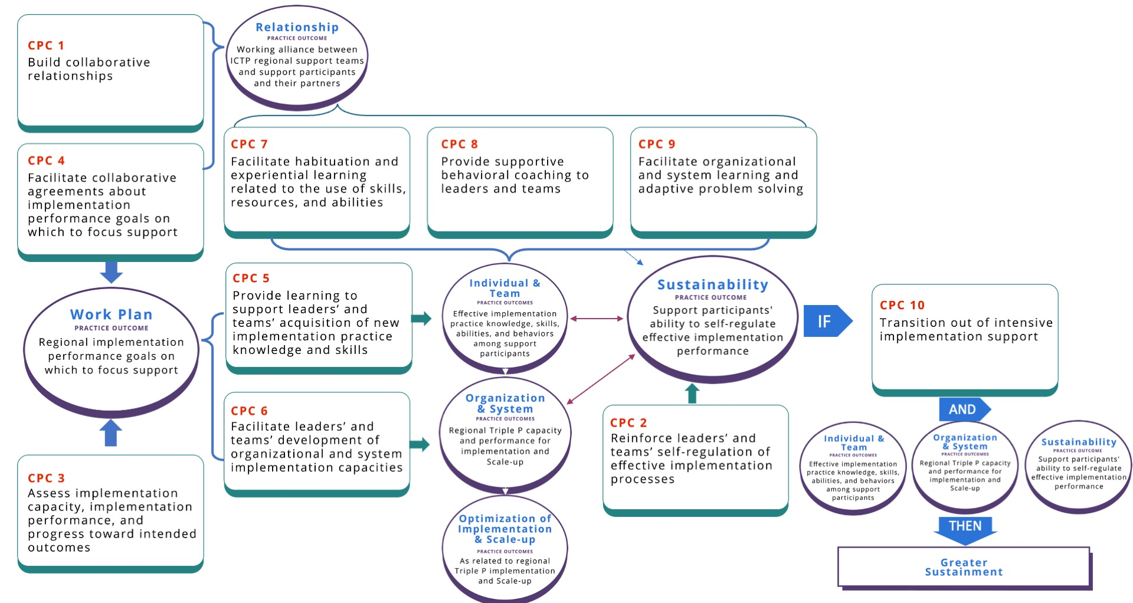

Patterns of Use to Influence Change at Multiple Levels
A second important feature of CPCs involves intentional patterns of use to influence practice outcomes at multiple levels. CPCs can be intentionally used by ICTP regional support teams to (1) co-design support processes, (2) influence behavior change at individual and team levels, and (3) influence learning and improvement at organizational and system levels [1].

Co-designing support processes. When co-designing support processes, ICTP regional support teams
- assess implementation capacity, performance, and progress (CPC 3) and
- use the results to facilitate collaborative agreements with regional Triple P partners about implementation performance goals on which to focus support (CPC 4).
For example, assessments may indicate that regional Triple P practitioners are not delivering Triple P to the extent expected or needed to meet community reach goals. If regional Triple P partners desire to work toward related performance goals, ICTP regional support teams can work with community leaders and implementation team members to co-design short-term support goals and activities that enable the region to develop the capacities they need to meet those performance goals and maintain them over time.

The necessity of delivering support at both individual/team and organizational/system levels of change is a well-described feature of external implementation support [5–11]. Table 6.2 indicates the primary focus of change for each CPC. In practice, however, ICTP regional support teams typically use CPCs in adaptive and dynamic ways, combining them within single or successive support interactions to influence change and improvement.

Individual and team levels. A typical pattern of CPC use to influence behavior change at individual and team levels involves ICTP regional support teams
- providing learning to support community Triple P leaders’ and teams’ acquisition of new implementation practice knowledge and skills (CPC 5),
- facilitating the habituation of skills and abilities among leaders and teams within their natural context (CPC 7), and
- providing supportive behavioral coaching to leaders and teams (CPC 8).

This pattern of practice components incorporates within the support process several best practices regarding adult learning [12].

Organization and system levels. A typical pattern of CPC use to influence organization and system performance improvements involves ICTP regional support teams
- facilitating community Triple P leaders’ and teams’ development of implementation capacity (CPC 6),
- facilitating the habituation of organizational resources and abilities (CPC 7), and
- facilitating collective learning and adaptive problem solving (CPC 9).

This sequence provides opportunities to shape or reshape organizational structures, policies, and procedures that will promote effective and equitable implementation.

In Figure 6.3, we depict the overall integration of these three typical patterns of implementation support practice, which are often cyclical and used in parallel. Co-design of support may occur initially and then be used periodically to monitor and adjust support goals and activities as improvement efforts begin. Additionally, as community Triple P leaders and implementation teams begin to enact individual and team behavior changes, they may use their new knowledge, skills, and abilities to shape or reshape organizational implementation capacities. Leaders and team members then put these capacities into use and actively manage them. ICTP regional support teams can then (1) provide supportive behavioral coaching for leaders and team members and (2) facilitate collective learning and adaptive problem solving with broader partners, who use these strategies to codify organizational learning and identify and address emergent adaptive challenges.

Because best practices in improvement science make use of small, iterative tests of change for learning and improvement [13], these support cycles repeat several times before ultimate performance goals are realized and support participants are ready to self-regulate and sustain implementation performance (CPC 10).

All three support cycles are only possible with strong working alliances in place. Additionally, these cycles depend on regional support teams reinforcing support participants when they demonstrate the ability to self-regulate effective implementation practices. As such, building collaborative relationships (CPC 1) and reinforcing leaders’ and teams’ self-regulation of effective implementation processes (CPC 2) are central to Figure 6.3 to indicate that they typically and necessarily occur continuously during these cyclical patterns of support practice.

For a more in-depth review of CPCs and the theory of change connecting CPCs to practice outcomes, including relevant literature and case examples from support engagements outside the ICTP projects, see Aldridge and colleagues [1]. In Brief 7, “Digging Deeper into the Implementation Support Practice Model at the Regional Level,” we delve further into these patterns of support practice, including a closer look at how combinations of CPCs interact to influence individual practice outcomes.

Figure 6.3 A Composite Model of the Primary Patterns of Core Practice Component Use in External Implementation Support. Note. CL = collective learning; APS = adaptive problem solving.
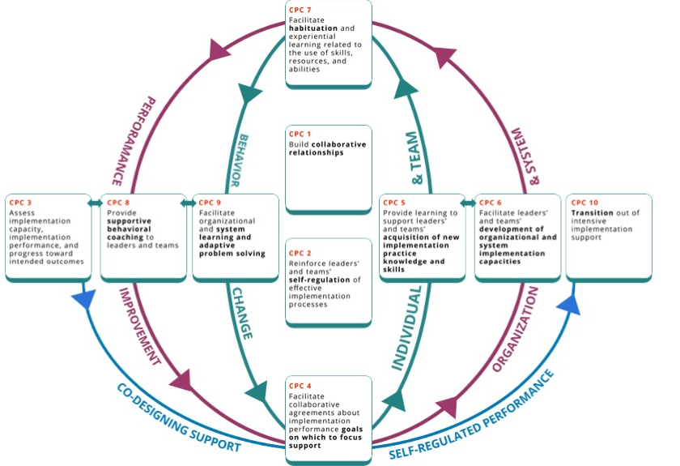

Practice Activities
To ensure that the 10 CPCs are usable and trackable by ISPs working in any project or practice setting, including ICTP regional support teams, several members of The Impact Center at FPG have worked over the years to operationalize each CPC. The approach has been to develop practice activities, defined as discrete behaviors and activities that ISPs may use to influence the intended outcomes of each CPC. The details of early efforts to operationalize the CPCs are described in the “Historical Development and Current Status of the ICTP Practice Model” section of this practice compendium and by Aldridge and colleagues in their report on the trajectory of ICTP implementation support practice activities over more than five years [14].

More recent sets of CPC practice activities identify essential activities and practice enhancers [14]. Essential activities are believed to directly contribute to the achievement of the near-term outcomes of each CPC. Practice enhancers are believed to accelerate or otherwise enhance the realization of near-term outcomes, even if outcomes may be sufficiently achievable in their absence.

In this practice compendium, we present the latest set of practice activities for each CPC (see Figure 6.4 and the “Practice Activity Deep Dive Resource” in Appendix C). For identification and tracking purposes, practice activities are labeled “[CPC number].[practice activity number]” (e.g., 1.1, 1.2, . . . 2.1, 2.2). Changes from the prior set of practice activities include clarified wording, adjusted identification of essential activities and practice enhancers, additional details about each practice activity, and the addition of two practice activities in CPC 8.

Practice activities may be used to proactively plan one or more consecutive support interactions. For example, with agreements in place about which performance goals to focus support on, ICTP regional support teams may plan to work with support participants to
- set new implementation practice learning objectives (5.1) and
- develop shared actions plans for capacity development (6.1), including to
      - provide structured learning that supports new implementation practice knowledge and skills (5.2) and
      - facilitate leaders’ and teams’ experiential learning activities to apply their new knowledge and skills (7.1).

However, practice activities do not happen in the context of proactive planning alone. Often, ICTP regional support team members find themselves responding to support participants’ needs, preferences, and requests in the moment. Similarly, windows may open suddenly for practice activities not previously planned, and ICTP regional support teams may pivot in the moment to take advantage. In these situations, following the support interactions, ICTP regional support teams may retroactively identify the applicable CPC(s) based on the practice activities used.

Regardless, due to the dynamic nature of implementation support practice, support interactions typically draw from practice activities across CPCs. ICTP regional support teams are not expected to stick to exhaustive sets of practice activities within one or more CPC, and they may unintentionally decrease the effectiveness of support interactions by doing so. Proactively or responsively combining individual practice activities across CPCs allows ICTP regional support teams to tailor support interactions, respond to specific situational cues or needs, and influence more than one practice outcome at a time [14]. As described by Aldridge and colleagues [14, p. 3]:
This approach recognizes the often-dynamic nature of implementation practice, the high level of flexibility and adaptation needed within any given support interaction, and places a premium on ISP experience, judgement, intuition, and skill. Likewise, training and coaching for ISPs and the application of this model in accordance with its guiding theory and practice principles becomes particularly important.
Aldridge and colleagues [14] believe that using the CPCs with fidelity in this dynamic practice model requires ongoing attention to the 38 essential activities and alignment with the underlying theories, values, and principles of the practice model. Future research and evaluation activities will be needed to better operationalize and test these assumptions.

In the next brief, we “dig deeper” into the typical patterns of implementation support practice, as illustrated in Figure 6.3, and provide a more detailed discussion of the practice activities within each CPC. Refer to Brief 7, “Digging Deeper Into the Implementation Support Practice Model at the Regional Level.”

Additional discussion about the dynamic nature of implementation support practice and using the ICTP practice model to tailor support processes is provided in the next section.

Dynamic Implementation Support: Flexibility, Adaptability, & Tailoring
DIVE DEEPER
Download Brief #5: Foundations of the ICTP Implementation Support Practice Model, section Practice Principles of Implementation Support Practice (docx) for more information on Proactive Support, Contextualized, Responsive Support.

Implementation and scale-up are adaptive processes by nature and are not limited to meeting technical challenges [15]. To navigate even the most typical support engagements, ISPs often must draw from their experience, judgment, intuition, and skill. They must be able to combine implementation science and skill training, facilitation, and supportive behavioral coaching, both proactively and responsively, for individuals, groups, and organizations [4]. This requires mindful attention for even the most seasoned ISPs. ISPs often need multiple ways to pivot, adapt, and tailor support activities overall and, at times, in the moment.

In the ICTP implementation support practice model, adherence refers to ongoing attention to the essential practice activities defined in the model and their utilization across the support engagement in a way that retains alignment with the model’s underlying theory of change, values, and principles [14]. However, full fidelity to any implementation support practice model also requires quality and support participants’ engagement in support processes. These necessitate high levels of flexibility, adaptability, and tailoring of support delivery—in short, dynamic implementation support practice. To build their confidence and competence to practice in this highly dynamic way, ISPs need ongoing support. Within the ICTP project, team members are encouraged to attend regular practice coaching sessions aimed at improving practices that demonstrate commitment to our values and principles and use of CPCs within the ICTP projects.
DIVE DEEPER
Download Brief #10: ICTP Project Infrastructure for Ongoing Learning and Improvement, in section Peer-To-Peer Coaching (docx) for more information.

Tailoring implementation support requires equal parts technical and relational skill. As such, high quality implementation support practice requires an artful staging rather than a procedural checklist. As Heifetz and colleagues [16] described about similar forms of adaptive leadership, “You need a plan, but you also need freedom to deviate from the plan as new discoveries emerge, as conditions change, and as new forms of resistance arise.”
DIVE DEEPER
Download Brief #5: Foundations of the ICTP Implementation Support Practice Model, Section Principles of Implementation Support Practice (docx) for more information on Practice Principles in Action: Adaptive Leadership.
Reference sidebar Dive Deeper for more information on the practice principle in
action: Adaptive Leadership.
In implementation support practice, this means thoughtfully creating tailored support activities ahead of support interactions, but identifying when, and having the skills, to pivot responsively to support participants’ needs and preferences in the moment. Figure 6.5 shows types of technical skills and relational skills.
Figure 6.5 Technical and Relational Skills Involved in Implementation Support Practice. Note. CQI = continuous quality improvement.
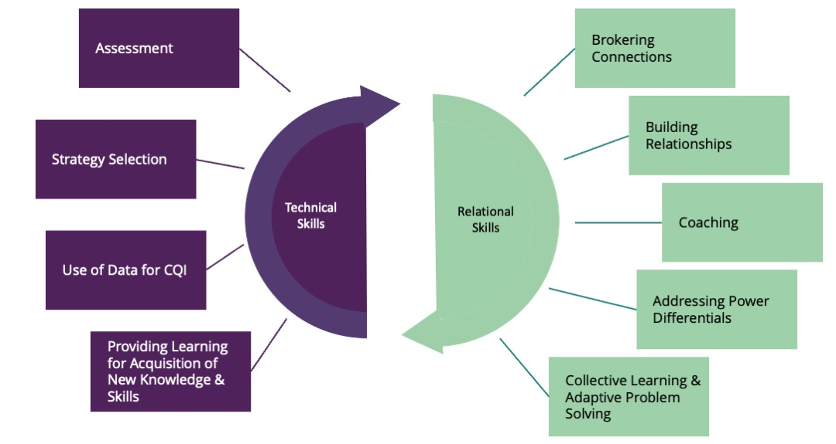
ISPs constantly monitor the context they are working in for a wide range of factors that signal the need for a pivot from the planned support. These factors include facilitators of and barriers to the likelihood of a practice activity’s success. Table 6.3 outlines facilitators and barriers, contextual factors to consider, and pivoting strategies. This is not meant to be an exhaustive list.
Table 6.3 Practice Activity Facilitators and Barriers
Facilitators and Barriers | Contextual Factors to Assess | Pivoting Strategies
Individual level:  Motivation | Complexity of the change  Structural factors that may inhibit perceived agency | - Teach skills through a step-by-step approach.  - Look for ways to eliminate steps.  - Find simpler ways to accomplish the same thing.  - Scale back the extent of the change.  - Engage support participants’ supervisors and mentors for change support.
Individual level:  Confidence and Competence | Structural factors that may inhibit self-efficacy and perceived agency  Access to tools | - Determine what is needed.  - Give options.  - Try it on, test it out.  - Be ready to offer something in the moment.  - Involve others pulling in resources/expertise.  - Engage support participants’ supervisors, coaches, and mentors for change support.
Team level  Leadership support  Stability or turnover | Limited power  Structural factors that may inhibit team-efficacy and perceived agency  Download Brief 5:Foundations of the ICTP Implementation Support Practice Model, section Theoretical Underpinnings (docx) for more information on Social Cognitive Theory in Action: Reciprocal Determinism, Human Agency, & Self-Regulation/Self-Efficacy. | - Determine who might be missing from the table.  - Assess expertise that can be leveraged.  - Facilitate peer-to-peer linking.  - Assess control versus influence.  - Engage agency leaders and broader co-creation partners for change support.
Agency/organization level  Implementation stages  Department changes | Taking too much time  Moving too fast | - Weigh the balance of feasibility vs. impact.  - Try something small and build on success.  - Talk through past experiences.  - Chunk out the work.  - Engage system leaders for change suppor
System level  Administration and bureaucracy  Policies changes | System pull or push | - Build consensus about the value and vision of the work.  - Engage leaders early and frequently.  - Build in times to assess the big picture of the work, mission creep (getting beyond the scope of the work), and readiness for next steps.
Box 6.1 ICTP Case Example of Dynamic implementation support practice within one NC Triple P region

One NC Triple P region had been long recognized for its high level of capacity and its ability to leverage community Triple P coalition partners for adaptive problem solving. However, the full community implementation team (CIT) turned over in a short period of time. This temporarily derailed Implementation Capacity for Triple P (ICTP) regional support specialists’ ongoing support activities within the region. Moreover, no one was available to onboard new hires, a role typically filled by CIT members, Triple P leaders in the lead implementing agency, and the Division of Child and Family Well-Being (DCFW) Triple P coordinator, which was also a vacant position at the time.

CITs are made up of coordinators who build capacity at the community level to support the use of Triple P. These teams are key to moving forward the day-to-day work of installing and sustaining Triple P in the community. CITs are typically staffed with three full-time equivalents (FTEs). Team members ideally have competencies in Triple P delivery, effective implementation and best practices, using data for decision making, and supporting organizational change or new program adoption.

ICTP regional support specialists assessed the situation and determined that they needed to broker connections with other system partners for onboarding support. ICTP regional support specialists temporarily changed the focus of their implementation support meetings and used these as a forum for new hires to connect with such system partners. For example, CIT new hires met with state Triple P data team members so that they could understand the quarterly data reporting requirements from state funders. CIT new hires also met with CIT members from other Triple P regions for peer mentoring and support. Once new CIT members were better connected to those who could support these initial capacity-building needs, ICTP regional support specialists were able to provide targeted learning to the new hires on effective implementation practices that would move their work forward. This included reengaging their prior community Triple P leadership team and understanding the region’s five-year Triple P strategic planning process. ICTP regional support specialists also helped new CIT members solve problems regarding the region’s access to state data platforms. Although these responsive support activities detoured from prior planned support activities, the flexibility of the support provided by ICTP regional support specialists re-anchored the region’s Triple P implementation and scale-up efforts in a time of transition and turbulence.

ISP Tiers of Support
ISPs provide support that is responsive to the dynamic needs of CIT and CLT members through the tiered model of support—another aspect of dynamic implementation support practice. This model includes three tiers of implementation support to assist local leaders’ and partners’ development of shared resources and abilities to enhance regional Triple P scale-up efforts. These three tiers are (1) intensive, broad-focused support; (2) brief, narrow-focused support; and (3) universal support (Refer to Table 6.4). ISPs developed the tiered model of support to be responsive to system partners’ changing implementation support needs over time. The selection of a support tier is mutually determined by ISPs and system partners based on the region’s needs and preferences and is reevaluated biannually. The “intensive, broad-focused” and “brief, narrow-focused” tiers focus on capacity building and make full and systematic use of the ICTP CPCs and practice activities. The “universal” tier does not include capacity building; rather, it includes universal access to tools, resources, and communication about effective implementation practices and responsive design and consultation supports.

Intensive, broad-focused support entails regular, ongoing, comprehensive support geared toward broad community resources and a region’s holistic abilities to scale-up Triple P. Brief, narrow-focused support is characterized by episodic support for discrete areas of regional capacity to enhance elements of Triple P performance. This tier of support is focused on addressing support needs related to time-limited contextual challenges, needs, or preferences. Universal support is provided to all regions and includes broadly applicable support information, resources, and assessments as well as access to group-based support provided by the ICTP projects through the Triple P North Carolina Learning Collaborative.

Table 6.4 Tiered Model of Support
Tier | Description | Format
Intensive Broad-Focused Support | - Typically entails regular, ongoing support with a comprehensive focus on regional capacity to scale-up Triple P (conceptually similar to a Level 4 Triple P approach).  - Generally, a good fit for regions starting up their initiatives, revamping their initiatives/planning on changes requiring broad consideration, or generally wanting to focus broadly across community resources and abilities to scale-up Triple P; and who are willing and able to commit time and effort to regular support. | At least quarterly in-person contacts plus more regular virtual contacts
Brief Narrow-Focused Support | - Typically entails episodic support on discrete areas of regional capacity to scale-up Triple P or discrete Triple P scaling challenges as indicated by regional needs (conceptually similar to a Level 3 Triple P approach).  - Generally, a good fit for established sites with broad capacity already in place and support needs related only to discrete topics; or for regions who are only able to engage in episodic support on discrete topics due to time-limited contextual challenges, needs, or preferences. | At least quarterly in-person contacts plus less regular virtual contacts
Universal Support | - Broadly applicable support information, resources, and assessments provided across regions, to participants in group settings, or accessed by participants independently for their own use and application. All Triple P Regions access these support activities. | - Community Capacity  - Assessments every 6 months  - 6-month check-in to evaluate support needs.  - NCLC & Office Hours  - Support  - Webinars  - ICTP Online Simulation Lab  - ICTP Communications activities

Tailoring Implementation Support to Different Stages of Community Triple P Scale-Up
ISPs may use CPCs and practice activities to different extents and in different patterns depending on whether they are entering the implementation support process during the start-up or continuation of Triple P scale-up.

For partners entering the support process at the beginning of Triple P scale-up, implementation support would start with building collaborative relationships (CPC 1), assessing the community’s implementation capacity (CPC 3), and facilitating collaborative agreements about implementation performance goals on which to focus support. For partners entering the support process later, during ongoing Triple P scale-up, initial implementation support would also include these activities. However, early in the support engagement, ISPs would likely focus on reinforcing leaders’ and teams’ self-regulation of effective implementation processes (CPC 2) and facilitating their application of skills, resources, and abilities within their community (CPC 7).

Regardless of the stage at which Triple P partners enter the implementation support process, dynamic support provision requires tailoring support activities to community, CIT, and CLT needs at any given time. First and foremost, it requires building a working alliance with the CIT and CLT; this creates the foundation on which to build future support activities throughout the engagement.

An important factor impacting the implementation support process is that in ongoing Triple P scale-up, different Triple P programs will be in different stages of implementation in the community. Some will be being explored, others installed, and still others in initial or full implementation. Refer to Box 6.2 for descriptions of implementation stages related to adopted Triple P interventions within a Triple P community.
Box 6.2 Stages of Implementation for Adopted Triple P Interventions Within a Triple P Community
Exploration: Triple P interventions in this stage of implementation are under consideration or are in planning for future use in the community coalition. Information is still being gathered on how these Triple P interventions may respond to identified needs in the coalition. Conversations with Triple P America about the characteristics and utility of these interventions may be ongoing. Conversations with coalition leaders, agencies, and other partners about the appropriateness and timing of these interventions may be ongoing. Coalition resources are not yet being used to install these Triple P interventions.

Installation: Community coalition resources are actively being used to implement Triple P interventions in this stage of implementation. Local practitioners may be training in and practicing their use of these Triple P interventions, but accreditation of practitioners has not yet occurred. As such, these interventions are not yet systematically being delivered to coalition families. Administrators and managers in service provider organizations may be preparing their organizations to support the systematic use of these Triple P interventions.

Initial Implementation: Community coalition Triple P practitioners have been accredited in Triple P interventions in this stage of implementation and they are in the early stages of being systematically delivered to community families. Practice behaviors related to these Triple P interventions are still relatively new for community Triple P practitioners. Administrators and managers in service provider organizations are also engaging in new behaviors and supporting new operations related to these Triple P interventions. Coalition and organizational implementation barriers and system needs may be emerging as new behaviors and operations come into contact with old behaviors and operations. Practitioner, organizational, and community partner buy-in for these newly implemented Triple P interventions may still need support and attention. Data collection and use of data for quality improvement may be in the early stages.

Full Implementation: The majority of community Triple P practitioners are delivering Triple P interventions as intended (i.e., with fidelity) during this stage of implementation. Although they still may require active attention and support, local service provider organizations have accommodated these Triple P interventions as a part of business as usual.

Supporting Community Triple P Service Providers in Partnership With Primary Support Recipients
At times, ISPs interact with community Triple P service providers who are in partnership with primary recipients of support. This dynamic support situation may occur when
- a support activity is needed that CITs are not ready to lead on their own, or
- CITs ask for support with community service providers related to a particular need or skill set with which ISPs are more experienced.
For example, ISPs may initially administer the Implementation Drivers Assessment for the Triple P System of Interventions alongside CIT members while they learn the administration protocol, co-facilitate with CIT members certain coalition meetings where the ISPs’ expertise or facilitation is needed, or support data collection for Social Network Analysis that may reveal patterns of relationships in the community or region.

When support provision includes interacting with community Triple P service providers, ISPs can model and provide in vivo demonstrations to help CIT members learn the process and prepare to take over the work. The goal is always to transfer any leadership roles to CIT members as soon as possible. A parallel process exists in how ICTP ISPs support CIT members and how CIT members support service provider organization leaders and implementation team members. This flexible and tailored approach to using the practice model allows CIT members to work side by side with ISPs to further the work in their community and increase their knowledge and skills to lead sustainable scale-up efforts.

Key Takeaways:
- ICTP implementation support practitioners (ISPs) consider regional Triple P partners’ readiness to engage in ICTP implementation support when determining the point at which to engage in support or which regional partners to prioritize for support. ISPs determine regional partners’ readiness based on five assumptions and may use strategies to influence or contribute to their readiness. Regional support participants (i.e., those partners receiving support) must be able to agree to and follow through with the expectations laid out in the ICTP document Partnering With the Impact Center at FPG’s Regional Support Team.
- NC Triple P regions range from a single community or county scaling Triple P to multiple communities or counties organized under a regional backbone organization. Regional partners range from community coalition members to any child and family support partners, participants, and advocates in the region. ICTP regional support teams should have conversations with regional Triple P leaders about how they define regional partners at any given time.
- ICTP ISPs provide regional implementation support to both primary support participants (i.e., community Triple P leaders and community implementation team members supporting Triple P scale-up in their region) and secondary support participants (i.e., broader regional Triple P partners, including service provider organizations).
- Regional and statewide co-creation partner activities and decisions, beyond those contributed by ICTP ISPs alone, play a significant role in regional Triple P scale-up outcomes. The more that ICTP ISPs can harness and guide broader co-creation partner activities toward productive processes and outcomes, the more impactful regional support contributions may be, and the more successful community Triple P scale-up efforts may be. This may include working with ICTP ISPs within the broader project team who may be providing support at different system levels.
- The two primary objectives of regional Triple P implementation support are (1) scaling Triple P in a way that is inclusive of community voice; supported by equitable partnerships; and directly responsive to identified community needs, readiness, and characteristics, including historical inequities and current disparities; and (2) optimizing regional Triple P implementation and scale-up outcomes.
- Five practice outcomes—which influence and are influenced by each other—support the achievement of these primary objectives:
  - a working alliance between ICTP regional support teams and support participants and their partners;
  - regional implementation performance goals on which to focus support;
  - effective implementation practice knowledge, skills, abilities, and behaviors among community leaders and implementation team members participating in support;
  - regional Triple P capacity and performance for implementation and scale-up; and
  - community leaders’ and teams’ ability to self-regulate effective implementation performance.
- The ICTP implementation support practice model outlines 10 core practice components (CPCs), believed to be the essential elements of implementation practice. ICTP regional support teams use various combinations and patterns of CPCs, via multiple pathways, to co-design support processes and to influence practice outcomes at individual and team levels and organizational and system levels.
- Practice activities are the discrete behaviors and activities that ISPs use in their support interactions to influence the intended outcomes of each CPC. Practice activities are broken down into essential activities and practice enhancers.
- ICTP ISPs use of CPCs and practice activities differs depending on whether support participants are entering the implementation support process during their start-up or continuation of Triple P scale-up.
- Given the complex nature of implementation and scale-up processes, ISPs must engage in dynamic implementation support practice. In other words, they must be highly flexible and adaptable, tailor their support activities, and pivot when needed in response to support participants’ needs and preferences. To practice in this way, ISPs are encouraged to obtain support from peers and participate in practice coaching sessions.
- To be responsive to system partners’ changing needs for implementation support over time, the ICTP practice model includes three tiers of support: (1) intensive, broad-focused support; (2) brief, narrow-focused support; and (3) universal support. The latter tier involves access to tools, resources, assessments, and communication rather than direct support to build implementation capacity.

Reference List

- Aldridge, W. A., II, Roppolo, R. H., Brown, J., Bumbarger, B. K., & Boothroyd, R. I. (2023). Mechanisms of change in external implementation support: A conceptual model and case examples to guide research and practice. Implementation Research and Practice, 4. https://doi.org/10.1177/26334895231179761
- Aldridge W. A., II, Boothroyd R. I., Fleming W. O., Lofts Jarboe K., Morrow J., Ritchie G. F., & Sebian J. (2016). Transforming community prevention systems for sustained impact: Embedding active implementation and scaling functions. Translational Behavioral Medicine, 6(1), 135–144. https://doi.org/10.1007/s13142-015-0351-y
- Doursat, R., & Ulieru, M. (2008). Emergent engineering for the management of complex situations. In Proceedings of the 2nd International Conference on Autonomic Computing and Communication Systems. https://dl.acm.org/doi/10.5555/1487652.1487666
- National Academies of Sciences, Engineering, and Medicine. (2019). Fostering healthy mental, emotional, and behavioral development in children and youth: A national agenda. The National Academies Press. https://doi.org/10.17226/25201
- Albers, B., Metz, A., & Burke, K. (2020). Implementation support practitioners - A proposal for consolidating a diverse evidence base. BMC Health Services Research, 20, 368. https://doi.org/10.1186/s12913-020-05145-1
- Amodeo, M., Ellis, M. A., & Samet, J. H. (2006). Introducing evidence-based practices into substance abuse treatment using organization development methods. The American journal of Drug and Alcohol Abuse, 32(4), 555–560. https://doi.org/10.1080/00952990600920250
- Berta, W., Cranley, L., Dearing, J. W., Dogherty, E. J., Squires, J. E., & Estabrooks, C. A. (2015). Why (we think) facilitation works: Insights from organizational learning theory. Implementation Science, 10, 141. https://doi.org/10.1186/s13012-015-0323-0
- Blase, K. (2009). Technical assistance to promote service and system change (roadmap to effective intervention practices #4). Tampa, Florida: University of South Florida, Technical Assistance Center on Social Emotional Intervention for Young Children. https://files.eric.ed.gov/fulltext/ED577840.pdf
- Foster-Fishman, P. G., Berkowitz, S. L., Lounsbury, D. W., Jacobson, S., & Allen, N. A. (2001). Building collaborative capacity in community coalitions: A review and integrative framework. American Journal of Community Psychology, 29(2), 241–261. https://doi.org/10.1023/A:1010378613583
- Rushovich, B. R., Bartley, L. H., Steward, R. K., & Bright, C. L. (2015). Technical assistance: A comparison between providers and recipients. Human Service Organizations: Management, Leadership & Governance, 39(4), 362–379. https://doi.org/10.1080/23303131.2015.1052124
- Ritchie, M. J., Parker, L. E., & Kirchner, J. E. (2020). From novice to expert: A qualitative study of implementation facilitation skills. Implementation Science Communications, 1, 25. https://doi.org/10.1186/s43058-020-00006-8
- Dunst, C. J., & Trivette, C. M. (2012). Moderators of the effectiveness of adult learning method practices. Journal of Social Sciences, 8(2), 143-148. https://doi.org/10.3844/jssp.2012.143.148
- Courtlandt, C. D., Noonan, L., & Feld, L. G. (2009). Model for Improvement - part 1: A framework for health care quality. Pediatric Clinics of North America, 56(4), 757–778. https://doi.org/10.1016/j.pcl.2009.06.002
- Aldridge, W. A., II, Roppolo, R. H., Chaplo, S. D., Everett, A. B., Lawrence, S. N., DiSalvo, C. I., Minch, D. R., Reed, J. J., & Boothroyd, R. I. (2023). Trajectory of external implementation support activities across two states in the United States: A descriptive study. Implementation Research and Practice, 4. https://doi.org/10.1177/26334895231154285
- Heifetz, R. A., & Laurie, D. L. (1997). The work of leadership. Harvard Business Review, 75(1), 124–134.
- Heifetz, R. A., Grashow, A., & Linsky, M. (2009). The practice of adaptive leadership: Tools and tactics for changing your organization and the world. Harvard Business Press.

