Historical Development & Current Status of the ICTP Practice Model
In 2016, Aldridge and colleagues [11] identified seven implementation support practice principles and 10 core practice components for EIS. Members of the ICTP projects team within The Impact Center at FPG then translated these principles and components into a tailored model of implementation support for the North Carolina ICTP project [12]. We updated this community-based implementation support practice model (which we’ll refer to as simply the “practice model”) in 2018 [13].

In addition to the 2018 update, we made several other revisions and additions to the practice model between 2016 and 2020, largely in response to training and supporting ICTP regional support specialists in their application of the practice model in the field. At the most basic level, we adjusted the names and groupings of core practice components to increase understanding and utility. Similarly, we modified the names and definitions of implementation support practice principles and added an eighth principle (stage-based approach). More substantively, we added a theory of change detailing the influences of core practice components on key practice outcomes, greatly enhancing the model’s utility with regard to how ISPs might use individual and combinations of core practice components to influence specific practice outcomes [10].

Another major development was the operationalization of core practice components through the addition of corresponding practice activities. A practice model leadership team within The Impact Center at FPG met frequently over two years to develop and refine practice activities based on feedback from ICTP regional support specialists. This resulted in three sets of practice activities being used in the ICTP projects—one from August through December 2017, a second from January 2018 through June 2019, and a third from July 2019 until the publication of this practice compendium.

The third set of practice activities was particularly noteworthy for the identification of essential activities and practice enhancers [14]. Essential activities are those believed to directly contribute to the achievement of the near-term practice outcomes of each core practice component. Practice enhancers are those believed to accelerate or otherwise enhance the realization of near-term practice outcomes, even if those outcomes could be achieved in their absence. The early details of the evolution and application of core practice components are well reported by Aldridge and colleagues [14] in their examination of the trajectory of EIS within the ICTP projects over more than five years.

Most recently, several events, developments, and decisions have led to the version of the ICTP practice model detailed in this practice compendium. First, from April through August 2021, members of The Impact Center at FPG met for deep dives into each core practice component. These sessions involved reflecting (again) on key background literature, reviewing several years of data from the ICTP projects, looking at examples of core practice components in action, and determining how to clearly differentiate between similar practice activities across core components. This led to our further refinement of the language and enhanced understanding about how core practice components could be used to drive regional practice outcomes at individual/team and organization/system levels.

In late 2021, ICTP project team members adopted 11 practice values, complementing the eight implementation support practice principles. Figure 4.2 demonstrates how the 10 core practice components are nested within the eight implementation support practice principles, which are further nested with the 11 practice values.

Figure 4.2 Nesting of ICTP Practice Values, Implementation Support Practice Principles, and Core Practice Component
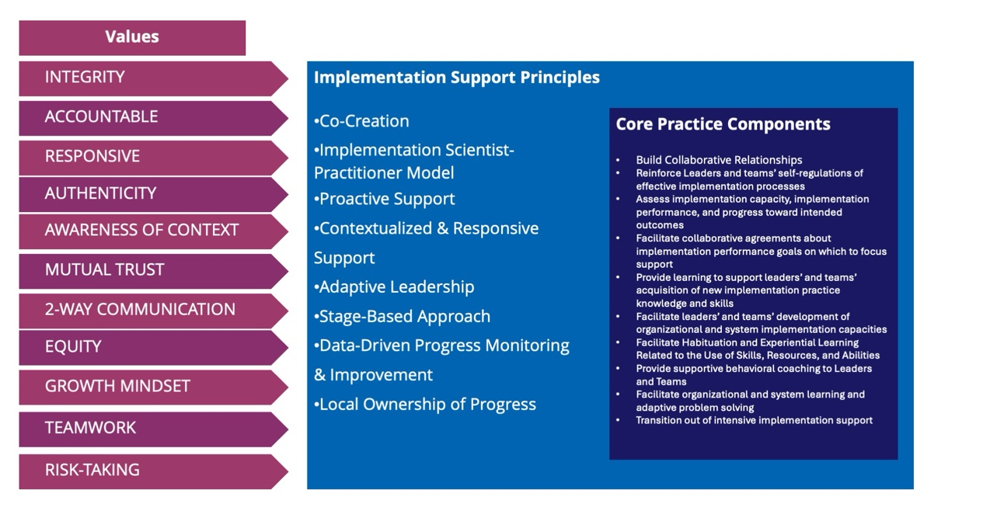

Shortly thereafter, several members of the ICTP project team wrote two journal articles that laid the foundations of the regional practice model in the peer-reviewed literature. The first article [10] focuses on the theoretical and conceptual foundations of the practice model, with a particular focus on the core practice components as mechanisms of change in implementation support practice. The second article [14] details the development of practice activities and reports the results of a study in which ICTP regional support teams across NC and SC Triple P regions used core practice components and practice activities for more than five years. This study illustrated the typically dynamic use of core practice components and practice activities by ICTP regional support teams and indicated the need for some refinements among the then-current set of practice activities.

These developments were then carried into The Impact Center at FPG’s sixth Foundational Professional Development Series on Implementation Science and Practice during spring/summer 2022. This training and mentoring series enabled ICTP project team leaders to develop and test new ways of teaching the regional practice model and receive feedback from learners.

In parallel to these recent events, the ICTP practice model has evolved by instituting
- a three-tiered model of regional support, detailing objectives, activities, and characteristics of Triple P regions participating in intensive/broad-focused support, brief/narrow-focused support, and universal support;
- a more robust agenda for media and networking activities focused on spreading effective implementation practices, including analyzing the relationships between system partners in both North Carolina and South Carolina and engaging in a variety of communication activities meant to complement direct EIS provided by ICTP regional support teams;
- “design and consultation support,” provided by ICTP implementation support specialists to state and regional partners to enhance implementation design and address specific challenges or changes;
- a more complete set of resources for learning and applying effective implementation practices for Triple P in the Carolinas, including comprehensive sets of implementation practice learning objectives and related practice tools for regional Triple P partners; and
- a more feasible and useful ICTP practice quality and outcome monitoring system, designed to improve ICTP implementation support through data-based decision making.

A timeline summarizing the major development activities for the ICTP implementation support practice model is provided in Figure 4.3 below.

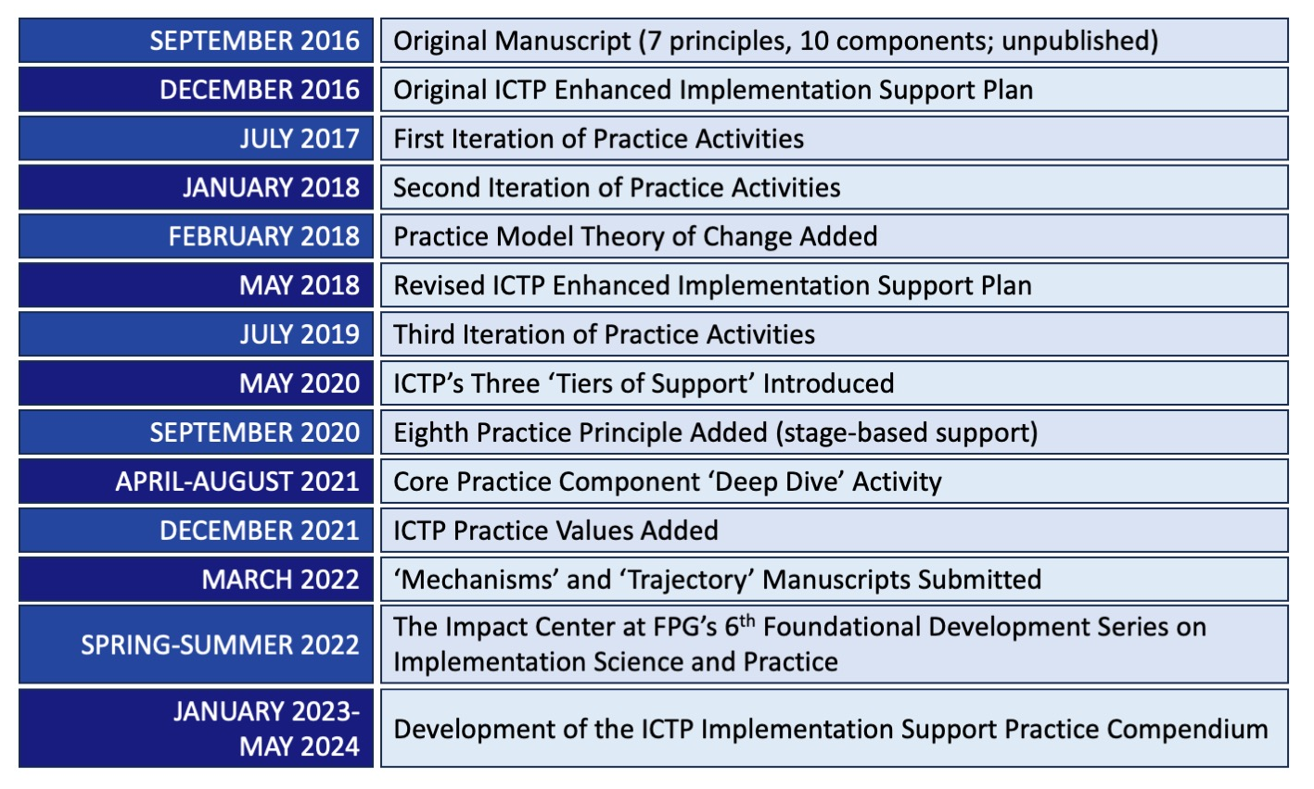

From the start, we’ve characterized our overarching approach to development of the practice model as a process of theorizing within implementation science, as advocated for by Kislov and colleagues [15]. According to Kislov and colleagues, the theorizing process accommodates a more fluid and repetitive interplay between scientific data, practice, and theory than that afforded by traditional methods of theory and intervention development. This also means that even the version of the practice model detailed in this compendium is subject to further refinement. Overall, this approach has lent itself well to linking, testing, and refining theory at each level of the ICTP practice model, as seen in Figure 4.4. Although readers may be unfamiliar with some terminology in the figure, we present it here to provide a visual depiction of the complex processes involved in refining the model.

Figure 4.4 Linking, Testing, and Refining Theory at Each Level of the ICTP Implementation Support Practice Model [Adapted from 15]

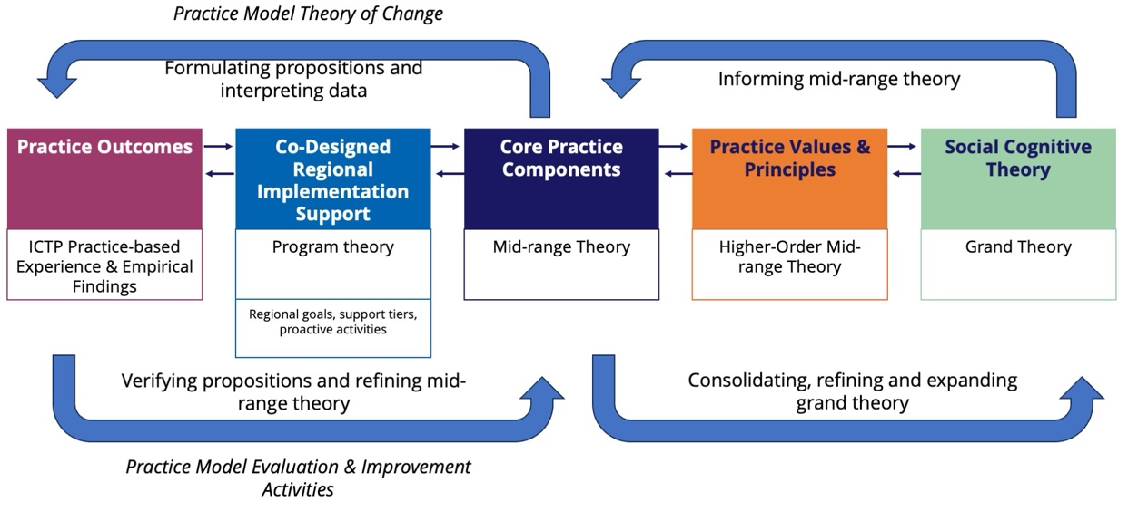

Beyond recognizing the major developments to our practice model in the past five years as described above, in this practice compendium we detail our two key aspirations for future ICTP implementation support: centering equity and more strongly integrating improvement science methods within our implementation support practice.

Regarding equity-centered implementation support, we recognize that the goal of supporting the achievement of population-level outcomes, alone, is neither sufficient nor justifiable. This goal must be paired with a matching goal of supporting the reduction or elimination of disparities in intended child and family outcomes—particularly as related to systemic inequities, social determinants of health, and institutional racism [16]—as Triple P implementation and scaling activities afford. Community-based initiatives, such as those required to support Triple P scale-up, are uniquely positioned for community-driven collective action for the interests of children and families.
DIVE DEEPER
Refer to Brief #7: Digging Deeper Into the Implementation Support Practice Model at the Regional Level and download section Organizational/
System Learning and Improvement Approaches (docx) for more information.
Improvement science is, like implementation science, an applied science. It “drives innovation, testing in the field, and spread and scale up to generate and disseminate learning about what changes, in which contexts, produce the improvements” in organizations and systems [17]. To integrate improvement science methods more thoroughly within our implementation support practice, we place greater focus on the aim of improving implementation performance—simply put, the quality and impact with which essential implementation practices are carried out—across organizations and systems. To do this, we use models, such as the widely used model for improvement [18], and methods, such as small tests of change, that have demonstrated usefulness in driving such changes across organizational and systems settings.

Centering these two aspirations, we look to the future of the ICTP projects with hope for enhanced success, sustainability, and equity of Triple P implementation throughout the Carolinas.

