Dynamic Implementation Support: Flexibility, Adaptability, & Tailoring
DIVE DEEPER
Download Brief #5: Foundations of the ICTP Implementation Support Practice Model, section Practice Principles of Implementation Support Practice (docx) for more information on Proactive Support, Contextualized, Responsive Support.

Implementation and scale-up are adaptive processes by nature and are not limited to meeting technical challenges [15]. To navigate even the most typical support engagements, ISPs often must draw from their experience, judgment, intuition, and skill. They must be able to combine implementation science and skill training, facilitation, and supportive behavioral coaching, both proactively and responsively, for individuals, groups, and organizations [4]. This requires mindful attention for even the most seasoned ISPs. ISPs often need multiple ways to pivot, adapt, and tailor support activities overall and, at times, in the moment.

In the ICTP implementation support practice model, adherence refers to ongoing attention to the essential practice activities defined in the model and their utilization across the support engagement in a way that retains alignment with the model’s underlying theory of change, values, and principles [14]. However, full fidelity to any implementation support practice model also requires quality and support participants’ engagement in support processes. These necessitate high levels of flexibility, adaptability, and tailoring of support delivery—in short, dynamic implementation support practice. To build their confidence and competence to practice in this highly dynamic way, ISPs need ongoing support. Within the ICTP project, team members are encouraged to attend regular practice coaching sessions aimed at improving practices that demonstrate commitment to our values and principles and use of CPCs within the ICTP projects.

Tailoring implementation support requires equal parts technical and relational skill. As such, high quality implementation support practice requires an artful staging rather than a procedural checklist. As Heifetz and colleagues [16] described about similar forms of adaptive leadership, “You need a plan, but you also need freedom to deviate from the plan as new discoveries emerge, as conditions change, and as new forms of resistance arise.”
DIVE DEEPER
Download Brief #5: Foundations of the ICTP Implementation Support Practice Model, Section Principles of Implementation Support Practice (docx) for more information on Practice Principles in Action: Adaptive Leadership.
Reference sidebar Dive Deeper for more information on the practice principle in
action: Adaptive Leadership.
In implementation support practice, this means thoughtfully creating tailored support activities ahead of support interactions, but identifying when, and having the skills, to pivot responsively to support participants’ needs and preferences in the moment. Figure 6.5 shows types of technical skills and relational skills.
Figure 6.5 Technical and Relational Skills Involved in Implementation Support Practice. Note. CQI = continuous quality improvement.
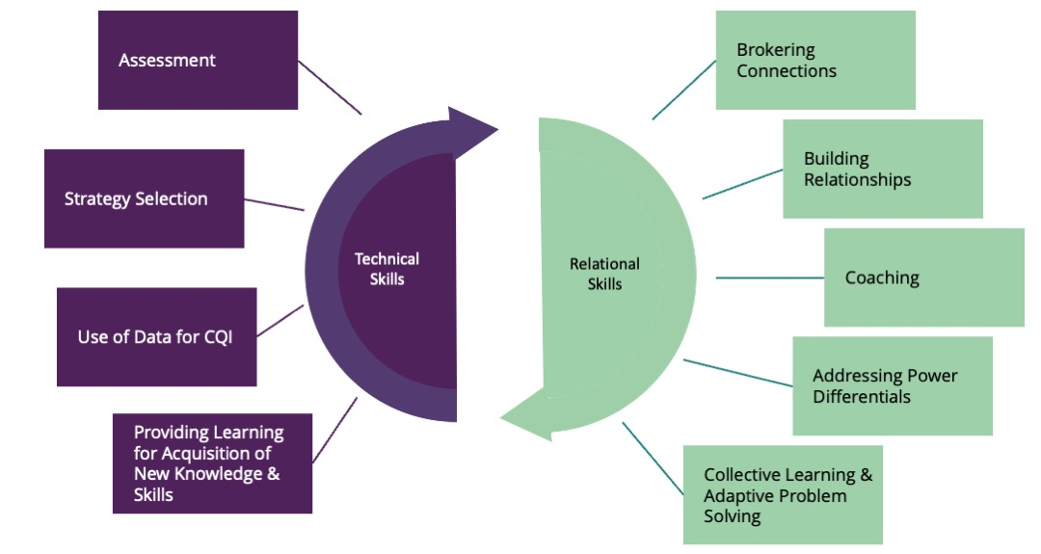
ISPs constantly monitor the context they are working in for a wide range of factors that signal the need for a pivot from the planned support. These factors include facilitators of and barriers to the likelihood of a practice activity’s success. Table 6.3 outlines facilitators and barriers, contextual factors to consider, and pivoting strategies. This is not meant to be an exhaustive list.

Table 6.3 Practice Activity Facilitators and Barriers
Facilitators and Barriers | Contextual Factors to Assess | Pivoting Strategies
Individual level:  Motivation | Complexity of the change  Structural factors that may inhibit perceived agency | - Teach skills through a step-by-step approach.  - Look for ways to eliminate steps.  - Find simpler ways to accomplish the same thing.  - Scale back the extent of the change.  - Engage support participants’ supervisors and mentors for change support.
Individual level:  Confidence and Competence | Structural factors that may inhibit self-efficacy and perceived agency  Access to tools | - Determine what is needed.  - Give options.  - Try it on, test it out.  - Be ready to offer something in the moment.  - Involve others pulling in resources/expertise.  - Engage support participants’ supervisors, coaches, and mentors for change support.
Team level  Leadership support  Stability or turnover | Limited power  Structural factors that may inhibit team-efficacy and perceived agency  Download Brief 5:Foundations of the ICTP Implementation Support Practice Model, section Theoretical Underpinnings (docx) for more information on Social Cognitive Theory in Action: Reciprocal Determinism, Human Agency, & Self-Regulation/Self-Efficacy. | - Determine who might be missing from the table.  - Assess expertise that can be leveraged.  - Facilitate peer-to-peer linking.  - Assess control versus influence.  - Engage agency leaders and broader co-creation partners for change support.
Agency/organization level  Implementation stages  Department changes | Taking too much time  Moving too fast | - Weigh the balance of feasibility vs. impact.  - Try something small and build on success.  - Talk through past experiences.  - Chunk out the work.  - Engage system leaders for change suppor
System level  Administration and bureaucracy  Policies changes | System pull or push | - Build consensus about the value and vision of the work.  - Engage leaders early and frequently.  - Build in times to assess the big picture of the work, mission creep (getting beyond the scope of the work), and readiness for next steps.
Box 6.1 ICTP Case Example of Dynamic implementation support practice within one NC Triple P region

One NC Triple P region had been long recognized for its high level of capacity and its ability to leverage community Triple P coalition partners for adaptive problem solving. However, the full community implementation team (CIT) turned over in a short period of time. This temporarily derailed Implementation Capacity for Triple P (ICTP) regional support specialists’ ongoing support activities within the region. Moreover, no one was available to onboard new hires, a role typically filled by CIT members, Triple P leaders in the lead implementing agency, and the Division of Child and Family Well-Being (DCFW) Triple P coordinator, which was also a vacant position at the time.

CITs are made up of coordinators who build capacity at the community level to support the use of Triple P. These teams are key to moving forward the day-to-day work of installing and sustaining Triple P in the community. CITs are typically staffed with three full-time equivalents (FTEs). Team members ideally have competencies in Triple P delivery, effective implementation and best practices, using data for decision making, and supporting organizational change or new program adoption.

ICTP regional support specialists assessed the situation and determined that they needed to broker connections with other system partners for onboarding support. ICTP regional support specialists temporarily changed the focus of their implementation support meetings and used these as a forum for new hires to connect with such system partners. For example, CIT new hires met with state Triple P data team members so that they could understand the quarterly data reporting requirements from state funders. CIT new hires also met with CIT members from other Triple P regions for peer mentoring and support. Once new CIT members were better connected to those who could support these initial capacity-building needs, ICTP regional support specialists were able to provide targeted learning to the new hires on effective implementation practices that would move their work forward. This included reengaging their prior community Triple P leadership team and understanding the region’s five-year Triple P strategic planning process. ICTP regional support specialists also helped new CIT members solve problems regarding the region’s access to state data platforms. Although these responsive support activities detoured from prior planned support activities, the flexibility of the support provided by ICTP regional support specialists re-anchored the region’s Triple P implementation and scale-up efforts in a time of transition and turbulence.

ISP Tiers of Support
ISPs provide support that is responsive to the dynamic needs of CIT and CLT members through the tiered model of support—another aspect of dynamic implementation support practice. This model includes three tiers of implementation support to assist local leaders’ and partners’ development of shared resources and abilities to enhance regional Triple P scale-up efforts. These three tiers are (1) intensive, broad-focused support; (2) brief, narrow-focused support; and (3) universal support (Refer to Table 6.4). ISPs developed the tiered model of support to be responsive to system partners’ changing implementation support needs over time. The selection of a support tier is mutually determined by ISPs and system partners based on the region’s needs and preferences and is reevaluated biannually. The “intensive, broad-focused” and “brief, narrow-focused” tiers focus on capacity building and make full and systematic use of the ICTP CPCs and practice activities. The “universal” tier does not include capacity building; rather, it includes universal access to tools, resources, and communication about effective implementation practices and responsive design and consultation supports.

Intensive, broad-focused support entails regular, ongoing, comprehensive support geared toward broad community resources and a region’s holistic abilities to scale-up Triple P. Brief, narrow-focused support is characterized by episodic support for discrete areas of regional capacity to enhance elements of Triple P performance. This tier of support is focused on addressing support needs related to time-limited contextual challenges, needs, or preferences. Universal support is provided to all regions and includes broadly applicable support information, resources, and assessments as well as access to group-based support provided by the ICTP projects through the Triple P North Carolina Learning Collaborative.

Table 6.4 Tiered Model of Support
Tier | Description | Format
Intensive Broad-Focused Support | - Typically entails regular, ongoing support with a comprehensive focus on regional capacity to scale-up Triple P (conceptually similar to a Level 4 Triple P approach).  - Generally, a good fit for regions starting up their initiatives, revamping their initiatives/planning on changes requiring broad consideration, or generally wanting to focus broadly across community resources and abilities to scale-up Triple P; and who are willing and able to commit time and effort to regular support. | At least quarterly in-person contacts plus more regular virtual contacts
Brief Narrow-Focused Support | - Typically entails episodic support on discrete areas of regional capacity to scale-up Triple P or discrete Triple P scaling challenges as indicated by regional needs (conceptually similar to a Level 3 Triple P approach).  - Generally, a good fit for established sites with broad capacity already in place and support needs related only to discrete topics; or for regions who are only able to engage in episodic support on discrete topics due to time-limited contextual challenges, needs, or preferences. | At least quarterly in-person contacts plus less regular virtual contacts
Universal Support | - Broadly applicable support information, resources, and assessments provided across regions, to participants in group settings, or accessed by participants independently for their own use and application. All Triple P Regions access these support activities. | - Community Capacity  - Assessments every 6 months  - 6-month check-in to evaluate support needs.  - NCLC & Office Hours  - Support  - Webinars  - ICTP Online Simulation Lab  - ICTP Communications activities

Tailoring Implementation Support to Different Stages of Community Triple P Scale-Up
ISPs may use CPCs and practice activities to different extents and in different patterns depending on whether they are entering the implementation support process during the start-up or continuation of Triple P scale-up.

For partners entering the support process at the beginning of Triple P scale-up, implementation support would start with building collaborative relationships (CPC 1), assessing the community’s implementation capacity (CPC 3), and facilitating collaborative agreements about implementation performance goals on which to focus support. For partners entering the support process later, during ongoing Triple P scale-up, initial implementation support would also include these activities. However, early in the support engagement, ISPs would likely focus on reinforcing leaders’ and teams’ self-regulation of effective implementation processes (CPC 2) and facilitating their application of skills, resources, and abilities within their community (CPC 7).

Regardless of the stage at which Triple P partners enter the implementation support process, dynamic support provision requires tailoring support activities to community, CIT, and CLT needs at any given time. First and foremost, it requires building a working alliance with the CIT and CLT; this creates the foundation on which to build future support activities throughout the engagement.

An important factor impacting the implementation support process is that in ongoing Triple P scale-up, different Triple P programs will be in different stages of implementation in the community. Some will be being explored, others installed, and still others in initial or full implementation. Refer to Box 6.2 for descriptions of implementation stages related to adopted Triple P interventions within a Triple P community.
Box 6.2 Stages of Implementation for Adopted Triple P Interventions Within a Triple P Community
Exploration: Triple P interventions in this stage of implementation are under consideration or are in planning for future use in the community coalition. Information is still being gathered on how these Triple P interventions may respond to identified needs in the coalition. Conversations with Triple P America about the characteristics and utility of these interventions may be ongoing. Conversations with coalition leaders, agencies, and other partners about the appropriateness and timing of these interventions may be ongoing. Coalition resources are not yet being used to install these Triple P interventions.

Installation: Community coalition resources are actively being used to implement Triple P interventions in this stage of implementation. Local practitioners may be training in and practicing their use of these Triple P interventions, but accreditation of practitioners has not yet occurred. As such, these interventions are not yet systematically being delivered to coalition families. Administrators and managers in service provider organizations may be preparing their organizations to support the systematic use of these Triple P interventions.

Initial Implementation: Community coalition Triple P practitioners have been accredited in Triple P interventions in this stage of implementation and they are in the early stages of being systematically delivered to community families. Practice behaviors related to these Triple P interventions are still relatively new for community Triple P practitioners. Administrators and managers in service provider organizations are also engaging in new behaviors and supporting new operations related to these Triple P interventions. Coalition and organizational implementation barriers and system needs may be emerging as new behaviors and operations come into contact with old behaviors and operations. Practitioner, organizational, and community partner buy-in for these newly implemented Triple P interventions may still need support and attention. Data collection and use of data for quality improvement may be in the early stages.

Full Implementation: The majority of community Triple P practitioners are delivering Triple P interventions as intended (i.e., with fidelity) during this stage of implementation. Although they still may require active attention and support, local service provider organizations have accommodated these Triple P interventions as a part of business as usual.

Supporting Community Triple P Service Providers in Partnership With Primary Support Recipients
At times, ISPs interact with community Triple P service providers who are in partnership with primary recipients of support. This dynamic support situation may occur when
- a support activity is needed that CITs are not ready to lead on their own, or
- CITs ask for support with community service providers related to a particular need or skill set with which ISPs are more experienced.
For example, ISPs may initially administer the Implementation Drivers Assessment for the Triple P System of Interventions alongside CIT members while they learn the administration protocol, co-facilitate with CIT members certain coalition meetings where the ISPs’ expertise or facilitation is needed, or support data collection for Social Network Analysis that may reveal patterns of relationships in the community or region.

When support provision includes interacting with community Triple P service providers, ISPs can model and provide in vivo demonstrations to help CIT members learn the process and prepare to take over the work. The goal is always to transfer any leadership roles to CIT members as soon as possible. A parallel process exists in how ICTP ISPs support CIT members and how CIT members support service provider organization leaders and implementation team members. This flexible and tailored approach to using the practice model allows CIT members to work side by side with ISPs to further the work in their community and increase their knowledge and skills to lead sustainable scale-up efforts.

