Maps of County & Regional Triple P Scale-Up in NC
The state of North Carolina is scaling-up the Triple P system of interventions with the aspiration to expand its reach statewide. Triple P system scale-up started with seven counties in 2012 and expanded to 37 counties by 2018 (see Figures 1.1–1.3). At that point, the state shifted from a county-driven scaling model to a regionally driven scaling model (see Figures 1.3 and 1.4). The intent of this shift was to create regional backbone organizations, referred to as “lead implementing agencies,” that could both support counties scaling the full Triple P system and provide a point of connection for counties not yet doing so. This model recognized that the state did not yet have the fiscal capacity to fully scale the Triple P system in all 100 counties, despite such visions among state leaders at that time.

Figure 1.1 North Carolina Triple P System County Scale-Up Map, All Funding Sources, March 2012
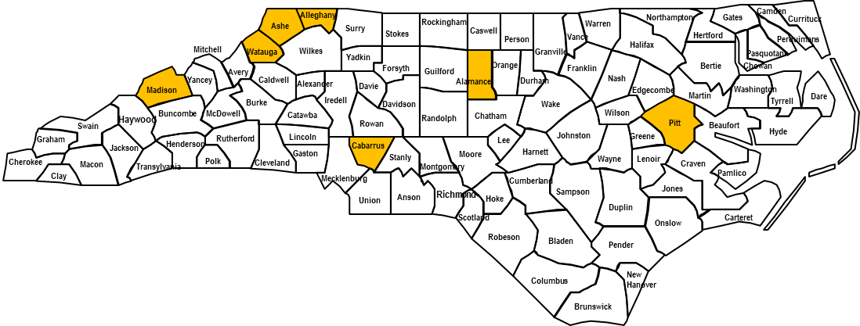

Figure 1.2 North Carolina Triple P System County Scale-Up Map, All Funding Sources, March 2013
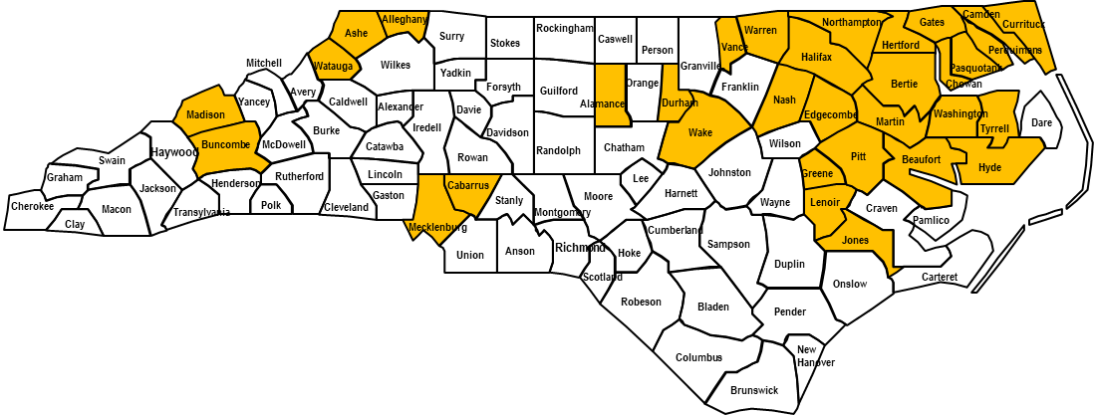

Figure 1.3 North Carolina Triple P System Regional Scale-Up Map Plus Non-scaling Triple P Counties, All Funding Sources, Early 2018. Note. Pale blue shading indicates non-scaling counties, except Wake County, which is a scale-up county; all other shading indicates scale-up counties.

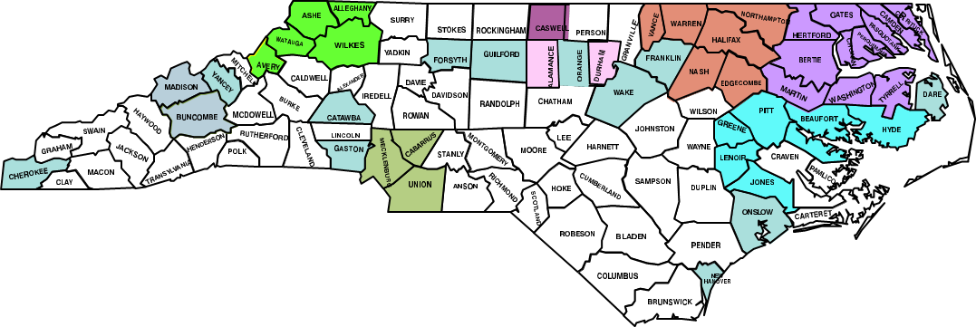

Figure 1.4 North Carolina Triple P System Regional Coverage Map, Early 2018. Notes. Black and red dots indicate locations of regional “lead implementing agencies.” In 2023, the Wake Triple P region merged into the Durham Triple P region, leaving nine total Triple P regions.
