Implementation Support Core Practice Components & Practice Activities
As described in “Historical Development and Current Status of the ICTP Practice Model,” the ICTP projects are based on a detailed model and robust theory of how external implementation support creates changes and how ISPs might influence implementation support practice outcomes over time. The ICTP implementation support practice model outlines 10 CPCs; these are believed to be the essential components, or active ingredients, of implementation practice. These CPCs are grounded in social cognitive theory and bolstered by 11 practice values and eight implementation support practice principles. In this section, we introduce two models that illustrate (1) the theory of change for how these CPCs work together to contribute to favorable practice outcomes and (2) the typical patterns through which these CPCs are used to co-design implementation support activities and influence changes at the regional level. We also introduce practice activities, which further operationalize the CPCs.

Core Practice Components
The 10 CPCs are listed in Table 6.2, along with their primary focus of change and most direct practice outcome(s). There are several key features of these CPCs to be aware of when using them in practice. Here we highlight two features that are central when considering ICTP implementation support at the regional level. (See Aldridge and colleagues [1] for a discussion of other important features.)

Table 6.2 Core Practice Components, Focus of Change, and Proximal Practice Outcomes
Core Practice Component | Primary Focus of Change | Proximal Implementation Support Practice Outcomes
Build collaborative relationships | Individuals, Teams | Working alliance
Reinforce leaders’ and teams’ self-regulation of effective implementation processes | Individuals, Teams | Self-regulation of effective implementation processes
Assess implementation capacity, implementation performance, and progress toward intended outcomes | Organization/System | Regional implementation performance goals on which to focus support
Facilitate collaborative agreements about implementation performance goals on which to focus support | Organization/System | Working alliance  Regional implementation performance goals on which to focus support
Provide learning to support leaders’ and teams’ acquisition of new implementation practice knowledge and skills | Individuals, Teams | Effective implementation practice knowledge, skills, abilities, and behaviors
Facilitate leaders’ and teams’ development of organizational and system implementation capacities | Organization/System | Regional Triple P capacity and performance for implementation and scale-up
Facilitate habituation and experiential learning related to the use of skills, resources, and abilities | Individuals, Teams  Organization/System | Effective implementation practice knowledge, skills, abilities, and behaviors  Regional Triple P capacity and performance for implementation and scale-up  Self-regulation of effective implementation processes
Provide supportive behavioral coaching to leaders and teams | Individuals, Teams | Effective implementation practice knowledge, skills, abilities, and behaviors  Self-regulation of effective implementation processes
Facilitate organizational and system learning and adaptive problem solving | Organization/System | Regional Triple P capacity and performance for implementation and scale-up  Self-regulation of effective implementation processes
Transition out of intensive implementation support | Individuals, Teams | Sustainment, under certain conditions

Multiple Pathways for Influencing Change
In Figure 6.2, we present a composite theory of change for external implementation support. This theory of change combines several smaller, elemental results chains—which describe how CPCs are used to influence individual practice outcomes—into an approximation of the whole picture. From this larger picture, we can see that CPCs are likely to influence practice outcomes in multiple ways. Practice outcomes (shown in shaded, lettered boxes) may be influenced through individual and combinations of CPCs (shown in unshaded, numbered boxes). For example, community leaders’ and teams’ implementation practice knowledge, skills, abilities, and behaviors may be influenced by ICTP regional support teams’ providing new learning to these support participants about effective implementation practices (CPC 5). At the same time, when ICTP regional support teams use combinations of CPC 5, CPC 7 (facilitate the habituation of skills, resources, and abilities), and CPC 8 (provide supportive behavioral coaching to leaders and teams) either in successive support interactions or over time, the potency of influence on community leaders’ and teams’ knowledge, skills, and abilities grows. Likewise, CPCs 7, 8, and 9 are likely to collectively influence leaders’ and teams’ self-regulatory abilities, particularly when used in combination with CPC 2 (reinforce leaders’ and teams’ self-regulation of effective implementation processes). These multiple pathways to influence practice outcomes can be helpful for tailoring support activities to a regional context.
Figure 6.2 A Composite Theory of Change for External Implementation Support, Adapted for the ICTP Projects [1]. Note. CPCs are shown in rectangles, numbered boxes; practice outcomes are shown in circles.
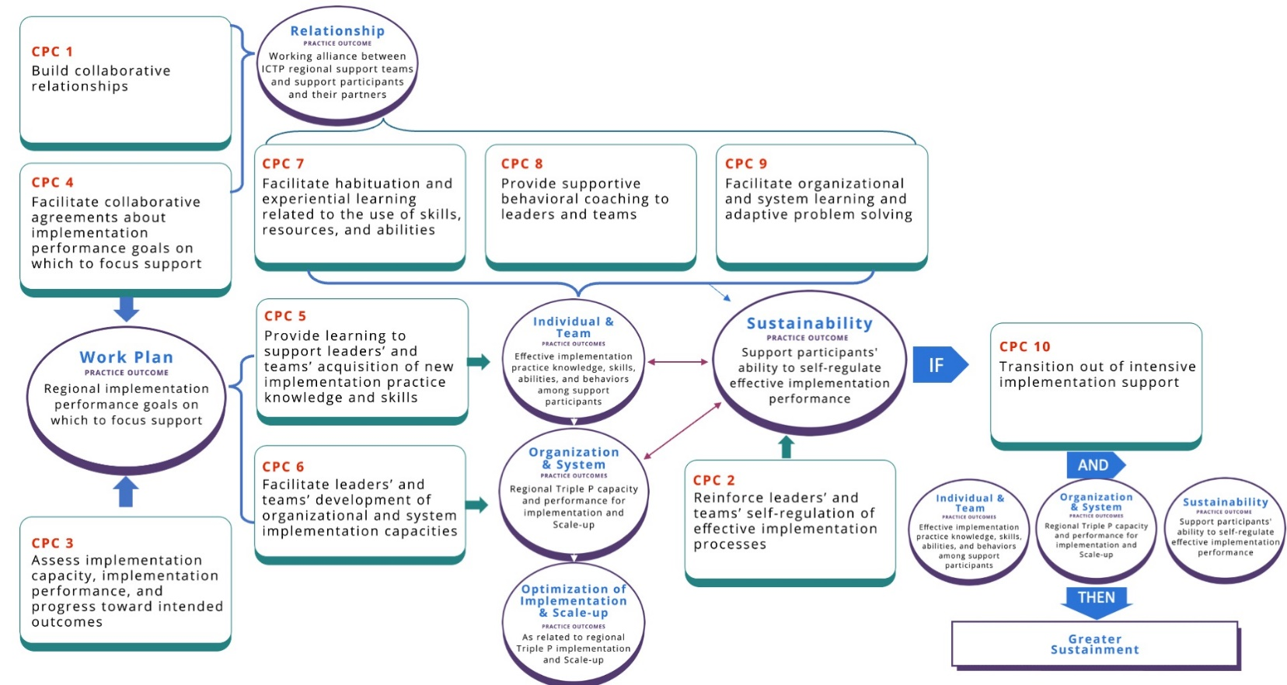

Patterns of Use to Influence Change at Multiple Levels
A second important feature of CPCs involves intentional patterns of use to influence practice outcomes at multiple levels. CPCs can be intentionally used by ICTP regional support teams to (1) co-design support processes, (2) influence behavior change at individual and team levels, and (3) influence learning and improvement at organizational and system levels [1].

Co-designing support processes. When co-designing support processes, ICTP regional support teams
- assess implementation capacity, performance, and progress (CPC 3) and
- use the results to facilitate collaborative agreements with regional Triple P partners about implementation performance goals on which to focus support (CPC 4).
For example, assessments may indicate that regional Triple P practitioners are not delivering Triple P to the extent expected or needed to meet community reach goals. If regional Triple P partners desire to work toward related performance goals, ICTP regional support teams can work with community leaders and implementation team members to co-design short-term support goals and activities that enable the region to develop the capacities they need to meet those performance goals and maintain them over time.

The necessity of delivering support at both individual/team and organizational/system levels of change is a well-described feature of external implementation support [5–11]. Table 6.2 indicates the primary focus of change for each CPC. In practice, however, ICTP regional support teams typically use CPCs in adaptive and dynamic ways, combining them within single or successive support interactions to influence change and improvement.

Individual and team levels. A typical pattern of CPC use to influence behavior change at individual and team levels involves ICTP regional support teams
- providing learning to support community Triple P leaders’ and teams’ acquisition of new implementation practice knowledge and skills (CPC 5),
- facilitating the habituation of skills and abilities among leaders and teams within their natural context (CPC 7), and
- providing supportive behavioral coaching to leaders and teams (CPC 8).

This pattern of practice components incorporates within the support process several best practices regarding adult learning [12].

Organization and system levels. A typical pattern of CPC use to influence organization and system performance improvements involves ICTP regional support teams
- facilitating community Triple P leaders’ and teams’ development of implementation capacity (CPC 6),
- facilitating the habituation of organizational resources and abilities (CPC 7), and
- facilitating collective learning and adaptive problem solving (CPC 9).

This sequence provides opportunities to shape or reshape organizational structures, policies, and procedures that will promote effective and equitable implementation.

In Figure 6.3, we depict the overall integration of these three typical patterns of implementation support practice, which are often cyclical and used in parallel. Co-design of support may occur initially and then be used periodically to monitor and adjust support goals and activities as improvement efforts begin. Additionally, as community Triple P leaders and implementation teams begin to enact individual and team behavior changes, they may use their new knowledge, skills, and abilities to shape or reshape organizational implementation capacities. Leaders and team members then put these capacities into use and actively manage them. ICTP regional support teams can then (1) provide supportive behavioral coaching for leaders and team members and (2) facilitate collective learning and adaptive problem solving with broader partners, who use these strategies to codify organizational learning and identify and address emergent adaptive challenges.

Because best practices in improvement science make use of small, iterative tests of change for learning and improvement [13], these support cycles repeat several times before ultimate performance goals are realized and support participants are ready to self-regulate and sustain implementation performance (CPC 10).

All three support cycles are only possible with strong working alliances in place. Additionally, these cycles depend on regional support teams reinforcing support participants when they demonstrate the ability to self-regulate effective implementation practices. As such, building collaborative relationships (CPC 1) and reinforcing leaders’ and teams’ self-regulation of effective implementation processes (CPC 2) are central to Figure 6.3 to indicate that they typically and necessarily occur continuously during these cyclical patterns of support practice.

For a more in-depth review of CPCs and the theory of change connecting CPCs to practice outcomes, including relevant literature and case examples from support engagements outside the ICTP projects, see Aldridge and colleagues [1]. In Brief 7, “Digging Deeper into the Implementation Support Practice Model at the Regional Level,” we delve further into these patterns of support practice, including a closer look at how combinations of CPCs interact to influence individual practice outcomes.

Figure 6.3 A Composite Model of the Primary Patterns of Core Practice Component Use in External Implementation Support. Note. CL = collective learning; APS = adaptive problem solving.
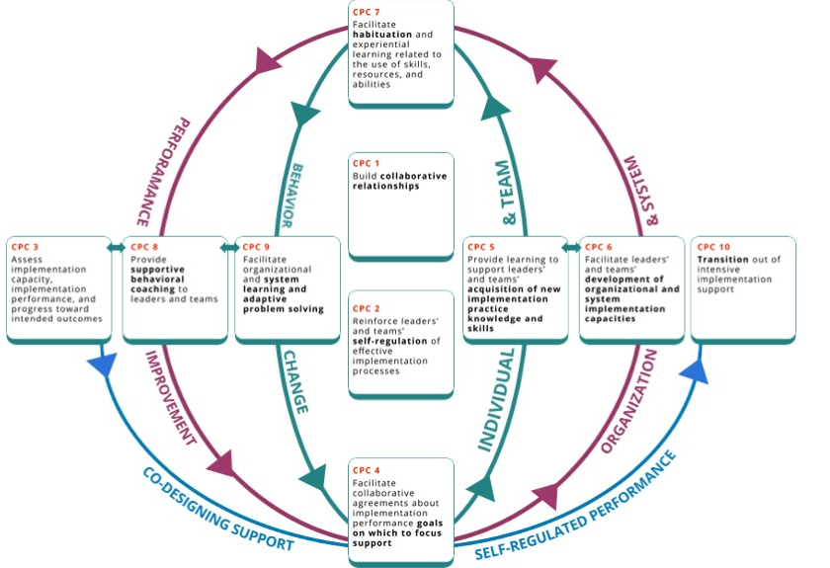

Practice Activities
To ensure that the 10 CPCs are usable and trackable by ISPs working in any project or practice setting, including ICTP regional support teams, several members of The Impact Center at FPG have worked over the years to operationalize each CPC. The approach has been to develop practice activities, defined as discrete behaviors and activities that ISPs may use to influence the intended outcomes of each CPC. The details of early efforts to operationalize the CPCs are described in the “Historical Development and Current Status of the ICTP Practice Model” section of this practice compendium and by Aldridge and colleagues in their report on the trajectory of ICTP implementation support practice activities over more than five years [14].

More recent sets of CPC practice activities identify essential activities and practice enhancers [14]. Essential activities are believed to directly contribute to the achievement of the near-term outcomes of each CPC. Practice enhancers are believed to accelerate or otherwise enhance the realization of near-term outcomes, even if outcomes may be sufficiently achievable in their absence.

In this practice compendium, we present the latest set of practice activities for each CPC (see Figure 6.4 and the “Practice Activity Deep Dive Resource” in Appendix C). For identification and tracking purposes, practice activities are labeled “[CPC number].[practice activity number]” (e.g., 1.1, 1.2, . . . 2.1, 2.2). Changes from the prior set of practice activities include clarified wording, adjusted identification of essential activities and practice enhancers, additional details about each practice activity, and the addition of two practice activities in CPC 8.

Practice activities may be used to proactively plan one or more consecutive support interactions. For example, with agreements in place about which performance goals to focus support on, ICTP regional support teams may plan to work with support participants to
- set new implementation practice learning objectives (5.1) and
- develop shared actions plans for capacity development (6.1), including to
      - provide structured learning that supports new implementation practice knowledge and skills (5.2) and
      - facilitate leaders’ and teams’ experiential learning activities to apply their new knowledge and skills (7.1).

However, practice activities do not happen in the context of proactive planning alone. Often, ICTP regional support team members find themselves responding to support participants’ needs, preferences, and requests in the moment. Similarly, windows may open suddenly for practice activities not previously planned, and ICTP regional support teams may pivot in the moment to take advantage. In these situations, following the support interactions, ICTP regional support teams may retroactively identify the applicable CPC(s) based on the practice activities used.

Regardless, due to the dynamic nature of implementation support practice, support interactions typically draw from practice activities across CPCs. ICTP regional support teams are not expected to stick to exhaustive sets of practice activities within one or more CPC, and they may unintentionally decrease the effectiveness of support interactions by doing so. Proactively or responsively combining individual practice activities across CPCs allows ICTP regional support teams to tailor support interactions, respond to specific situational cues or needs, and influence more than one practice outcome at a time [14]. As described by Aldridge and colleagues [14, p. 3]:
This approach recognizes the often-dynamic nature of implementation practice, the high level of flexibility and adaptation needed within any given support interaction, and places a premium on ISP experience, judgement, intuition, and skill. Likewise, training and coaching for ISPs and the application of this model in accordance with its guiding theory and practice principles becomes particularly important.
Aldridge and colleagues [14] believe that using the CPCs with fidelity in this dynamic practice model requires ongoing attention to the 38 essential activities and alignment with the underlying theories, values, and principles of the practice model. Future research and evaluation activities will be needed to better operationalize and test these assumptions.

In the next brief, we “dig deeper” into the typical patterns of implementation support practice, as illustrated in Figure 6.3, and provide a more detailed discussion of the practice activities within each CPC. Refer to Brief 7, “Digging Deeper Into the Implementation Support Practice Model at the Regional Level.”

Additional discussion about the dynamic nature of implementation support practice and using the ICTP practice model to tailor support processes is provided in the next section.

