Co-creation Partners & Processes
Metz and Bartley [5] defined co-creation for public services as
the active involvement of stakeholders in all stages of the production process resulting in a shared body of usable knowledge across scientific, governance, and local practice boundaries. From this perspective, the use of evidence is often a result of iterative, messy, and dynamic interactions among public agencies, policymakers, researchers, intervention developers, practitioners, communities, and families. (p. 117)
Metz and Bartley further described several conditions that foster co-creative processes, the foremost being the ability to leverage collaborative relationships and draw on interpersonal contacts between and within partner groups at multiple system levels. Other conditions that foster co-creation, according to Metz and Bartley, include
- taking into account multiple perspectives and all factors when defining problems;
- jointly developing models of analytic tools through repetitive processes and learning;
- “zooming in” on the needs of users of research evidence; and
- “zooming out” to promote systems thinking among key stakeholders. (p. 119)

The result of co-creation partnerships and processes is what Metz [18] describes as co-creative capacity, a “joining of scientific resources, governance capability, and adaptive leadership at multiple and whole systems levels to create the infrastructure and conditions needed for the sustainable use of evidence” (p. 1).

Features of co-creation partnerships and processes can be traced back to foundational principles of ecological systems theory, social cognitive theory, and collective behavior and learning theories. Although a description of these theories is beyond the scope of this brief, they all recognize the importance of choice, systems, context, and lived experience as central lenses through which interventions research and practice should be approached [19–23]. Furthermore, these theories view behavior as a response to and interaction with a complex, multilayered system context [19, 20].
DIVE DEEPER

Download
Brief #5: Foundations of the ICTP Implementation Support Practice Model, section Theoretical Underpinnings (docx) for more info on:

- Social Cognitive Theory in Action: Reciprocal Determinism

To dive deeper into these theories, refer to Dive Deeper sidebar.

These perspectives highlight the importance of understanding the contexts in which interventions are being implemented, the people implementing the interventions, and the interactions within and across different levels of the system to ensure implementation success [24–26]. In addition to its vital role in human services, co-creation is an essential process in business, design science, and technology development.

Key Features of Co-creation
Co-creation processes necessitate working alongside multiple system partners to develop and design approaches that blend each partner’s experiential and content knowledge. Approaches developed through such processes are more likely to be implemented with success—for example, with fidelity and sustainability—and to yield positive outcomes. For more information, see person-centered planning approaches (e.g., [25, 27, 28]).

Metz [18] originally conceptualized the range of partners necessary for sufficient co-creation processes during implementation and scale-up to include
- service provider organizations,
- funders and policymakers,
- intermediary and purveyor organizations,
- community members and consumers, and
- program developers and researchers.
When the full range of co-creation partners are actively and equitably engaged, the value and need for services and the ways in which they are implemented are defined in more effective, sustainable, and culturally relevant ways. All co-creation partner voices, but particularly those of community members and families, must be empowered, invited, and supported to speak about system characteristics, the potential impact of policies and practices, and community values and needs. Collectively, co-creation partners build a vision for the work and ensure aligned leadership and management, delivery support, and problem-solving forums to support change.

When this process is working well, co-creation partners are
- actively engaged and supported across the full range of implementation stages to build, organize, align, and refine the capacities needed for effective implementation (see Figure 3.1);
- contributing time, effort, connections, funds, and other resources to nurture the ongoing development and sustainment of system-wide implementation capacities; and
- welcoming and creating safe spaces for other co-creation partners to contribute to the system environment.
Furthermore, when co-creation processes are successful, knowledge is expanded, alliances are strengthened, services and outcomes are improved (see Figure 3.1), and communities and service systems thrive [29].
DIVE DEEPER
Learn more on co-creation structures, refer Brief #1: NC Triple P System,
- Download Section Interactive Systems (Word docx) for more information on the NC Triple P Learning Collaborative and Design Team
- Download section Scale-Up Plan and Strategic Planning (Word docx) to learn more on Community Leadership Teams in the NC Triple P Model Scale-Up Plan.

Ensuring effective co-creative processes requires deliberate and resourced attention to co-creation. This includes
- creating opportunities for partners to self-organize into meaningful co-creative roles;
- developing and maintaining effective co-creation structures (e.g., learning collaboratives involving system partners from multiple levels, community leadership teams involving community partners from multiple levels or roles, system teams that integrate co-creation partners for design and decision making);
- centering the importance of relationships, diversity, equity, inclusion, communication, and transparency in teaming structures, group agreements, norms, and values;
- defining what co-creation looks like (e.g., roles, behaviors, processes, goals);
- continually assessing how engaged and supported stakeholders are in sharing perspectives and new knowledge for the development of system implementation capacities; and
- learning and improving co-creation processes with process checks and feedback loops.

Key Features of Co-creation Partner Roles
The key features of co-creation partner roles as identified in the ICTP integrated theory of change and described below are not intended to be comprehensive. Individual co-creation partners may serve a variety of unique and shared functions. Furthermore, the nature and intensity of partner roles may shift and change over time as Triple P implementation and scale-up progresses.

Community Members, Families, & Partners
EQUITY IN ACTION

Download Brief #5: Foundations of the ICTP Implementation Support Practice Model, Section Equity in Implementation Practice (docx) for additional discussion on equity in implementation practice.
As the only partner group not connected to community Triple P systems through professional or paid roles, family and community members are unique co-creation partners. Because they are the primary consumers and beneficiaries of community-based programs like Triple P, families and other community members are best positioned to speak to the community’s history, needs, priorities, and values related to parenting and family supports. Family and community members need to be engaged in defining why, how, and to what end Triple P programs might be regionally adopted and implemented. They are also best positioned to communicate with other community members about the value or benefits of programs like Triple P, both personally and for the community as a whole.

Because family and community members are not connected to community Triple P systems through professional or paid roles, they are also at risk for being positioned in purely extractive roles: feeding information and other personal or cultural investments into community systems without structural support, recognition, or compensation. This can reinforce existing inequities and indignities, even if unintentional. Structural considerations to ensure that the participation of family and community members is both meaningful and dignified must be made to prevent this from happening. Examples of structural mechanisms that might be considered include compensation policies for families and community members, standardized procedures for providing childcare and travel support, and explicit opportunities for family and community members to be recognized within leadership roles alongside other system leaders involved in co-creation processes.

Integrating families and community members into programmatic and implementation decisions, particularly in response to identified trends in disaggregated data from the community, ensures that their needs and preferences are accommodated, often resulting in higher community reach. Integrating community members into key implementation processes (e.g., leading and supporting Triple P scale-up, gathering and using data for decision making, developing competent and confident practitioners, mobilizing Triple P beyond direct practitioner delivery) ensures that the community’s strengths and assets are capitalized on, often resulting in greater appropriateness and stronger sustainability of regional Triple P scale-up.

Defining family and community member functions in implementation and scale-up has benefited from prior practice engagements. For example, prior partnerships between The Impact Center at FPG and community partners have helped operationalize key functions related to community members’ participation in implementation and scale-up. Collaborative reflection and writing activities held with community and system partners addressing institutional racism, historical community trauma, and racial disparities in the California child welfare system suggested key community member functions to ensure a more equitable approach during implementation [30]. And results from the TPIE-Qualitative evaluation, which focused on scaling Triple P in the Carolinas, suggested key community member functions specifically related to Triple P scale-up [31]. These functions are detailed in Table 3.1.

Table 3.1 Family and Community Member Functions in Implementation and Scale-Up
Family and Community Member Functions to Ensure a More Equitable Approach During Implementation [30] | Family and Community Member Functions Related to Triple P in the Carolinas [31]
Listening to learn about and begin to address historical trauma (historical maltreatment of families in key communities identified by social factors such as race or income level), mistrust of agencies and systems, and other longstanding and institutional barriers to safety, health, and well-being | Providing feedback and supporting continuous quality improvement of Triple P delivery at service provider, county, and state levels
Working with community members to identify systemic barriers to improved outcomes for children and families and implement action plans to address those barriers | Catalyzing Triple P engagement within their communities by word-of-mouth advertising, sharing positive experiences, and transferring Triple P learning and parenting skills to community parents and partners
Collaborating with community members to establish culturally relevant supports and services to meet the underlying needs of children and families | Championing Triple P with local, county, and statewide partners
Meaningfully involving community members in practitioner professional development activities and community design teams for effective, sustained implementation | Fully participating in Triple P implementation structures, such as decision-making bodies that select which Triple P programs to adopt or adapt locally
Ensuring partnership meetings, forums, and feedback loops are sustained so that community members are continuously connected to and help guide practice and system changes
Of particular note from the TPIE-Qualitative evaluation is that participants suggested an overall need for more actively and purposefully engaging families and community members in local Triple P implementation activities and decision making [31]. To this end, the ICTP projects apply the “community engagement to ownership” model for decisions directly related to community programmatic and implementation processes (sample in Figure 3.2 and related resources in Appendix F; [32]). Based on this model, ICTP ISPs strive to influence co-creation processes that reflect a stance of “collaborate” at all times and that have an impact of “community ownership” when possible and most important.

Figure 3.2 The Spectrum of Community Engagement to Ownership [32, p. 2] Available in “community engagement to ownership” model document, page 2.
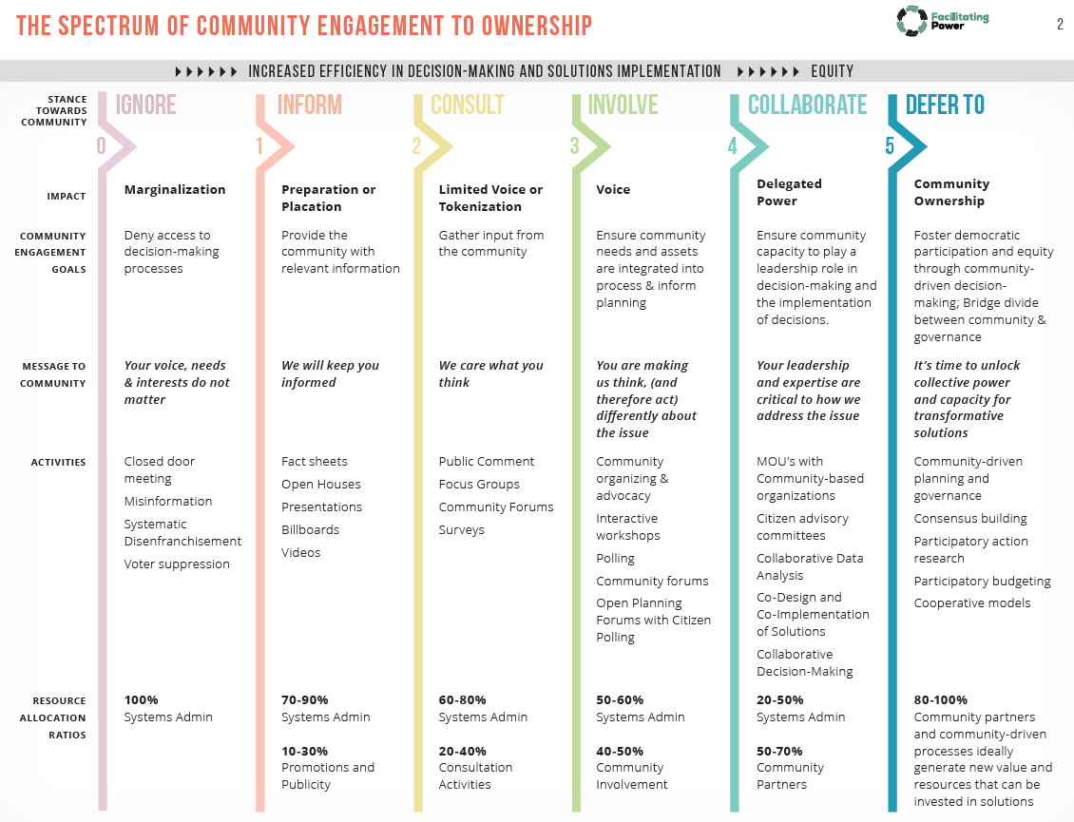

Strategies for engaging families and community members in Triple P implementation and scaling activities include
- using asset mapping and other data-collection methods to identify all families that the community Triple P initiative needs to serve and how best to engage them;
- establishing shared purposes and goals, while balancing them with responsive and flexible approaches [29];
- presenting information as ideas to get started rather than final decisions;
- empowering new partners to share their voices and perspectives on how activities will unfold;
- making intentional efforts to advance community partnerships high on the spectrum of community engagement to ownership (see Figure 3.2);
- financially compensating community members for their participation in co-creation and other Triple P implementation activities;
- integrating families and community members into community Triple P leadership and other teaming structures to ensure meaningful connections to the system; and
- developing written partnership engagement plans to guide and monitor the progress of partnerships with families and community members.

For additional community engagement strategies that have demonstrated the ability to increase Triple P program fit and reach, see Sanders and Kirby [33]. For more detailed information about engaging and supporting family members as co-creation partners, see the ICTP online microlesson, Families as Co-creation Partners. A case example of one NC Triple P region’s efforts to bring families and community members into their community Triple P leadership team is available in the December 2022 issue of The Implementeer.
EQUITY IN ACTION

The expertise of leadership, staff, and practitioners within community service organizations that belong to minoritized racial or ethnic groups will allow them to provide essential insight into the needs and experiences of families who participate in Triple P. However, they should not bear the burden of racial translation for other colleagues. Often, in the absence of readily available learning mechanisms, operationalizing racial equity becomes the job of minoritized staff. Organizational supports for racial equity learning and application among all staff will mitigate this risk.” Refer to Brief #5: Foundations of the ICTP Implementation Support Practice Model, download Section Equity in Implementation Practice (docx) for additional discussion on equity in implementation practice.

Service Provider Leadership, Staff, & Practitioners
Leadership, staff, and practitioners within community service organizations have essential insight into the needs and experiences of families who participate in Triple P. As such, they can provide particularly helpful perspectives about, and support, several key Triple P implementation factors and functions.

Leadership, staff, and practitioners engage in conversations about, and foster readiness for, Triple P implementation and scale-up at local levels. Local readiness for implementation can be understood as an ongoing combination of partners’ commitment to necessary change processes and their collective belief that they can make the required changes [34]. Several factors may influence readiness, such as the value placed on making the necessary changes, potential task demands, resource availability, and relevant situational factors.

Leaders and staff within community service organizations must also ensure several leadership and coordination functions for implementing Triple P in their organizations [35]. For example, an organization’s Triple P executive leaders can support success and sustainability by (1) demonstrating ongoing commitment to organizational and systems change processes and the inclusion of community partnerships, and (2) actively creating and nurturing opportunities for change [35].

Service provider leadership and staff may also contribute to community Triple P efforts by helping ensure that (1) Triple P and related family support programs are well aligned and usable by practitioners and families, (2) community-wide policies and practices facilitate delivery of Triple P interventions as intended, and (3) service changes and successes are well communicated across partners and community members [35].

Finally, teams managing Triple P program implementation within and across community service provider organizations can support success and sustainability by (1) organizing, aligning, and sustaining the necessary infrastructure to support Triple P implementation, and (2) actively using data and other information for Triple P implementation quality improvement [35].

Institutionalizing, or embedding, these leadership, management, and coordination functions within team structures across community service provider organizations is an essential part of developing and sustaining local implementation capacity and performance [7, 35, 36]. Moreover, continually integrating the unique perspectives of service provider leadership, staff, and practitioners into Triple P implementation activities strengthens community efforts and supports more hospitable climates for scaling Triple P [11].

State/Local Funders & Policymakers
State and local funders and policymakers have important roles in creating nurturing system environments for community Triple P scale-up. In particular, key functions include [37]
- ensuring the availability of adequate financial resources to develop implementation capacity and support the delivery of Triple P,
- ensuring adequate time and space to reasonably expect community efforts to translate into population-level outcomes, and
- setting expectations and providing resources for monitoring quality and outcome across all levels of the Triple P system.
Like service provider leaders and staff, funders and policymakers must also play active and engaged leadership roles by (1) demonstrating ongoing commitment to necessary change processes and equitable change partnerships, and (2) creating and nurturing opportunities for change within state and local service systems. This often means identifying, leveraging, and/or changing administrative and legislative policies that may be facilitating or hindering successful scaling efforts or perpetuating systemic inequities that lead to disparities. Funders and administrators also support and participate in statewide learning collaboratives, statewide implementation support partnerships, and statewide communication campaigns.

Finally, research consistently demonstrates that administrative and legislative policymakers in implementation are more effective when they develop broad political and administrative support by engaging multiple partners, such as community service providers and academic institutions, rather than forcing top-down approaches or using mandates [38, 39].

Triple P America & Intermediaries
Triple P America (TPA) is the U.S.-based purveyor of Triple P training, materials, and implementation support. Triple P International published the Triple P Implementation Framework (TPIF), which details TPA’s roles in supporting Triple P implementation and sustainability [40]. TPIF details five phases of activities for TPA to engage in with local service partners adopting Triple P interventions:
- Engagement: Initial interactions with community stakeholders to explore if Triple P is a good fit for the community’s goals and needs
- Commitment and Contracting: Confirmation of the scope of Triple P implementation and facilitation of written agreements for training, resources, and support
- Implementation Planning: Collaboration on creation of an implementation plan, including plans for communications, training and accreditation, service delivery, quality assurance, and evaluation
- Training and Accreditation: Delivery of standardized training and management of the accreditation process for practitioners
- Implementation and Maintenance: Engagement in feedback cycles with community partners around service delivery, quality improvement, ongoing development, and sustainability mechanisms

Across these five phases, TPA helps to support organizational leaders’, managers’, and practitioners’ professional development to improve their delivery of Triple P interventions as intended, ensure quality, enable outcome monitoring, and contribute to the development of local program capacity to support and improve Triple P implementation.

To accomplish its roles, TPA works closely with intermediary organizations. These organizations differ from program purveyors in that they support the implementation of more than one evidence-based program or practice and, therefore, typically have a more expanded role than program purveyors [41]. They are often housed within academic institutions or nonprofit organizations. As defined by Mettrick and colleagues [42], an intermediary organization
supports service array development through implementation technical assistance, creative financing options, training, coaching, education, continuous quality improvement monitoring, and outcomes evaluation. [An intermediary organization] connects providers, state agencies, local jurisdictions, and purveyors to ensure that effective implementation leads to improved outcomes and builds on existing systems reform efforts. (p. 3)

Unlike program purveyors, which typically have a national or international presence, intermediary organizations are usually located within the same region as implementation sites and are therefore able to serve more specialized functions. Following the model of a Center of Excellence Learning Community funded by the Annie E. Casey Foundation, Mettrick and colleagues [42] detailed five core functions for intermediary organizations:

- tailored implementation support for evidence-based programs;
- research, evaluation, and data-linking;
- partnership engagement and collaboration;
- workforce development activities (including practitioner training and coaching); and
- policy and finance expertise.

Intermediary organizations do not replicate the role of state agencies or program purveyors; rather, they work in concert with state agencies, funders, and program purveyors to support the achievement of common goals. Where functions or activities overlap among any co-creation partners, it becomes essential to develop clear agreements about roles and how to support synergistic, rather than duplicative, work patterns.

Within the context of the ICTP projects, The Impact Center at FPG serves as an intermediary support structure to provide information, consultation, and tailored implementation support to NC regions and state partners in both North Carolina and South Carolina scaling‐up Triple P.

Triple P Developers & Researchers
Triple P developers and researchers have both proactive and responsive roles relative to the implementation and scale-up of Triple P. Proactively, Triple P developers need to ensure that Triple P programs and strategies are equitable and usable within community prevention and intervention systems [36, 43–45]. Interventions that meet usability criteria are regarded as teachable, learnable, doable, repeatable, and assessable in practice [44, 45]. Triple P researchers have a key role in ensuring that Triple P programs and media strategies are, and remain, evidence-based. This was one of the most widely identified roles of Triple P researchers during the TPIE-Qualitative evaluation [31]. As identified in TPIE-Qualitative, Triple P researchers also have ongoing roles in (1) making the Triple P evidence base accessible and usable to state and community partners and (2) using naturally occurring implementation efforts as opportunities to test and refine Triple P implementation strategies.

