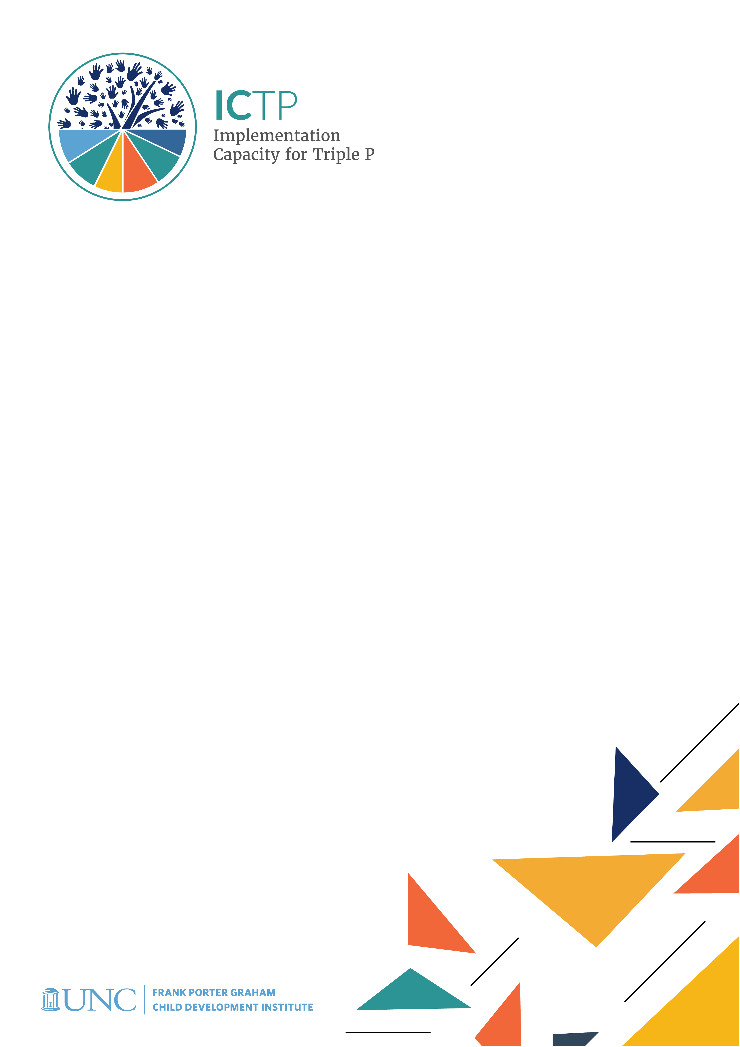

BRIEF 4

ICTP Implementation

Support Practice Model: Background & Development

Acknowledgements
Development of the ICTP Implementation Support Practice Compendium was supported by the following funding sources:
- The Duke Endowment Grant Agreement No. 2081-SP, The Implementation Capacity for Triple P (ICTP) Projects in North Carolina and South Carolina.
- The North Carolina Department of Health and Human Services, Division of Social Services Contract Numbers 00042356, 00044072, and 00045540, North Carolina Implementation Capacity for Triple P Project.

The authors would like to acknowledge all current and former team members of The Impact Center at Frank Porter Graham Child Development Institute for their contributions to the development and improvement of the practice model represented in the ICTP Implementation Support Practice Compendium. For their reviews, feedback, copyediting, and formatting support, we would like to acknowledge Rona Bernstein of PsycEditing; Kamilah Pickett and Paula Dressel of Race Matters Institute at MDC; and Jennifer Robinette, Julie Chin, LaMana Donadelle, and Lindsay Holland of the ICTP Projects Team, Frank Porter Graham Child Development Institute, UNC-Chapel Hill.

The authors would like to acknowledge Rohit Ramaswamy for his mentoring around theorizing in implementation science.

Suggested citation: Aldridge, W. A., II, DiSalvo, C. I., Banks, C. R., & the members of the ICTP Projects Team (2024, May). ICTP implementation support practice model: Background and development (ICTP Implementation Support Practice Compendium, Brief No. 4). University of North Carolina at Chapel Hill, The Impact Center at Frank Porter Graham Child Development Institute. https://ictp.fpg.unc.edu/wp-content/uploads/background-and-development-of-the-ictp-implementation-support-practice-model.docx

Christina DiSalvo is now at The Duke Endowment.

The members of the ICTP Projects Team include Principal Investigator William A. Aldridge II; Co-Principal Investigators Christina I. DiSalvo and Jessica J. Reed; Co-Investigators Rebecca H. Roppolo, Sandra J. Diehl, Renée I. Boothroyd, Capri R. Banks, Tamara Robertson, Devon R. Minch, Rohit Ramaswamy, Wendy M. Morgan, and Ximena Franco-Jenkins; and additional team members Shannon D. Chaplo, Sherra C. Lawrence, Kimberly R. Maloney, Marais Pletsch, Ariel B. Everett, Alana Gilbert, Jennifer B. Robinette, Julie Chin, LaMana Donadelle, Andrea Ross, Christine C. Harradine, Lindsay Holland, Margaret Sullivan, and Meera Kumanan.

Correspondence concerning the ICTP Implementation Support Practice Compendium should be addressed to Will Aldridge at FPG Child Development Institute, University of North Carolina at Chapel Hill, CB #8180, Chapel Hill, NC 27599-8180, USA or via email, will.aldridge@unc.edu, phone, 919-966-4713, or fax, 919-966-7532.

ICTP Implementation

Support Practice Model: Background & Development

In this brief, we provide a concise overview of implementation science to serve as context in which to understand the Implementation Capacity for Triple P (ICTP) implementation support practice model, a detailed approach for supporting Triple P implementation and scale-up in the Carolinas. Following this, we describe the development and status of the ICTP implementation support practice model. A starting point to appreciating implementation science and its use as the foundation of the ICTP projects is understanding that the field originated to address critical challenges that persist today regarding the implementation of evidence-based prevention programs.

Evidence-based prevention programs offer a great deal of promise to support the health and well-being of children, youth, families, and communities. Many funders and service providers have shifted toward program models that have demonstrated (a) positive impact through rigorous evaluations and (b) positive outcomes with regard to choice, fit, and feasibility within adopting locations.

However, in the context of established health, well-being, and prevention systems, the implementation and scale-up of these innovations can be challenging. Implementation is defined as “a specified set of activities designed to put into practice an activity or program of known dimensions” [1] (p. 5). Scale-up refers to systematic approaches used to increase intervention coverage, range, and sustainability [2]. Scale-up can occur both vertically (i.e., involving multiple system levels) and horizontally (i.e., spread across individual or cross-sector networks). For example, a program can expand from a successful local program into regional, national, or international levels.

One reason implementation and scale-up often prove challenging is that despite their best intentions, longstanding, complex, and fragmented service systems tend to revert from innovation back to past practices. Additionally, structural inequities that result in the marginalization of diverse community, family, and practitioner voices often limit the optimization of scale-up. These challenges continue to prevent evidence-based strategies from yielding intended outcomes. To address challenges related to implementation and scale-up, the ICTP projects utilize implementation science and related equity-informed practices to develop methods, materials, and opportunities to support statewide partners and local communities in North Carolina and South Carolina to successfully and sustainably scale the Triple P – Positive Parenting Program (Triple P) system of interventions. Our long-term goal is to support our partners to realize intended population-level benefits while substantially reducing or eliminating disparities among children, families, and communities, at least insofar as Triple P implementation and programmatic opportunities may afford.

More specifically, the ICTP projects leverage
- current research and effective practices from implementation science, particularly those that reinforce health equity and may help counteract historical system and community inequities;
DIVE DEEPER
Refer Brief #2: NC Triple P Implementation Evaluation, for more information.
- mixed-methods evaluation findings from the North Carolina Triple P Implementation Evaluations (TPIE and TPIE-Qualitative); and
- partnerships with statewide stakeholders involved in scaling-up the Triple P system.

In the next section, we offer a brief synopsis of the components of implementation science as they pertain to the ICTP projects.

Implementation Science: Research & Practice
Implementation science is defined as “the scientific study of methods to promote the systematic uptake of research findings and other evidence-based practices into routine practice, and, hence, to improve the quality and effectiveness of health services and care” [3]. In accordance with this definition, implementation science is evolving into a field that recognizes both research and practice activities (see Figure 4.1; [4]). Implementation research focuses on developing and testing generalizable approaches to applying effective interventions (e.g., programs, practices, and policies) in typical human service settings. Implementation practice focuses on tailoring and applying those approaches within context-specific settings to achieve intended outcomes. Implementation research and practice also entail developing innovative interventions or adapting existing effective interventions in real-world practice settings. Implementation research and practice operate on a common set of implementation outcomes: adoption, feasibility, appropriateness, fidelity, acceptability, reach, cost, and sustainability [5].

Figure 4.1 The Two Equally Important Components of Implementation Science [4, p. 2]
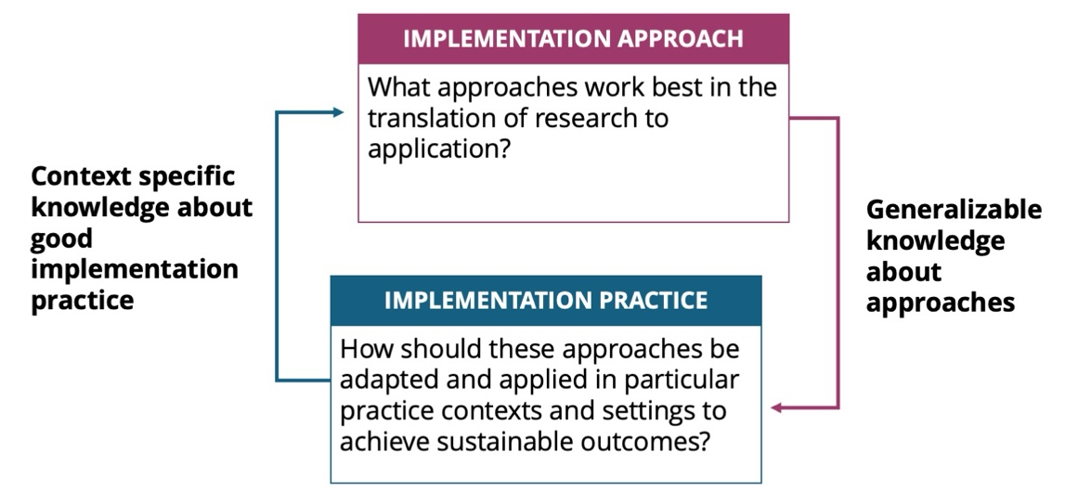

In implementation practice, the focus of much of this compendium, the goal is not discovering whether things could work, but rather engineering strategies and approaches that enable things to work within specific contexts and for involved partners [6]. The focus is on figuring out how, rather than examining whether, success can be achieved. To these ends, the ICTP projects align with the view that implementation practice is a process that “involves multiple decisions, actions, and corrections to change the structures and conditions necessary to implement and sustain new practices and programs successfully” [7].

Among the partners engaged in implementation practice are implementation support practitioners (ISPs) [8]. ISPs draw from widely recognized disciplines—such as technical assistance, practice facilitation, system coaching, change agency, and knowledge brokerage—that aim to move research into practice and policy. Metz and colleagues [9] explain that ISPs
. . . can reside outside the service systems they work in but may also operate from within a service system when those systems have internal work units specifically designed to support innovation, implementation, improvement, and/or scaling efforts [e.g., implementation teams]. Implementation support is often delivered through partnerships between professionals residing inside and outside public service systems. (p.239–240)

The ICTP implementation support practice model, described below, was designed by Aldridge and colleagues [10] for ISPs who reside outside the service systems in which they work. Thus, this approach is referred to as external implementation support (EIS). EIS is aimed at influencing internal practice change and improvement among people, processes, and structures. As a form of implementation practice, EIS has been characterized as “both proactive and responsive in nature and usually involves a combination of implementation science and skills training, facilitation, and supportive behavioral coaching for individuals, groups, and organizations” [6, p. 192]. Through EIS, ISPs foster the partnerships and conditions needed for internal change agents to implement and scale-up effective interventions successfully and equitably.

Historical Development & Current Status of the ICTP Practice Model
In 2016, Aldridge and colleagues [11] identified seven implementation support practice principles and 10 core practice components for EIS. Members of the ICTP projects team within The Impact Center at FPG then translated these principles and components into a tailored model of implementation support for the North Carolina ICTP project [12]. We updated this community-based implementation support practice model (which we’ll refer to as simply the “practice model”) in 2018 [13].

In addition to the 2018 update, we made several other revisions and additions to the practice model between 2016 and 2020, largely in response to training and supporting ICTP regional support specialists in their application of the practice model in the field. At the most basic level, we adjusted the names and groupings of core practice components to increase understanding and utility. Similarly, we modified the names and definitions of implementation support practice principles and added an eighth principle (stage-based approach). More substantively, we added a theory of change detailing the influences of core practice components on key practice outcomes, greatly enhancing the model’s utility with regard to how ISPs might use individual and combinations of core practice components to influence specific practice outcomes [10].

Another major development was the operationalization of core practice components through the addition of corresponding practice activities. A practice model leadership team within The Impact Center at FPG met frequently over two years to develop and refine practice activities based on feedback from ICTP regional support specialists. This resulted in three sets of practice activities being used in the ICTP projects—one from August through December 2017, a second from January 2018 through June 2019, and a third from July 2019 until the publication of this practice compendium.

The third set of practice activities was particularly noteworthy for the identification of essential activities and practice enhancers [14]. Essential activities are those believed to directly contribute to the achievement of the near-term practice outcomes of each core practice component. Practice enhancers are those believed to accelerate or otherwise enhance the realization of near-term practice outcomes, even if those outcomes could be achieved in their absence. The early details of the evolution and application of core practice components are well reported by Aldridge and colleagues [14] in their examination of the trajectory of EIS within the ICTP projects over more than five years.

Most recently, several events, developments, and decisions have led to the version of the ICTP practice model detailed in this practice compendium. First, from April through August 2021, members of The Impact Center at FPG met for deep dives into each core practice component. These sessions involved reflecting (again) on key background literature, reviewing several years of data from the ICTP projects, looking at examples of core practice components in action, and determining how to clearly differentiate between similar practice activities across core components. This led to our further refinement of the language and enhanced understanding about how core practice components could be used to drive regional practice outcomes at individual/team and organization/system levels.

In late 2021, ICTP project team members adopted 11 practice values, complementing the eight implementation support practice principles. Figure 4.2 demonstrates how the 10 core practice components are nested within the eight implementation support practice principles, which are further nested with the 11 practice values.

Figure 4.2 Nesting of ICTP Practice Values, Implementation Support Practice Principles, and Core Practice Component
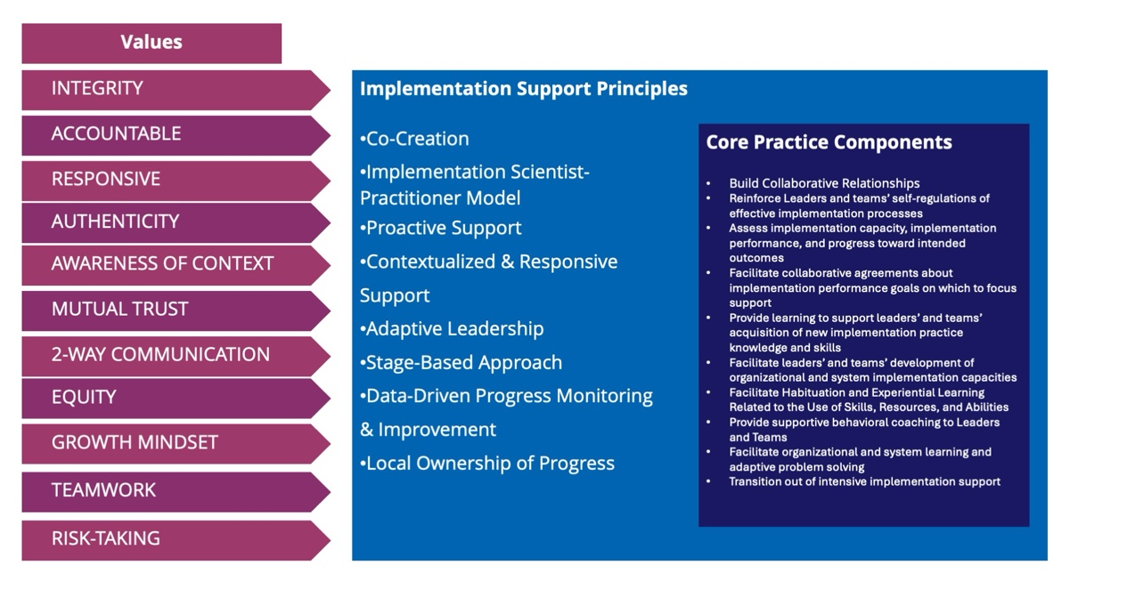

Shortly thereafter, several members of the ICTP project team wrote two journal articles that laid the foundations of the regional practice model in the peer-reviewed literature. The first article [10] focuses on the theoretical and conceptual foundations of the practice model, with a particular focus on the core practice components as mechanisms of change in implementation support practice. The second article [14] details the development of practice activities and reports the results of a study in which ICTP regional support teams across NC and SC Triple P regions used core practice components and practice activities for more than five years. This study illustrated the typically dynamic use of core practice components and practice activities by ICTP regional support teams and indicated the need for some refinements among the then-current set of practice activities.

These developments were then carried into The Impact Center at FPG’s sixth Foundational Professional Development Series on Implementation Science and Practice during spring/summer 2022. This training and mentoring series enabled ICTP project team leaders to develop and test new ways of teaching the regional practice model and receive feedback from learners.

In parallel to these recent events, the ICTP practice model has evolved by instituting
- a three-tiered model of regional support, detailing objectives, activities, and characteristics of Triple P regions participating in intensive/broad-focused support, brief/narrow-focused support, and universal support;
- a more robust agenda for media and networking activities focused on spreading effective implementation practices, including analyzing the relationships between system partners in both North Carolina and South Carolina and engaging in a variety of communication activities meant to complement direct EIS provided by ICTP regional support teams;
- “design and consultation support,” provided by ICTP implementation support specialists to state and regional partners to enhance implementation design and address specific challenges or changes;
- a more complete set of resources for learning and applying effective implementation practices for Triple P in the Carolinas, including comprehensive sets of implementation practice learning objectives and related practice tools for regional Triple P partners; and
- a more feasible and useful ICTP practice quality and outcome monitoring system, designed to improve ICTP implementation support through data-based decision making.

A timeline summarizing the major development activities for the ICTP implementation support practice model is provided in Figure 4.3 below.

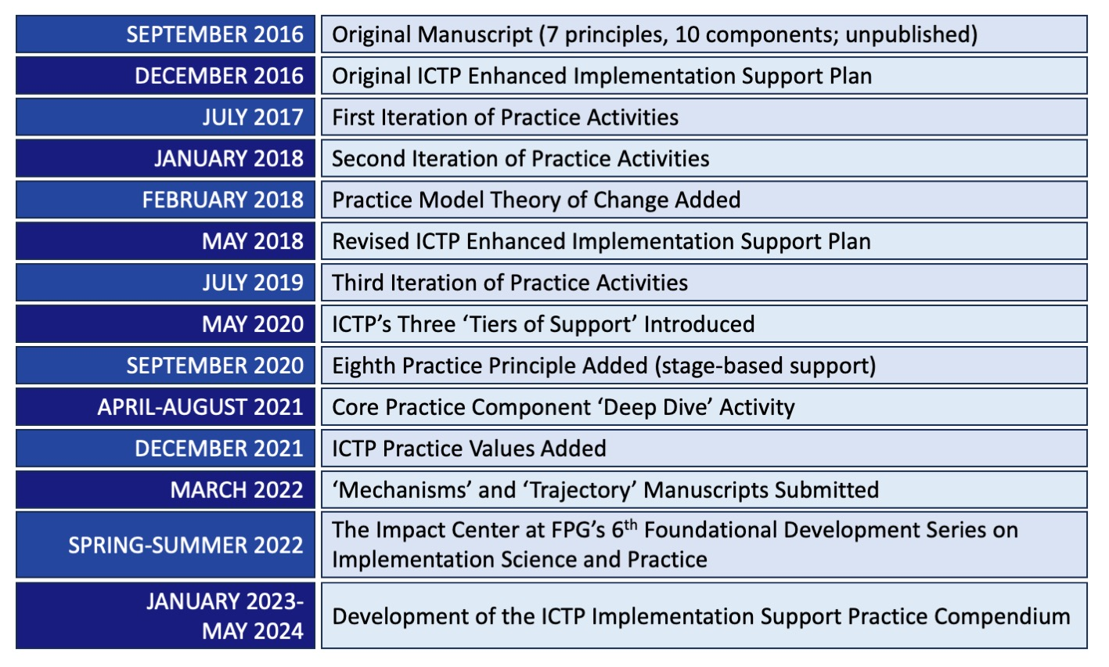

From the start, we’ve characterized our overarching approach to development of the practice model as a process of theorizing within implementation science, as advocated for by Kislov and colleagues [15]. According to Kislov and colleagues, the theorizing process accommodates a more fluid and repetitive interplay between scientific data, practice, and theory than that afforded by traditional methods of theory and intervention development. This also means that even the version of the practice model detailed in this compendium is subject to further refinement. Overall, this approach has lent itself well to linking, testing, and refining theory at each level of the ICTP practice model, as seen in Figure 4.4. Although readers may be unfamiliar with some terminology in the figure, we present it here to provide a visual depiction of the complex processes involved in refining the model.

Figure 4.4 Linking, Testing, and Refining Theory at Each Level of the ICTP Implementation Support Practice Model [Adapted from 15]

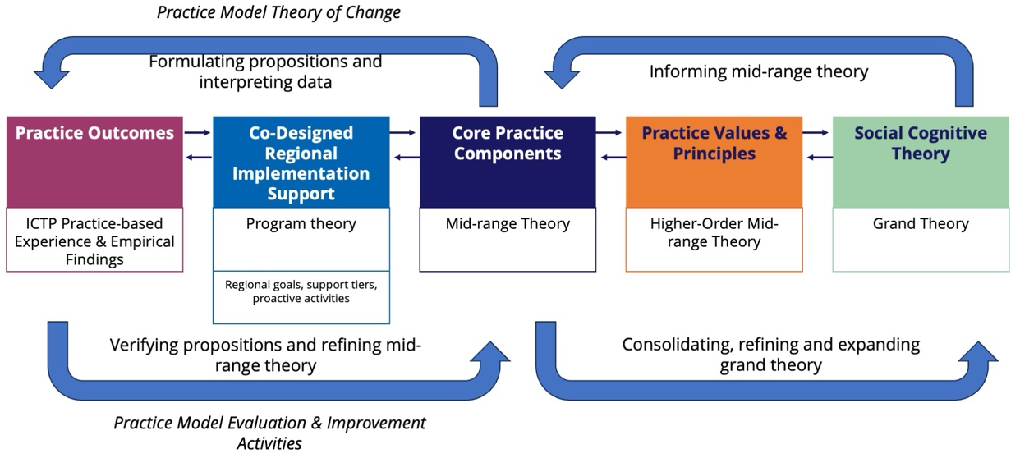

Beyond recognizing the major developments to our practice model in the past five years as described above, in this practice compendium we detail our two key aspirations for future ICTP implementation support: centering equity and more strongly integrating improvement science methods within our implementation support practice.

Regarding equity-centered implementation support, we recognize that the goal of supporting the achievement of population-level outcomes, alone, is neither sufficient nor justifiable. This goal must be paired with a matching goal of supporting the reduction or elimination of disparities in intended child and family outcomes—particularly as related to systemic inequities, social determinants of health, and institutional racism [16]—as Triple P implementation and scaling activities afford. Community-based initiatives, such as those required to support Triple P scale-up, are uniquely positioned for community-driven collective action for the interests of children and families.

Improvement science is, like implementation science, an applied science. It “drives innovation, testing in the field, and spread and scale up to generate and disseminate learning about what changes, in which contexts, produce the improvements” in organizations and systems [17]. To integrate improvement science methods more thoroughly within our implementation support practice, we place greater focus on the aim of improving implementation performance—simply put, the quality and impact with which essential implementation practices are carried out—across organizations and systems. To do this, we use models, such as the widely used model for improvement [18], and methods, such as small tests of change, that have demonstrated usefulness in driving such changes across organizational and systems settings.
DIVE DEEPER
Refer to Brief #7: Digging Deeper Into the Implementation Support Practice Model at the Regional Level and download section Organizational/
System Learning and Improvement Approaches (docx) for more information.

Centering these two aspirations, we look to the future of the ICTP projects with hope for enhanced success, sustainability, and equity of Triple P implementation throughout the Carolinas.

Key Takeaways:
- The ICTP projects are grounded in implementation science, the study of methods to utilize research findings and evidence-based practices to improve the quality and effectiveness of health-related services. This field includes implementation research, which focuses on developing and testing approaches to applying effective and generalizable interventions, and implementation practice (the primary focus of this compendium), which focuses on tailoring and applying those approaches within specific settings to achieve intended outcomes.
- By incorporating implementation science and an equity lens to practice work, the ICTP projects address two common reasons service systems face challenges implementing and scaling-up programs: (1) the tendency, despite their best intentions, to revert to previous ways of doing things, and (2) racial and other inequities that perpetually marginalize certain community members, families, and practitioners.
- The ICTP projects employ implementation support practitioners (ISPs) to provide external implementation support to service systems aimed at influencing change and improvement among people, processes, and structures within the system. ISPs’ work is grounded in the ICTP implementation support practice model (ICTP practice model, for short).
- The ICTP practice model originated in 2016, when Aldridge and colleagues [11] developed core principles and components of effective implementation support, which were then translated into a tailored model of support. The practice model evolved over the next five years, with the addition of practice activities as well as the ICTP theory of change for external implementation support (see Brief #6). The current version of the ICTP practice model includes 10 core practice components nested within eight implementation support practice principles, further nested within 11 practice values.
- Additional developments have included a three-tiered model of regional support, enhanced media and networking activities, “design and consultation support” to state and regional partners, a more complete set of resources for learning and applying effective implementation practices for Triple P, and an improved system for monitoring the quality and outcomes of ICTP implementation support.
- Moving forward, the ICTP projects aim to further emphasize (1) equity and (2) improvement science (the scientific study of improvement within systems and organizations) within its implementation support practice.

Reference List

- Ramaswamy, R., & Upshaw, V. (2018, January 26). PPP system and components, pre-work for strategic planning retreat. Chapel Hill, NC: Gillings School of Global Public Health, University of North Carolina at Chapel Hill.
- Wandersman, A., Duffy, J., Flaspohler, P., Noonan, R., Lubell, K., Stillman, L., Blachman, M., Dunville, R., & Saul, J. (2008). Bridging the gap between prevention research and practice: The interactive systems framework for dissemination and implementation. American Journal of Community Psychology, 41(3-4), 171–181. https://doi.org/10.1007/s10464-008-9174-z
- Prinz, R. J., Sanders, M. R., Shapiro, C. J., Whitaker, D. J., & Lutzker, J. R. (2009). Population-based prevention of child maltreatment: The U.S. Triple P System Population Trial. Prevention Science, 10(1), 1–12. https://doi.org/10.1007/s11121-009-0123-3
- Prinz, R. J., Sanders, M. R., Shapiro, C. J., Whitaker, D. J., & Lutzker, J. R. (2016). Addendum to "Population-based prevention of child maltreatment: The U.S. Triple P System Population Trial". Prevention Science, 17(3), 410–416. https://doi.org/10.1007/s11121-016-0631-x
- Mettrick, J., Harburger, D. S., Kanary, P. J., Lieman, R. B., & Zabel, M. (2015). Building cross-system implementation centers: A roadmap for state and local child- and family-serving agencies in developing Centers of Excellence (COE). The Institute for Innovation & Implementation, University of Maryland. http://hdl.handle.net/10713/7379
- Metz, A., Burke, K., Albers, B., Louison, L., & Bartley, L. (2020). A practice guide to supporting implementation. ISP Practice Guide-v1-10.27.22.pdf|

