Intermediary and Implementation Support Reference Sheet
Implementation Support (IS): an intermediary support function to help communities build core implementation capacities locally

INTRODUCTION
Implementation Support (IS): IS focuses on helping communities to build and strengthen the multi-level implementation capacities necessary for “what it takes” to effectively support the use of innovations locally. The work is both proactive and responsive, and involves working with local leadership and implementation teams to help ensure (i) co-creation partner engagement plans, (ii) leadership and team structures, (iii) workforce development systems, (iv) quality and outcome monitoring systems for improvement, and (v) media and networking capacities to expand program benefits beyond direct program services.

Background: Intermediary Organization (IO)
What is an Intermediary Organization?
An intermediary organization is a statewide center or partnership that supports state and local child‐ and family‐serving agencies in designing, implementing, and sustaining evidence‐based programs. Most service delivery agencies are not set up to systematically attend to the day-to-day work involved in the process of implementation. The addition of external support can strengthen the odds of local systems’ effective program delivery and getting to improved outcomes for children and families. Intermediary support organizations often address five areas of needs and challenges that typically exist among local service delivery agencies:
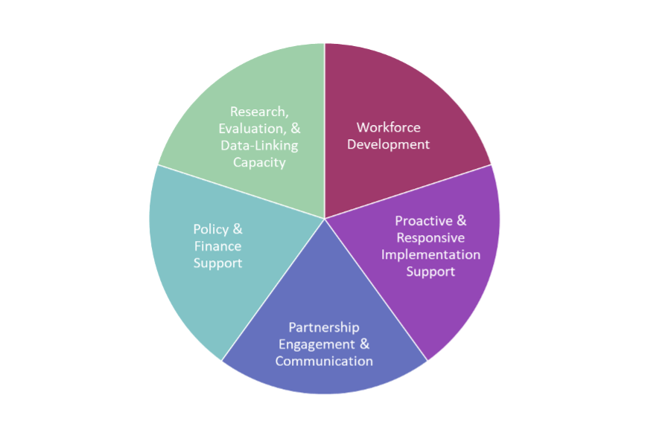
- Partnership, Engagement, and Communication (PEC): “PE” support helps ensure that the right co‐creation partners are at the table to support a hospitable context to achieve program goals; and “C” helps to ensure widespread and consistent messaging related to program goals.
- Research, Evaluation, and Data Linking Capacity (REDL): REDL support involves data gathering, analysis, sharing, and use at state and community levels, often guided by a comprehensive evaluation design, to understand progress and improve efforts.
- Workforce Development (WFD): Here, WFD support focuses on practitioners’ competent and confident delivery of the program. It helps communities select the right practitioners, ensure that training is accessible, and that practitioners are getting high quality coaching after training.
- Policy and Finance Support (PF): PF support explores alignment of the program with state and local policies, and helps local partners explore and navigate finance contexts for sustainability.

A Focus on Implementation Support (IS)

What does it look like when Implementation Support (IS) is working well?
When implementation support is working well, community backbone organizations and service organizations are developing prevention and wellbeing goals based on local data; selecting intervention strategies responsive to local needs, preferences, context and goals; supporting co-creation processes for broad engagement in implementation and scaling activities; strengthening the resources and abilities of people and organizations needed for successful and sustainable scale-up; mobilizing knowledge and behavior change beyond those receiving direct services; and improving implementation performance over time so that local goals are realized.

Why is Implementation Support (IS) important?
Children and families cannot benefit from effective programs and practices that they do not receive. Ensuring that effective implementation processes actually support the use of effective programs and practices requires deliberate and resourced attention by people and organizations. We know that traditional ways of implementing programs through funding, training, and sharing information are not enough to see the outcomes we want. Approximately 10-15% of service delivery agencies are set up to do this important implementation work on their own. What about the other 85%? The addition of carefully designed, intentional, and ongoing implementation support helps to ensure that communities develop resources and abilities (capacity) in five key areas and use those capacities in a systematic way so that children, families, and communities experience the full benefits of effective strategies.

Implementation Support (IS) – General Best Practices
For the organization providing IS:
- Accountability – clearly identified, resourced person(s) with dedicated time who are responsible for providing implementation support to local implementing sites
- Clear, job, position, role descriptions for those responsible for IS
- Written implementation support plan
- System of collecting multiple sources of data about implementation support being provided
- Written plan for coaching implementation support staff
- Formally allocated non-human resources to support the implementation support plan
- Sufficient tools and materials to carry out quality implementation support
- Documented sustainability plan for the provision of implementation support
- Among those responsible for IS,
  - Fluency in active implementation support/ technical assistance practices (PRIS 5)
  - Proficient with the use of implementation science and best practices (PRIS 6)
  - Proficient in the Triple P Implementation Framework (TPIF) (PRIS 7)
  - Proficient in the development of community prevention coalitions (PRIS 8)
  - Understanding the role of external implementation support

Important Knowledge & Skills
- Definitions of implementation science and support and rationales for support
- Give elevator speeches to typical stakeholders to pitch implementation science and support
- Usable interventions and practice profiles
- Implementation teams, infrastructure and best practices for each driver
- Implementation stages
- Plan, Do, Study, Act (PDSA) improvement strategies
- Understanding the components and need for understanding readiness for change
- Understanding the interface and linkages across the five implementation capacity domains, and how they support each other
- Knowledge of how implementation support (IS) and implementation capacity best practices across five core domains can be measured
- Utility and administration of implementation capacity assessments; using this data for goal setting process and for ongoing action planning for support development in each of the five implementation capacity domains.
- NOTE: the following are more “generic” skills that cut-across Implementation Support focused on all five implementation capacity core areas (see each reference document)
  - Relationship building
  - Organizational and community assessment processes
  - Facilitation, reflective listening (also group, collaborative facilitation)
  - Adult learning best practices
  - Supportive behavioral coaching
  - Collaborative learning and adaptive problem solving
  - Adaptive leadership

Resources and Tools
- Implementation Capacity for Triple (ICTP) Simulation Lab, https://ictp.fpg.unc.edu/simulation-lab/

What does building local implementation capacities look like? What might progress look like?
Implementation Support (S) focuses on facilitating building local implementation capacities in five core domains: (i) Co-Creation Partners; (ii) Leadership and Teams; (iii) Workforce Development Systems; (iv) Quality and Outcome Monitoring Systems; and (v) Media & Networking Systems. The remainder of this comprehensive resource includes a reference document for each of the five implementation capacity domains. Each Implementation Capacity Domain reference document is organized in the same format:
- Background
- What is it?
- What does it look like with it is working well?
- Why is it important?
- Best Practices
- Important Knowledge and Skills
- Resources and Tools
- What does building capacity for it look like? What might progress look like?
The last section reminds us that the work to build implementation capacities takes place across stages of implementation. Each Implementation Capacity Reference Document uses three functional stages of implementation to outline questions that can guide the work of building each capacity. Here is a sample of general Implementation Support activities. Please know - each stage of implementation does not discreetly end as another begins, and attending to each of the five implementation capacity can begin and unfold in different stages and in very different ways.

Assessment, Exploration, & Readiness | Installation | Initial Implementation
- From where are we starting? What are our strengths and areas of development? | - How can we develop, acquire, repurpose, and strengthen resources and abilities for what it takes to effectively support this program? | - How are we doing, now that the program is being delivered? What are we seeing, what are we learning about what it takes to support implementation?
- Building relationships  - Assessing current status of implementation capacities  - Develop goals and action plan based on collective learning to strengthen implementation capacities | - Adult learning to build knowledge and skills related to the content and focus of priority goal areas  - Capacity development to build plans and resources to get capacities in place | - Reflective practice – what are we seeing? What is aiding in success, putting up barriers?  - How might we amplify success? How might we cycle back and address gaps in capacities that might help us make progress?

NOTE: Other local activities specific to program rollout are occurring at the same time as these implementation capacity activities.

