Assessing Parent Supports in Your Community

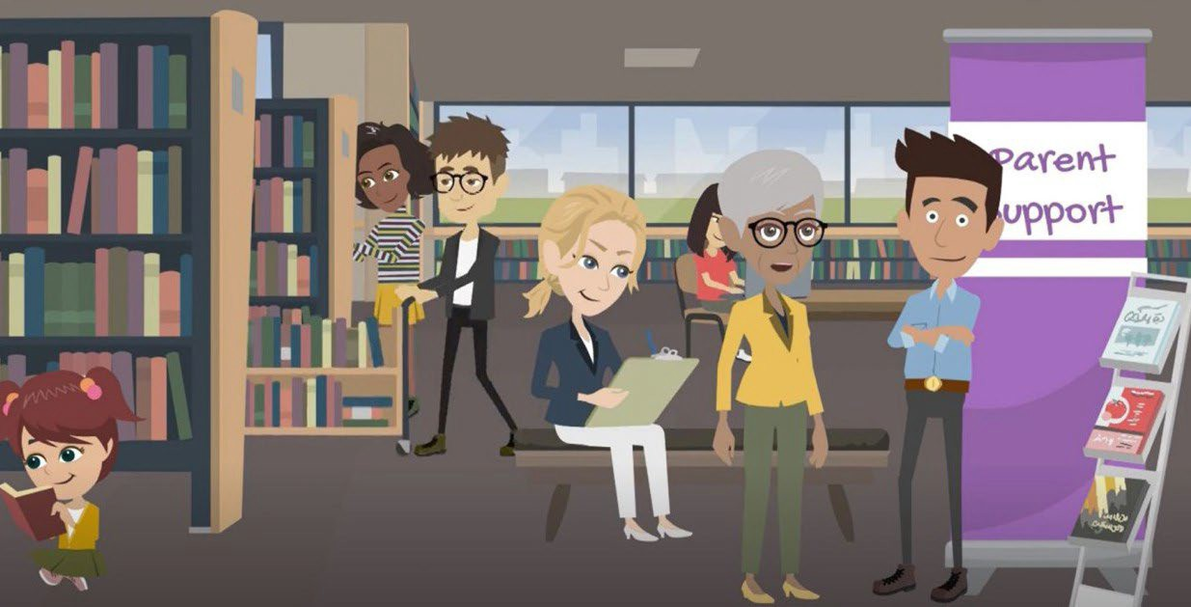
Every community has people and groups that support our families. A parent support assessment can help you ﬁnd the people in your Triple P region whom parents interact with for information, advice, and support related to parenting. The assessment can also identify the places and spaces where parents spend time.

What are the advantages of this assessment?
The process:
- Honors family engagement because the data come straight from parents and caregivers and not from professionals/leaders
- Promotes using a system approach to assess support for a more inclusive representation of caregiver voices
- Brings in equity, including data disaggregation (demographic, geographic; identiﬁcation of parent supports in diverse communities), to drill down and understand more precisely gaps and needs in your community

The data:
  - Supports strategic marketing and outreach because you’ll ﬁnd out where caregivers spend time in your community AND what social platforms they use
  - Supports geo-mapping to see how the location and density of Triple P providers align with where caregivers live
  - Helps identify coalition partners, beyond the ‘usual,’ straight from caregiver nominations.
  - Helps identify community inﬂuencers/peers to potentially engage with caregivers in your
community.
  - Identiﬁes top parenting concerns to tailor marketing and outreach

What’s Involved?
  - Getting buy-in and engagement from any system or group of organizations who serve your
population of interest. Examples are:
    - Schools/school systems
    - Childcare centers/childcare systems,
    - Healthcare centers or health systems
  - Disseminating a 10–15-minute survey to caregivers in partnership with the system or group of organizations identiﬁed
  - Summarizing data
  - Applying the data to outreach, communication, and coalition activities

The Impact Center can support you in:
  - Using strategies to decide what population is of interest
  - Engaging systems or organizations in the assessment process
  - Recruiting parents and caregivers to participate in the survey
  - Data analysis
  - Strategically using your results to inform your community implementation work

Additionally, the Impact Center has templates for your use in various stages of this work.

Knowing more about parent support can strengthen reach, connections, and collaboration between parents, caregivers, and the community-based groups who collectively work together to improve the well-being of kids and families in your community.


