A decision-support data system helps answer questions about program scale-up by collecting information across a range of programmatic areas, from practitioner workforce development through population-level outcomes. There are many areas in your program or system where data can show what is and what is not working well. These areas are particularly informative for improvement and scale-up:
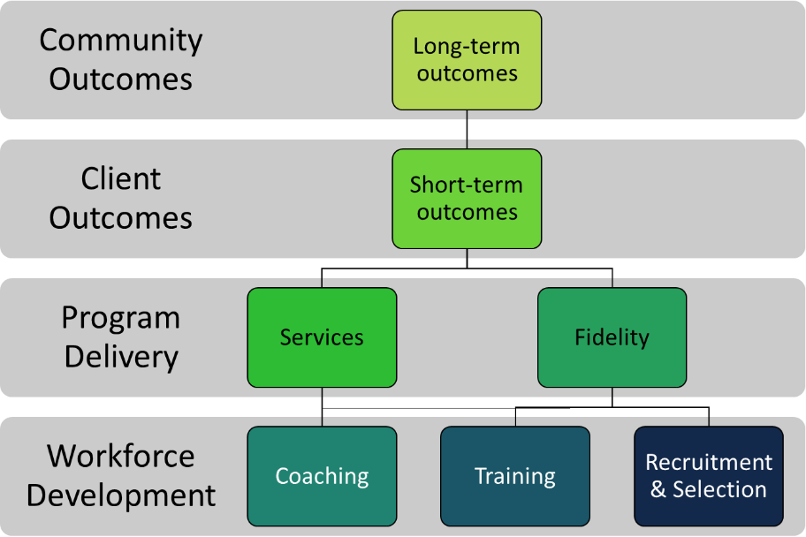
- Practitioner recruitment and selection data,
- Practitioner training data,
- Practitioner coaching data,
- Program fidelity data,
- Program service delivery data,
- Short-term program outcomes for clients, and
- Long-term program outcomes for community populations.
If you only collect data from one or two areas, you might be missing important information that could help solve challenges or understand successes.

Data Mapping
  - Where to start? How much data do you need to collect?
Building a decision-support data system can feel like a lot of work. Using a process called “data mapping,” these worksheets will help you plan for data collection, reporting, and use within each area. The table below describes the types of questions and information you will need to provide as you work through each worksheet.
What data you choose should depend on your community’s stage of implementation, your specific goals and interests, and your staff capacity to collect and use data for improvement. Start with a manageable process and build on your successes.

Data Mapping Worksheet Format
What area of the program are you looking at?
What do you want to know? |  | How are you going to know it? |  |  | How are you going to use it?
Measurement question | Type of question | Data point | Collection Method/Tool | Source | Frequency | Data use and improvement
What do you want to know about this area? | Output, Outcome, or Quality | What data point is this? | How are these data being collected? | Who/where are you collecting the data from? | How often do you collect the data? | When/how do you look at the data and use it for learning and decision-making?

What do you want to know?
For each area of your program, ask the question “what do I want to know?” and list the various measurement questions you come up with. An online module is also available to guide learners through this process. In general, these questions can be answered by one of the following three type types of data:
- Outputs: the direct product of activity and are often a “count” of something, such as the number of practitioners recruited.
- Outcomes: the result of outputs and measure achievement toward an objective, such as retention of practitioners or percent of accredited practitioners who are actively delivering the program.
- Quality: an assessment of how well the program was carried out or the caliber of the delivered features, such as following standardized recruitment and selection process that assess practitioner fit and abilities.
Look back through your measurement questions and label them as output, outcomes, or quality. Notice if you are missing any type(s) of question and brainstorm what else you might want to know. Collecting different types of data within each area helps identify where successes and/or barriers are happening. This could be missed if only one type of data is collected.
Note that in the example worksheets and appendix, measurement questions are organized by type for clarity. If this way of thinking about what data to collect makes more sense, feel free to use whatever approach works for you.

How are you going to know it?
Next, identify the specific data point(s) needed to answer each question. Document the collection methods or tools, such as administrative information, surveys, focus groups, interviews, or archival data sources like census data, and the source of these data. For ideas on measurement sources for data, see NCIC-TP Local QOM Guidance Brief 2017 or the Triple P Data Resources for Needs Assessment developed by the Children & Youth Branch at the NC Department of Health and Human Services.
The balance between the difficulty collecting data and the usefulness of the information to planning and decision-making efforts can help determine data collection frequency. Data that are easy to collect or influence your day-to-day decision-making might be collected more frequently than data that are difficult to obtain or less informative to problem-solving or planning.

How are you going to use it?
Documenting how you intend to use data for improvements, such as discussion during monthly data meetings, quarterly strategic planning sessions, board meetings, or quarterly coalition meetings, formalizes the plan to use data for learning and decision-making.

